CORRECT/RETRACT LINK IN STAR PANEL
*THIS IS LINK TO PEGASUS REQUESTS FOR TO BE USED FOR REQUESTING ALL MEDICAL RECORDS DELETIONS OR CORRECTIONS.*
In StarPanel, in the black menu bar
- CLICK HELP
- CLICK CORRECT DELETE
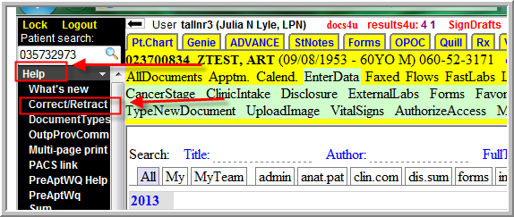
- LOG IN, AS THIS OPENS A PAGE IN PEGASUS THAT MUST BE COMPLETED BY YOU.
- COMPLETE THE REMAINDER OF THE FORM
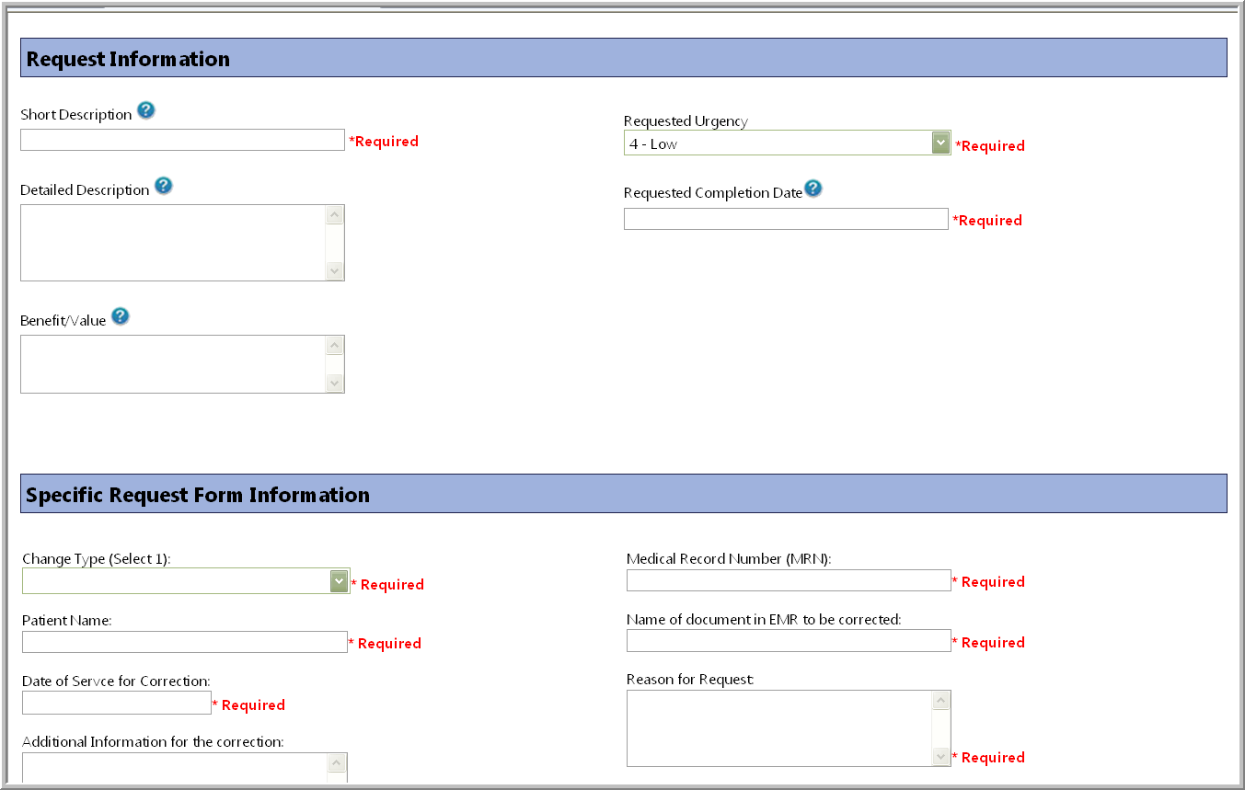
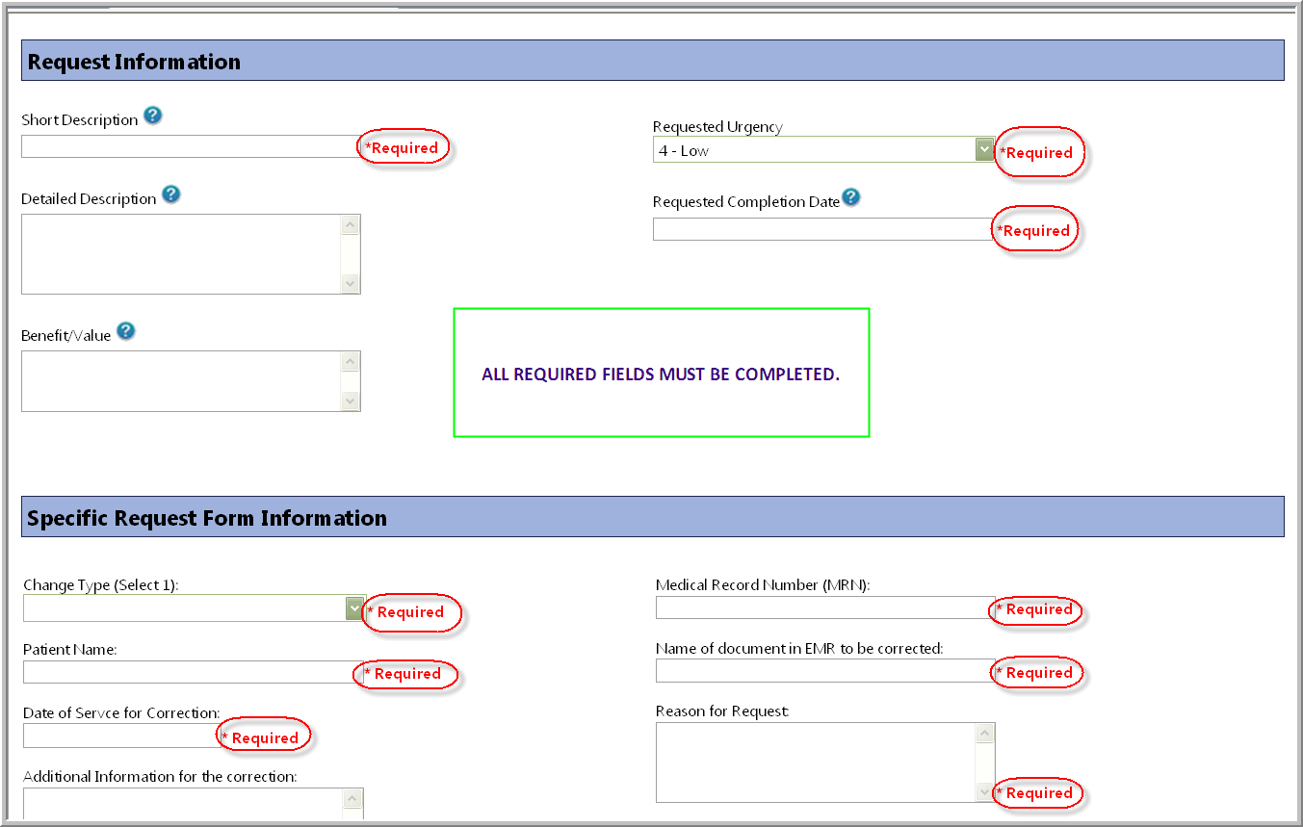

5) ONCE COMPLETED CLICK ADD
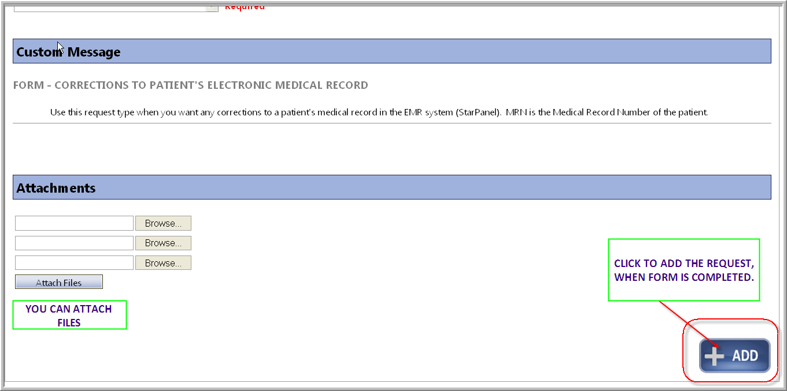
Providers can also click on Request or Move in their SignDrafts to communicate with MIS re moving or deleing a document in their SignDrafts:
