**How to Remove an Immunization Entry in StarPanel**

8/24/12/kh

**Background**:

When an immunization is charted in Admin-Rx, the documentation gets sent to StarPanel. If for whatever reason doesn’t actually get given (i.e. the patient refused) after the nurse Confirmed, the nurse can delete from Admin-Rx but the corresponding documentation will still display in StarPanel. That must be deleted.

**When might you use this?**

* Nurse documents in Admin-Rx med given but is not able to actually give
* When any investigation turns up a vaccine on the Immunization Record that is judged to be erroneous
  + These would most likely be found by someone else and reported to us.
  + If in doubt about whether to remove, consult with Gwen or Karen before removing

**How to access:**

1. You have to be on a team: cid:image001.png@01CD81D7.EFC1F530
2. lick on Teams in black bar, select (This team will NOT display you click on “Teams” or in StarCopy):

cid:image002.png@01CD81D8.633A3310

1. Enter your RacF ID
2. If you are not seeing this team, go back to teams and select “Link to someone elses teams”, type in Karen Hughart,
3. Click on the team cid:image001.png@01CD81D7.EFC1F530

**How to Delete an Immunization Record once on correct team**:

1. Bring up Immunization Record in StarPanel
2. Click on Show Age-View hyperlink:

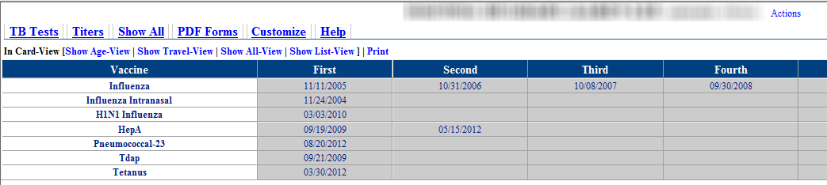

1. Click on the vaccine entered in error that needs to be removed

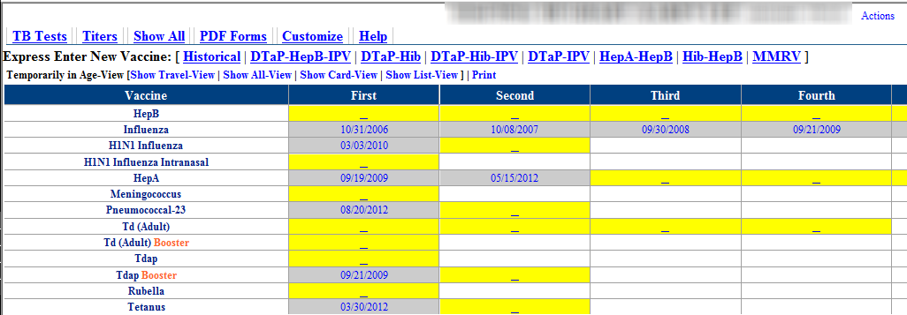

1. Click on the Delete button in the Detail box

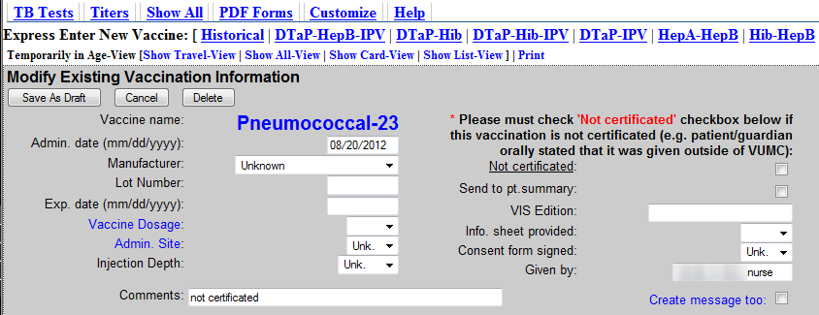

1. Click OK in response to the “Are you sure question”:

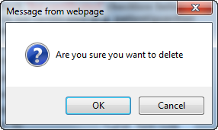

1. You will need to Click one more time to final save changes; note that the vaccine has already disappeared from the list:

