Content Outline:
- Step-by-Step Instructions

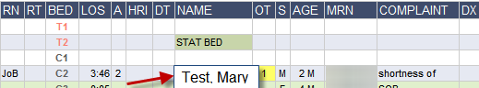
- Access StarPanel for your patient from the ED Whiteboard by clicking on patient name.

- When viewing All Documents in top frame, type in “Orders” in the Title search field
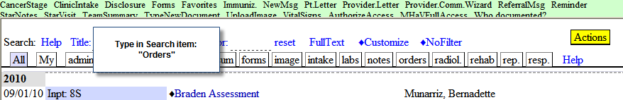
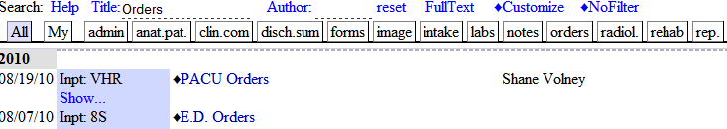
- This will pull up a list of Orders documents for the patient. The ED Orders include all orders performed in the ED and documented in Order Tracker. To access the ED Orders, click on the blue title “E.D. Orders.”

- The ED Orders will load in the frame below. Status column will display the completed orders. Medications show the date and time administered, as well as any comments.
- To print this list of ED Orders, click on “Print” at the top of the document.
