**Troubleshooting AWS Printers**

|  |  |  |  |
| --- | --- | --- | --- |
| **PURPOSE: Provide steps on how to recover lost settings for AWS printers.** | | | |
| **Date of Creation/initials:** | 1.8.13 LM | **Date of latest revision**: | **1..8.13** |

1. Go to control panel on your computer.

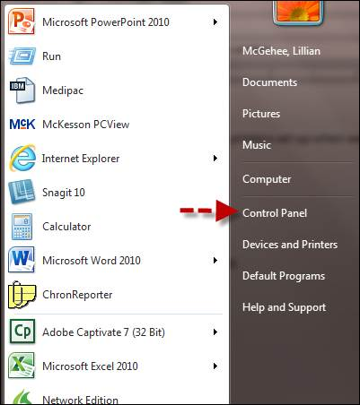

1. Select Administrative tools and select Services.

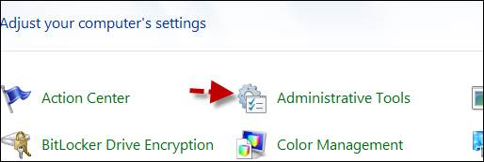 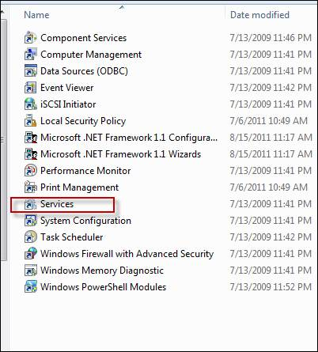

1. Select Printer Spooler and restart.

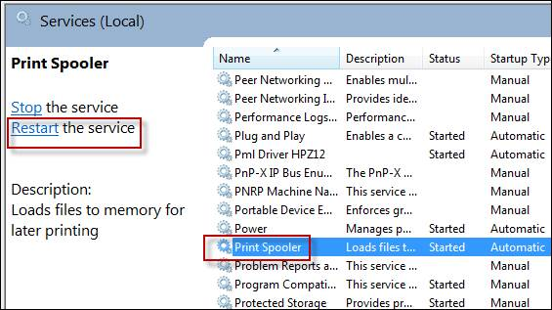

1. Printers should reappear.

