EAEX, EPEX, and VUIT Locations in HEO/WIZ

PURPOSE: To outline the purpose and functionality of the EAEX, EPEX, and VUIT locations in HEO/WIZ. To describe basic troubleshooting related to these locations.
Date of Creation/initials: | EB | Date of latest revision: | 7.2012

EAEX and EPEX:
- Temporary HEO/WIZ locations for Emergency Department (ED) treat and release patients (Medipac patient type “E”) who have been discharged
  - EAEX—for Adult ED patients
  - EPEX—for Pediatric ED patients

- Process:

- Nurse discharges a treat and release patient from ED Whiteboard, using “Nurse Discharge” selection on D/C column (DCRN function)
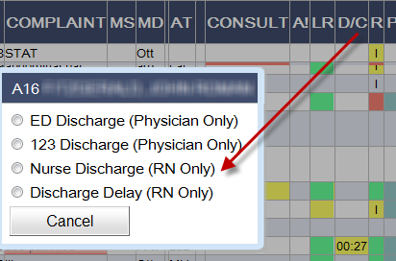

- Patient’s name moves to Recent Discharge Section of ED Whiteboard
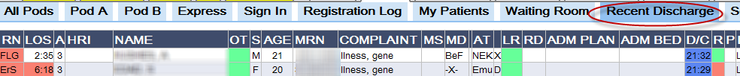

- Patient automatically moves in HEO/WIZ from EMER or ED/P location to EAEX or EPEX for one hour. This hour delay allows staff to move the patient back to ED bed with current orders if discharge was in error.
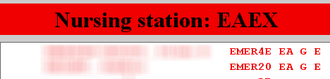

- After one hour, an automatic departure in Medipac occurs

- HEO/WIZ orders can be recovered on these patients for 4 hours after the Medipac departure (or 5 hours after moving the patient off the ED Whiteboard)

- Registration staff monitor these locations to make sure automatic Medipac departure occurs and patient moves out of HEO/WIZ

VUIT
- Temporary location in HEO/WIZ for either adult or pediatric ED patients with inpatient or observation status (Medipac patient type of “I” or “O”)

- Orders cannot be entered when patient is in the VUIT location

- Process for transferring patient from ED to another unit:
- Nurse discharges an inpatient or observation patient from ED Whiteboard using DCRN function.

- Patient’s name moves to Recent Discharge Section of ED Whiteboard.

- If the patient remains in Medipac location of EMER or ED/P, then HEO/WIZ automatically moves the patient from EMER or ED/P to VUIT in Wiz.
The process is set up this way to prevent providers from entering inpatient orders when patient is in transition to an inpatient unit or is in a testing/procedural area (radiology, cath lab, etc.) prior to arrival on unit.

- Help Desk Ticket troubleshooting for entering orders in VUIT status:
  - Call the Medical Receptionist on the receiving unit and ask him or her to perform a Medipac transfer on this patient to the correct inpatient unit location
  - HEO/WIZ automatically moves the patient from VUIT to that inpatient unit location. The provider can enter orders.
  - If patient is in a procedure and not yet on the unit, the provider can enter orders as draft and play the orders back when patient arrives on unit.

