Setting Up the Inpatient Whiteboard on Labor and Delivery and 4MSC Clinical Workstations with Fetal Monitoring Screensavers

PURPOSE: To outline the steps used to set up the inpatient whiteboard display in StarPanel for Labor and Delivery (L&D) and 4MSC clinical workstations that have fetal monitoring system as screensaver.
Date of Creation/initials: | 5.2.2012/EB | Date of latest revision:
- L&D (medipac code 4NPL) and 4MSC have multiple clinical workstations that have the CPN Fetal Monitoring System (formerly known as QMI or QS) as screensavers.
- These clinical workstations do not automatically open to StarPanel and do not automatically display the Inpatient Whiteboard upon sign on to StarPanel.
- This set up will need to be performed for all new workstations with a fetal monitoring screensaver or when the workstation’s IP address changes.
Setting Up the Inpatient Whiteboard Display on these Workstations:

- Log onto the workstation using green arrow on bottom toolbar:

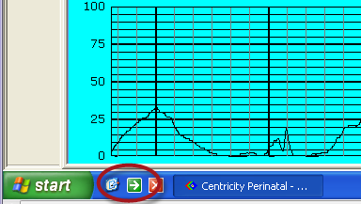

- Click on the desktop icon

- Locate the StarPanel icon on the desktop and load StarPanel

- Paste one of the following links in the StarPanel browser and press enter

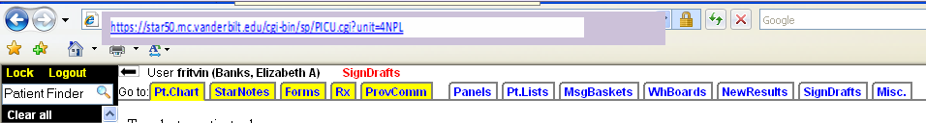

  - For L&D
https://star50.mc.vanderbilt.edu/cgi-bin/sp/PICU.cgi?unit=4NPL

  - For 4MSC
https://star50.mc.vanderbilt.edu/cgi-bin/sp/PICU.cgi?unit=4MSC

- The Inpatient Whiteboard Screensaver for that Unit will Display

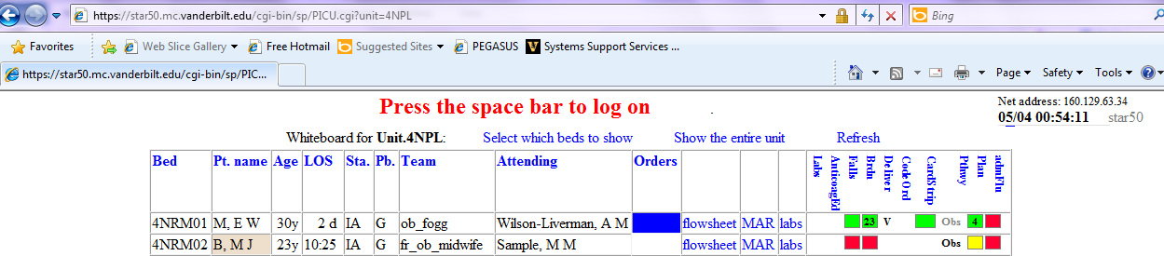

- Go back to the browser and remove the detail after cgi-bin/sp/

- Press enter and this will bring back the StarPanel log in page
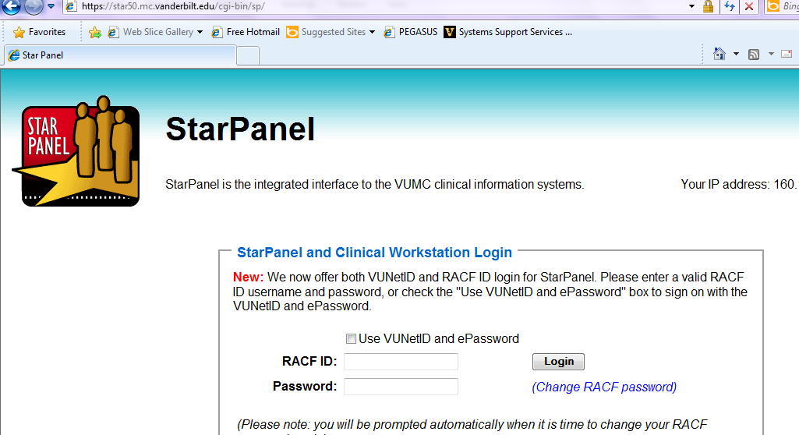

- Log back into StarPanel

- Click on Inpatient Whiteboard, located on black toolbar under Dashboards or Favorites
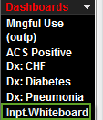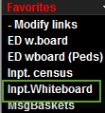

- Inpatient Whiteboard for correct unit will display:
