First ,on the “My Details” page, click the Temporary Replacement link on the left and click the “Add New” link.
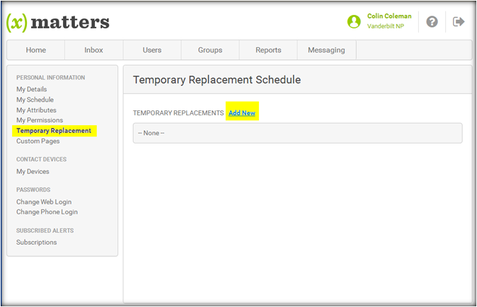

Next, either choose a recently used replacement by using the “Recently Used” drop-down list or search for a new replacement by clicking the “Lookup Replacement” link.
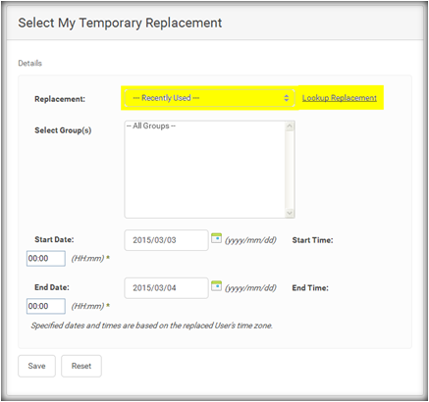

Then, select the groups you want to associate with this replacement and finally, select the start/end times and dates when the replacement will be active and click the Save button.

