Options to Send Messages to Providers Not in Your Message Basket Dropdown List
(DC 8/20/12)
Message Baskets:
Send to a user from Actions button to a provider in your basket group(s)
Send to a user from Actions button to provider not in your basket group
Send to user from within an open document you want provider to review (attaches the document)
Worklist:
Send a document to a users worklist for review
If you select Actions anywhere in a patients chart use the New Message option to send the provider a message:
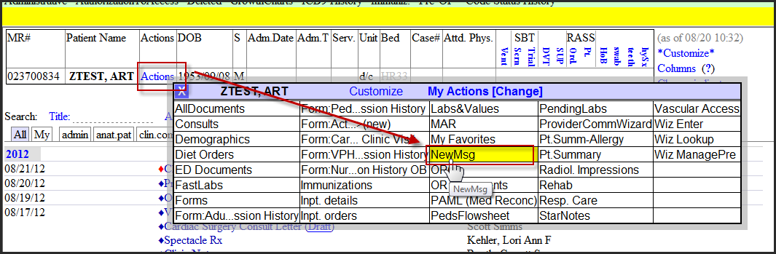
Then you will get this: Choose provider from a basket group you have access to OR type in their name at Target provider at the bottom of the screen: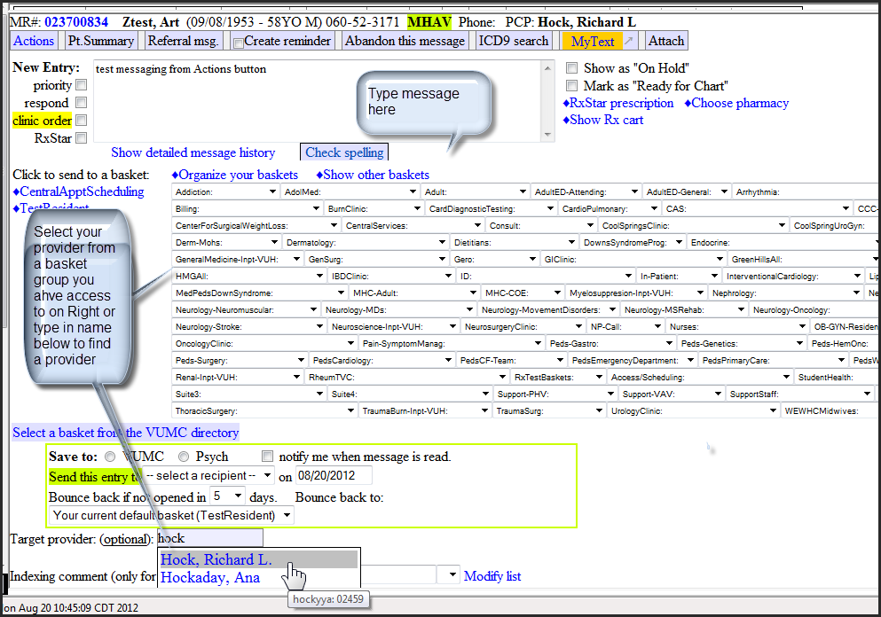
If you need to send a note to a provider to review select “Send in a message” from the note. Note is automatically attached is really the only difference from above.

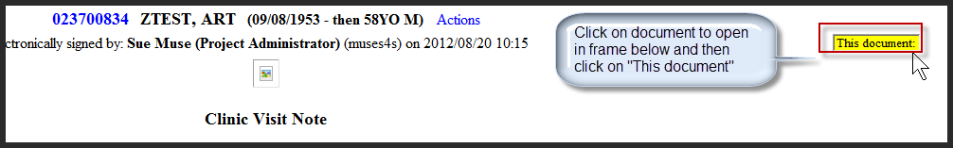
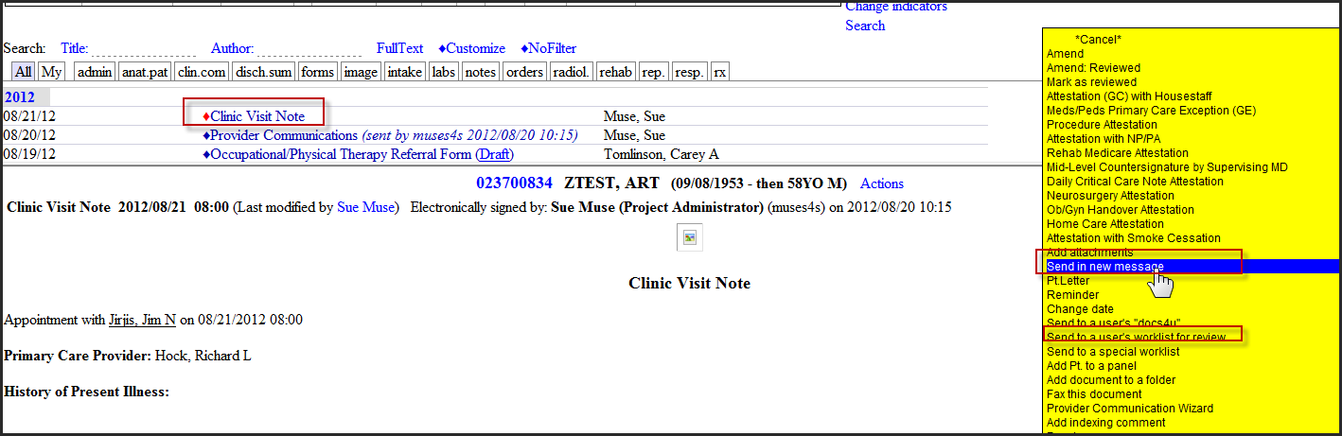

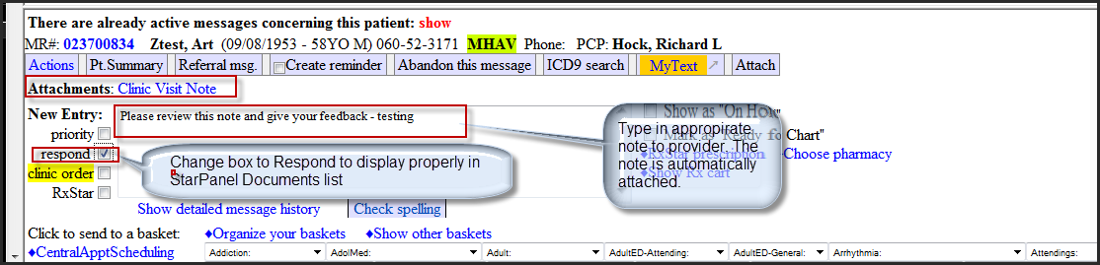
If you select “Send to Users Worklist” - Document will appear in their worklist to review and give feedback
