Content Outline:
- Wired Scanner
- Wireless with Two Cords
- Wireless with One Cord

*Over 95% of scanner problems can be resolved when the scanner is reset.

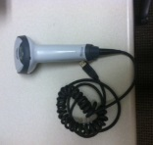
Wired Scanner:

- Open Scanner Reset document from HED
- Scan top barcode
- Scan bottom barcode
- Scan medication

Wireless Scanner with Two Cords:

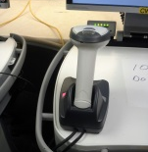

- Open Scanner Reset document from HED
- Scan top barcode
- Dock scanner
- Listen for series of sounds
- Scan second barcode
- Scan medication

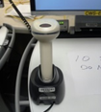
Wireless Scanner with One Cord:

- Requires a unique reset barcode attached to the base of the scanner
- Scan single barcode
- Scan medication

*If the medication will not scan after the scanner reset, administer the medication manually.

