**Registry Orders**

|  |  |  |  |
| --- | --- | --- | --- |
| **PURPOSE:** Description of Registry Orders | | | |
| **Date of Creation:** | **4/11/2012/kr** | **Date of latest revision**: |  |

Registry Orders are used by select teams and have been available before ZTeams re developed. Currently they are used by a consulting service (patient admitted under a different service). These services may have a Zteam scratch along with a 2nd scratch for consults.

* In WIZ, type “Registry” to pull up the various registry orders.

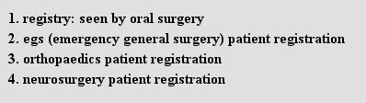

* Selecting any of the 4 will pull up a registration page whereby the user will enter the appropriate information.

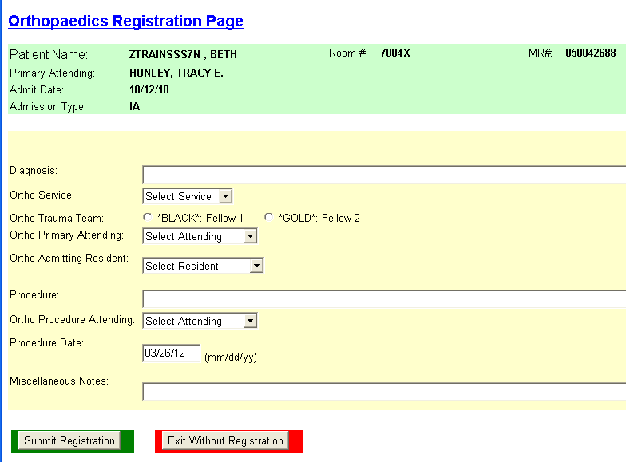

* “Auto” will be displayed next to those teams using Registry Orders when setting up a scratch census.

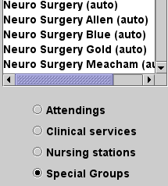

* Teams might use both primary and secondary scratch to identify patient’s admitted to their service and patient’s they consult on.

cid:image004.png@01CD0B72.FDC89250