RESETTING RACF TRAINING ID PASSWORD
Go to this link: https://ifm66wp-web.mc.vanderbilt.edu/vum/login.php and enter your RACF ID and password as shown below:
- Hover over the “t” then click
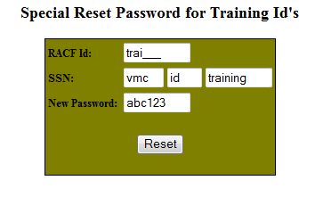
- Enter the RACF training ID
- Enter vmc id training for the SSN
- Click on “Reset” to reset the password to abc123
- Either go to a CWS or use the Clinical Remote Agent to remote into a CWS
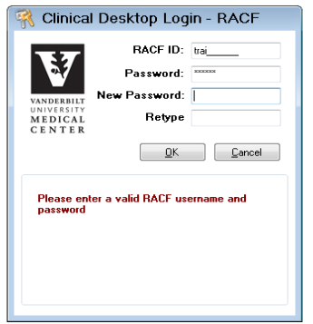
- Type in the RACF training ID
- Type in abc123 for the password
- You will be prompted to enter a new password
- Retype the new password

RESETTING VUNETID TRAINING ID PASSWORD
- Go to this link: https://it.vanderbilt.edu/accessvu/ and click on Existing Users
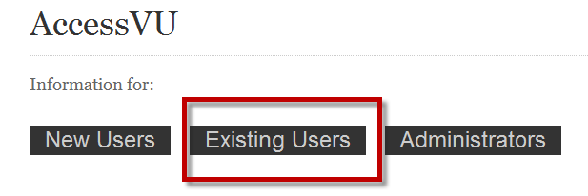
- Click on “Change ePassword”
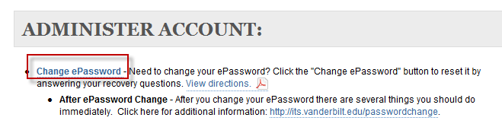
- Type in the VUNetID training ID and current ePassword and click on “Log In”
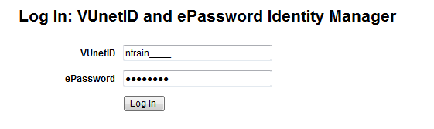
- Click on “Change ePassword”
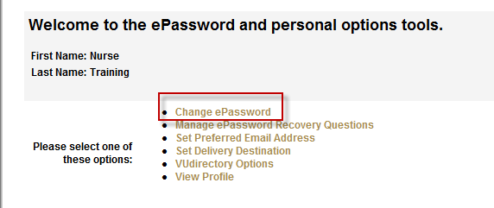

- Enter the new ePassword, then retype the new ePassword to confirm, then click on “Change Password”
