Content Outline:
- Printing from HEO/Wiz
- Printing from StarPanel
- Printing from Label Printers

Printing from HEO/Wiz
Orders: If a patient leaves the ED (changes Medipac location) and comes back to the ED, the orders entered in the other location do not appear in Order Tracker.
- Orders do not print for patients bedded in the EDs
- Most orders go directly from HEO/Wiz to Order Tracker
- The following orders do not appear in Order Tracker:
  - Admission patient care team
  - Admission service
  - Clinical Problem
  - Patient specific data
  - Team pager
  - Some pharmacy orders such as height and allergy info
- “Admit to” Orders have special print logic:
  - Adult side will print to EDLIASO and ADM
  - Peds side will print to PED/ED and VCHADM
Requisitions:
- Requisitions print based on the patient’s ED Whiteboard bed location
- Marty’s Magnificent Printer Table shows print routings for ED beds
  - Marty’s printer table shows ED beds and the logical printer name
https://belegost.mc.vanderbilt.edu/~wizorder/

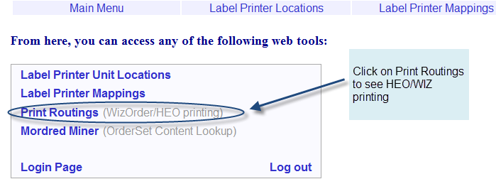

- Use HI$ Print Table to match logical printer name with actual printer name
http://ifm60wp-web-vm/vtm_ssl/login.php

- Default printers are setup for both EDs
  - If HEO/Wiz does not have a Whiteboard bed location for a patient, the requisitions will print to the default printer
- Certain Respiratory, Radiology, and Cardiology orders are set up to print requisitions to specific locations. These requisitions include:
  - Holter Monitor, 24hr and 48hr
  - EKG
  - RES (respiratory) Order requisitions
  - Orders with a department of CAR and a sub-department of HST or CAR/EXR. CAR/EXR also prints to CARECHO if it is a treadmill order, CARCON otherwise.
  - Some radiology order requisitions

These orders print as follows:

Adult ED: If patient's bed starts with an A, T, or WR, the requisition prints to EDMRAREA, otherwise EDMR.

Peds ED: If the patient's bed is any of these: O1 O2 O3 O4 O5 O6 O7 O8 O9 O10 FT1 FT2 FT3 FT4, it prints to PED/UC. Otherwise it uses the standard routes defined in Marty's tool.

Discharge Instructions for Admitted Patients (using HEO/Wiz Discharge Process):
- These are set up to print based on ED Whiteboard bed location for the patient, as listed in Marty’s Magnificent Printer Table
- RxStar prescriptions print to single tray tamper proof printers
  - Adult ED: Located in B Pod MD Area
  - Peds ED: Located in OBS Area, nurse’s station

Printing from StarPanel
Most StarPanel documents print to the closest printer to the workstation. Users should be aware of possible variations in the expected print location if using a Virtual Clinical Workstation. In this case, documents will print to the printer closest to their original log-in location for that shift.
ED Discharge: The discharge application within the StarPanel EDWhiteboard allows user to select a printer for discharge instructions and prescriptions (these must be dual tray printers).
  - Adult ED: Triage, A Pod, B Pod, VPEC
  - Peds ED: MD Area, OBS Area, Triage Area, DOT 8th Floor
Printing from Label Printers
Marty’s Magnificent Printer Table also lists Label Printer Mapping
https://belegost.mc.vanderbilt.edu/~wizorder/

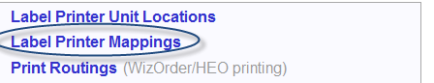
- Most of the Adult and Peds ED workstations are mapped to print to particular label printers
- For the Adult ED, if the workstation is not mapped to a label printer, then labels print to the default EMER, EMER A or EMER B label printer

