Posting Files on Etraining Server
3/17/14 mh

- Create the document in the appropriate Microsoft application and save it as Web page on the V Drive under WEB Page>WebDAV
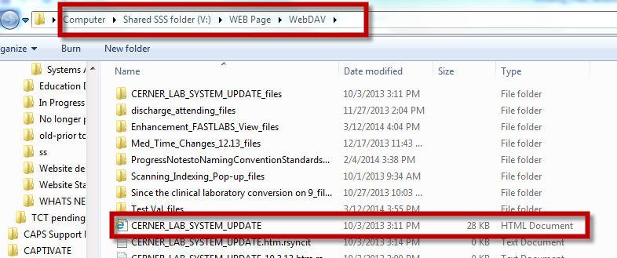
- Right click on the document from the V drive then copy it on the etraining server in the WebDav folder




