Peds Message Baskets
8/12 dc/jm

- Christina Braswel supports pediatric message baskets for both outpatient and inpatient pediatrics
- VCH message baskets are set up and maintained by Christina
- Any tickets on these baskets should be referred to Christina

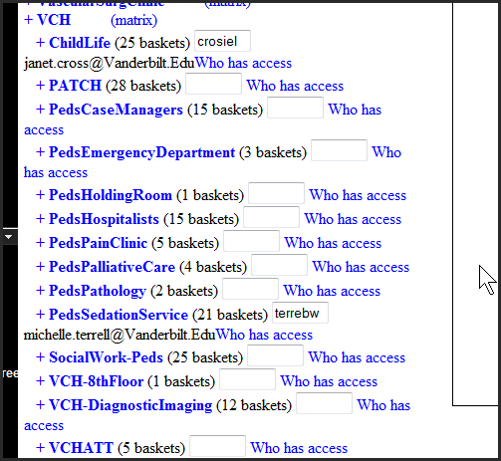

- SSS frequently gets ticket for the Peds ED
- Christina built and supports these as well:
- The Peds Emergency Department Basket Group has 3 baskets in it.
- She set them up for Dr. Jirjis after a pilot with some other peds ed baskets. The other baskets were not used consistently, or monitored so they were deleted and NO MORE will be added.

The 3 baskets currently set up for the Pediatric ED are for communication between the case managers, the Primary Care Chief residents, and their coordinators.

PedsEmergencyDepartment (3 baskets)
♦PEDSCommCoord ♦PedsEDCaseMgr ♦PedsPrimCare-Chief

- If you get requests to add a basket – the answer is “no we will not be adding any baskets to the PedsEmergencyDepartment group”

- If you get a request to add or remove a person to one of these 3 baskets – refer the ticket to Christina Brasel on the VMG support group via the Help Desk. You can reach her at 364-1240 to discuss if you need to.

- Christina also builds and supports baskets for the peds hospitalists.

