**Nurse Managed Heparin Protocol**

**4/14/14/lm**

There are two nurse managed Heparin protocols in WIZ/HEO on certain units:

**Low dose**

**High Dose**

* Providers initiate the Heparin protocol and the nurse manages the protocol by submitting PTT labs six hours after the last Heparin dose change.
* The nurse then enters a protocol order and clicks on the Heparin order to modify the VGR.
* Based on weight, the latest PTT, and other parameters the nurse will be presented with adjusted dose and orders for the next PTT lab draw.

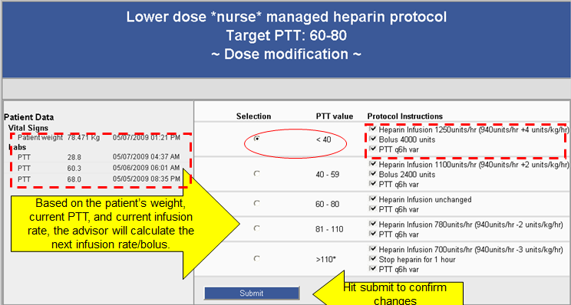

**Call issue - “the screen is greyed out.”**

Instruct the user that it could be that the six hours did not pass from the last time the orders were changed.  Reasons why this happen:

* Scenario 1 – someone went into the Heparin VGR and before six hours have passed clicked on “Modify Heparin infusion anyway”
* Scenario 2 – the PTT has not resulted yet in StarPanel and the nurse goes into the VGR  instead to look up the lab value and inadvertently clicks “Modify Heparin infusion anyway”
* Scenario 3 – the PTT gets sent early and the results come back.  The nurse forgets that it was sent early and goes into the VGR and sees a grey screen

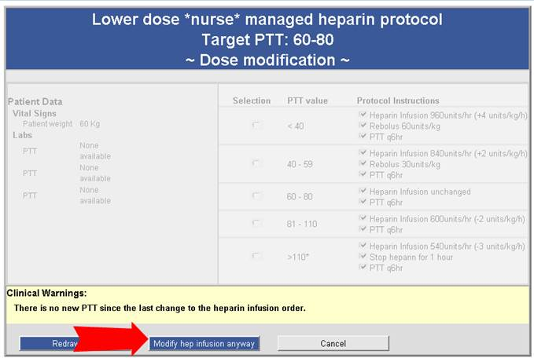

**Education to Learner:**

Have them look in StarPanel to see if the PTT is back.  They can use the lab indicator as well on the Inpatient Whiteboard to monitor for any labs coming back but the VGR screen will remain grey if they try to go into it before 6 hours

There is view history screen when they click on the Heparin rate order to see a view of all the changes made based on the PTT results that have come back

