New request forms now available for clinical and administrative workstations
LAN Management Services will move to Dell beginning this month. This transition comprises the second phase of a larger project that began in October 2014.
As part of this transition, new request forms are now available in Pegasus for clinical workstations (CWS) and administrative workstations (AWS). The new request types and their descriptions are shown in the chart below. Each request type is marked “all CWS,” “all AWS” or “all CWS and AWS” to help you determine which ones apply to you.
Users at One Hundred Oaks, Grassmere, Crystal Terrace and 3401 West End should begin using these forms immediately. The remainder of users moving to Dell’s support model should begin using these forms on Thursday, Feb. 26.
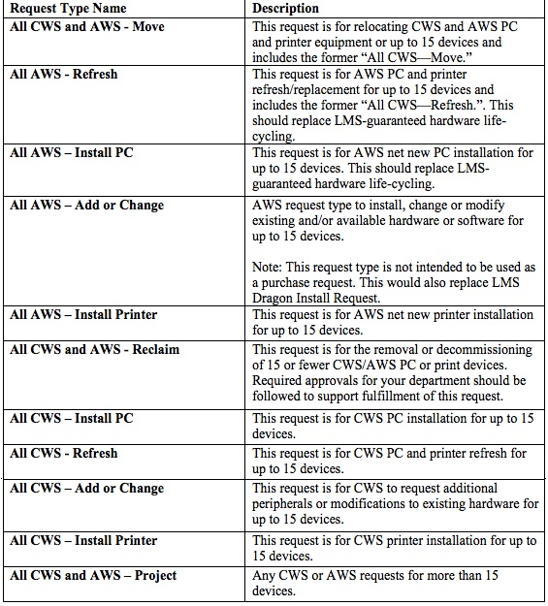
In addition to the transition currently underway, it was announced last month that clinical workstations throughout VUMC would undergo an expansive upgrade early this year. Once the upgrade is complete, clinical staff should see markedly faster performance and better reliability and will be utilizing higher quality monitors.
For more information, please email dellquestions@vanderbilt.edu.

