Mapping the Etraining Server to Your Computer
10/29/14/dc/mh
- To set up access to the etraining server, follow these steps. Click on the Start button then click on Computer.
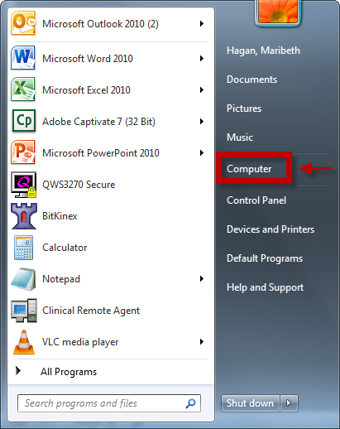

- Click on Map network drive.
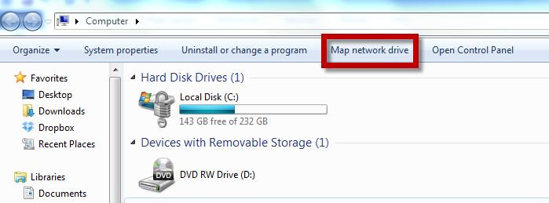
- Select a blank drive, then type in the address \\10.109.11.217\ss in the folder field. Then click on Finish.
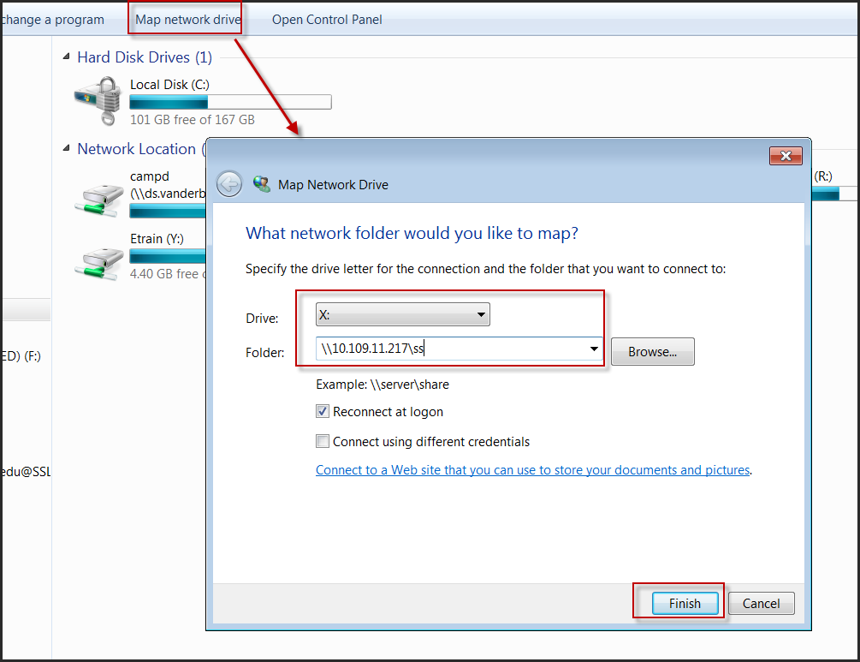

Note – you may see \\10.109.11.217\ss or Etrain for the drive name when you go back to Computer and click on your drives. You can rename the drive to Etrain by R clicking on the drive name and selecting Rename.
