PURPOSE: To assist providers with a method for listing procedures that they have performed
Locating Procedures Performed by a Provider

Date of Creation: | 11/21/201/kr | Date of latest revision:
There are times when a physician will require a list of procedures that they have performed.
- Direct them to the DeskTop, and select “KM Portfolio.”
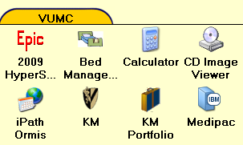
- Encourage requesting provider to seek assistance of colleagues; many providers utilize this tool
- If there are any user issues/concerns, refer them to Glenn Stein, Department of Biomedical Informatics at 615-936-2078 AS WE DO NOT SUPPORT THIS APPLICATION.

