**How to Determine Appropriate Group to Forward a Ticket To**

|  |  |  |  |
| --- | --- | --- | --- |
| **PURPOSE: To help SSS find the appropriate workgroup to forward a ticket to** | | | |
| **Date of Creation/initials:** | 1/23/12/dc | **Date of latest revision**: |  |

Can’t decide which workgroup should get a ticket you need to forward to someone more technical etc.? Here is a way to find the information about what a workgroups responsibilities are.

Here is a good example of one we rarely use but maybe should _(read the responsibilities):

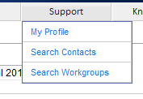



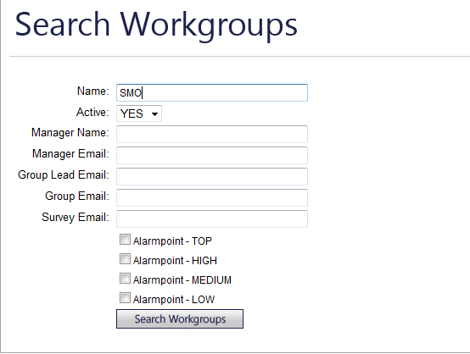

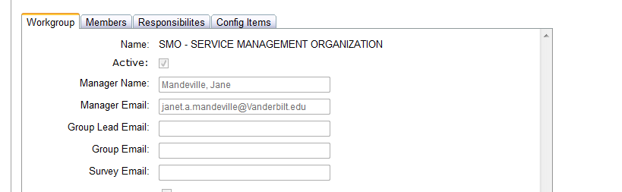

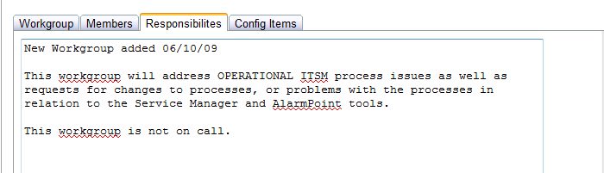

Another example -HCI Operations:

