How to Insert/Remove the Red System Wide Downtime Notification
And Downtime Flowsheet Banners
3/7/13 SP
Purpose: To describe the process for placing a system wide notification banner (red box), flowsheet banners and guidance regarding best use
- Help desk gets calls triggering system problems – pages IT AOC, ACs, SSS and Administrative Bridge established
- Status of problem determined by technical team
- AC, IT AOC, SSS determine message to place in StarPanel banner, overhead page and if yellow/ orange alert needed.
- HELP Desk or SSS enter banner in StarPanel – use standardized message whenever possible(see below)
- As status changes, update StarPanel banner
- When problem resolved leave banner with downtime end date/time in StarPanel X 48 hours.
A system wide donwtime banner provides specific information about the occurance of a system wide downtime (scheduled or unscheduled). This notification will appear as an alert on the Inpatient Whiteboard and as a red box when logged into StarBrowser/StarPanel. The decision to place a system wide notification banner depends on an agreement from the technical teams and Systems Support leadership and the AC.
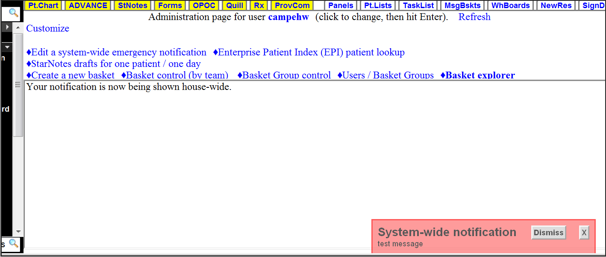
System wide banners can be placed for broadly used applications such as the lab system, Wiz/HEO, HED/AdminRx and frequently used functions within StarPanel such as RxStar, Outpatient Whiteboard, StarForms/StarNotes, and wireless network issues, pager system failure, telephone system failure, IMPAX and others. System wide banners should be avoided in departmental applications that do not affect the whole medical center.
Directions:
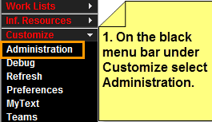
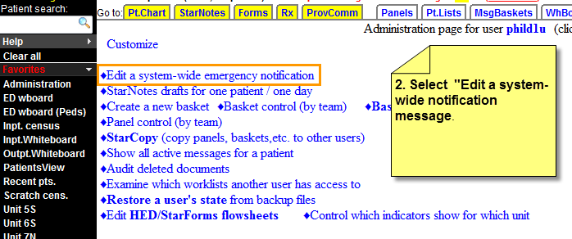

3. Enter the appropiate message that includes the application and/or functions affected:
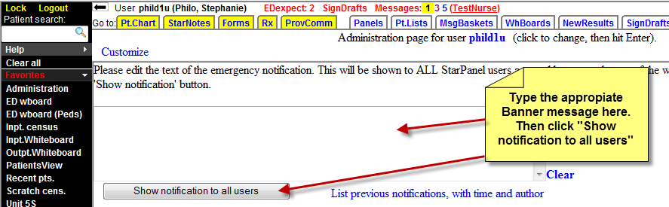
Date/Time “System(s) name” is experiencing problems. The Technical Team is assessing.
Just know there is a problem

Date/Time “System(s) name” is experiencing problems. Expect a fix shortly (give time if possible). Use Downtime Procedures if urgent.
Know the cause and should be fixed soon

Date/time “System(s) name” is experiencing problems. The Technical Team is working on a fix. Use Downtime Procedures.
Don’t know the cause or when it will be fixed

Date/Time “System(s) name” is experiencing problems. The Technical Team is assessing. “Insert customized instructions”
Know there is a problem and there are customized instructions
KK

Date/time “System(s) problem resolved-Downtime ended “date/time” Implement downtime recovery procedures.
Problem is fixed at date/time

4. Once the affected application/function is restored, use the “Problem is fixed” message (last one).

If it is an HED/AdminRx downtime you must also enter a Flowsheet Banner which provides specific information about the occurrence of the HED/AdminRx downtime once the overhead downtime announcements are made. This banner appears on the nursing flowsheets (adult, peds, OB) and the eMAR. Additionally, a red vertical line in the eMAR shows users the times when AdminRx was not available.

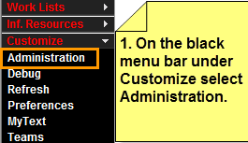

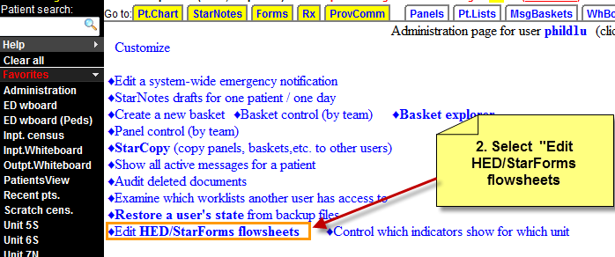

3. Select the blue Adult Nursing Flowsheet link to access a dropdown of different views.

4. Select one of the 3 flowsheets (Adult, Obstetrical, or Peds) and select the Add/modify Comment link.
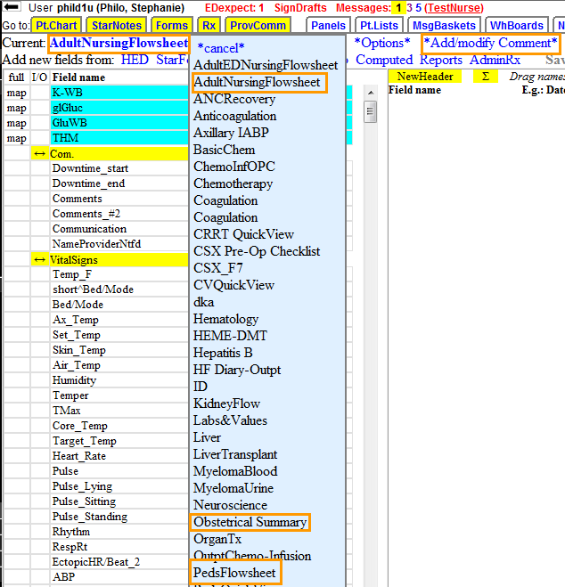

5. Document one of the following standardized phrases below into the comments field and add the date/time at the beginning and the end of downtime.
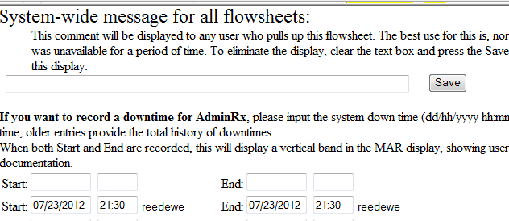
NOTE: only put in start and end times in the bottom section for AdminRx downtime
Beginning of Downtime:
START
“(Clinical System) downtime began at _____. Please see paper documentation for complete clinical information.

End of Downtime:
“(Clinical System) downtime began at ______ and ended at ______. Please see paper documentation for complete clinical information.
END

6. Create a calendar reminder or make arrangements with a colleague to remove the comments after 48 hours. The reminder should be set 48 hours out from the end time. Leave start and end times so that red vertical bands appear on the eMAR for users to reference paper documents.

