HOW TO SEE HED NURSING DOCUMENTATION IN FAST LABS IN STARPANEL
(or how to find the field name of an HED documentation field)
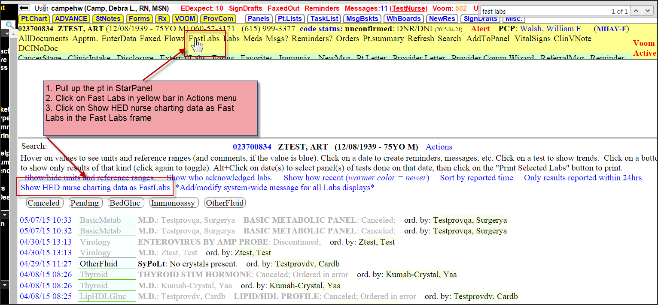
You will see data element documented as a field name and the information documented:
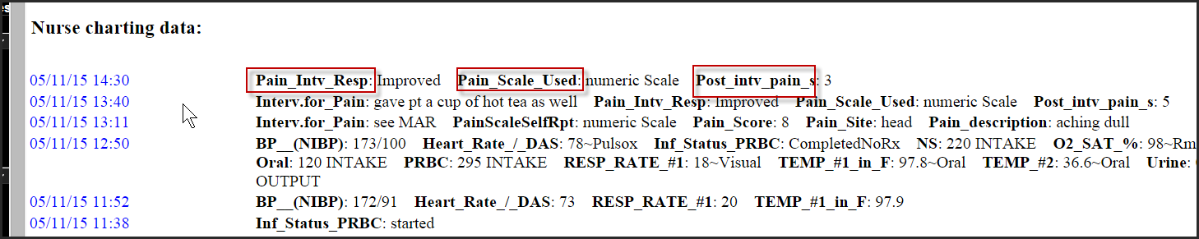

If the HCI team or StarPanel team asks you for the field name of a specific field you need them to address you can use Fast Labs to find the field name.

