Change Time, Update, Amend, Correct, and Delete Data Documented
Why would you need to do this:
If documented on the wrong patient or wrong data on a patient
Or patient admitted to the wrong encounter

Who can Update/Amend/Correct/Delete on a patient:
Only the person who entered the data can delete, modify it or change to another time

When can you Update/Amend/Correct/Delete Data Documented:
You can modify data for up to 72h in the past or up to 47 h after discharge

How to find the patient if no longer on your floor: (discharged patients remain on your floor census at the bottom without a room number for 47h after discharge).
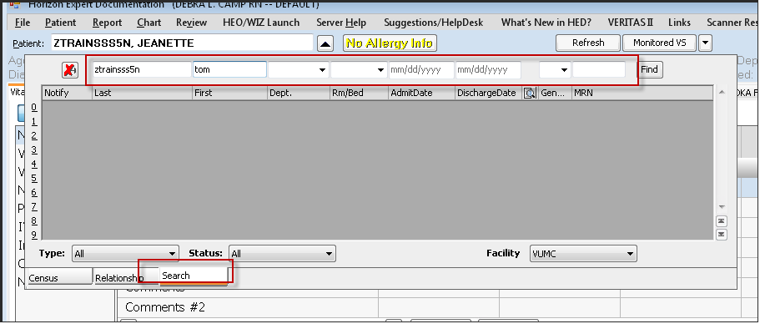
If you don’t find the patient here they may be admitted incorrectly i.e. to the wrong encounter and won’t be on the census. To find the patient:
- Go to Care Organizer
- Click on Pt Select
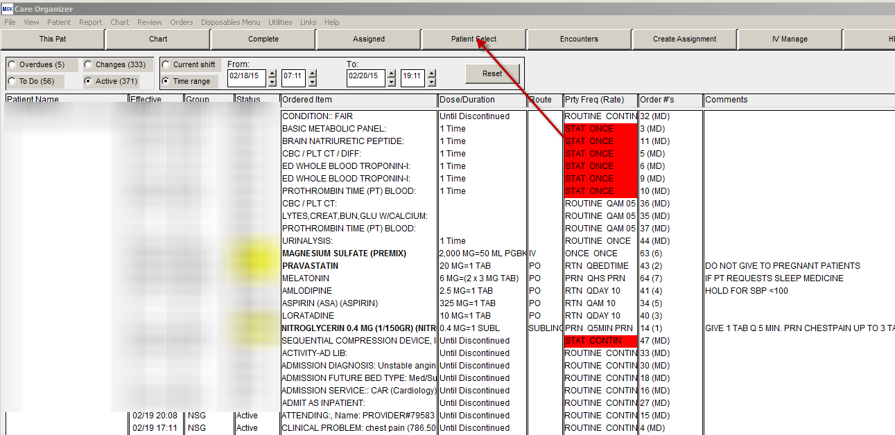
From the View dropdown list choose: By Search (CPI)
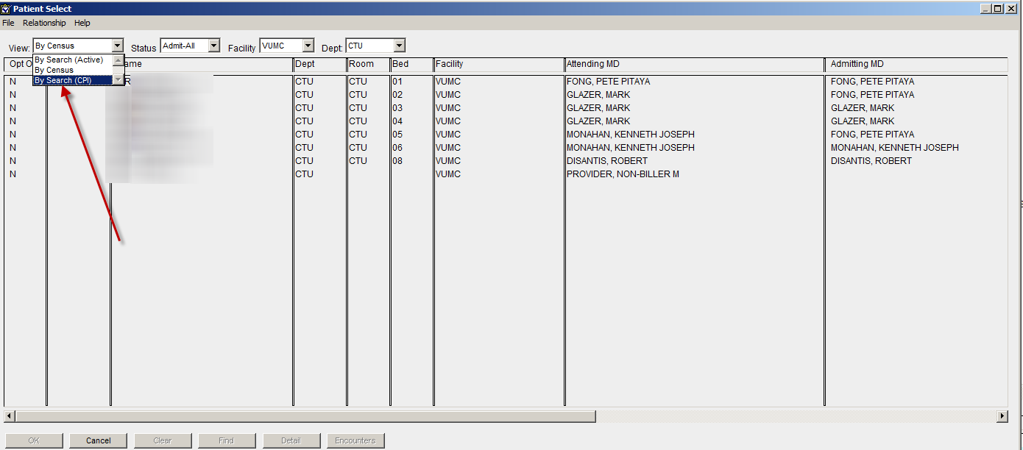
When the search screen comes up, type the MRN in the Enterprise ID field:
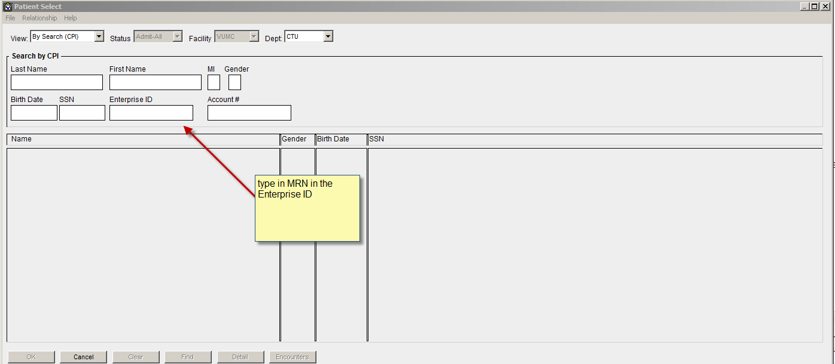
Click Enter
When the patient comes up- click on the Encounter button at the bottom R
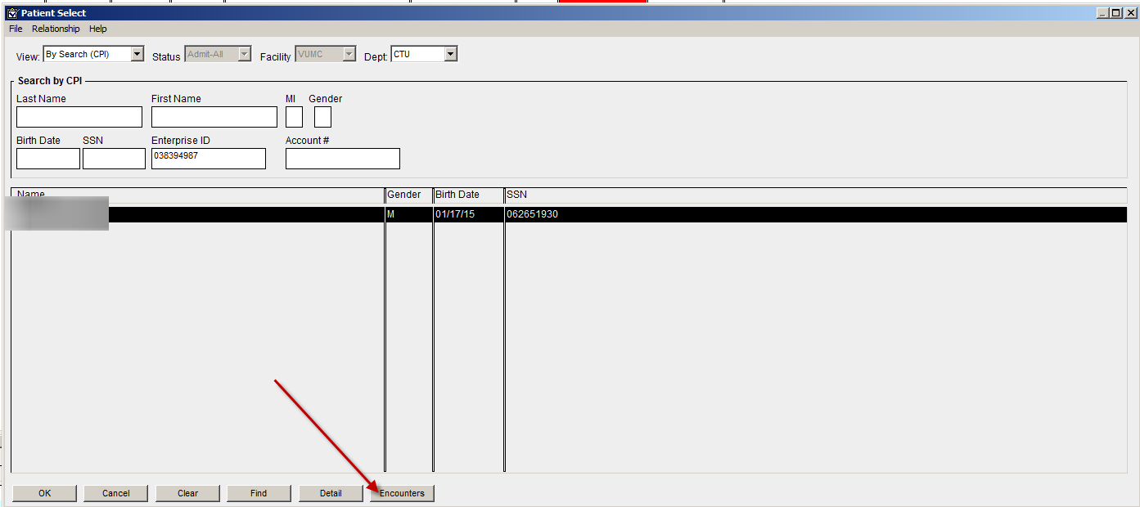
Identify the account number that needs to be addressed (amended or deleted), highlight then click OK at the bottom L
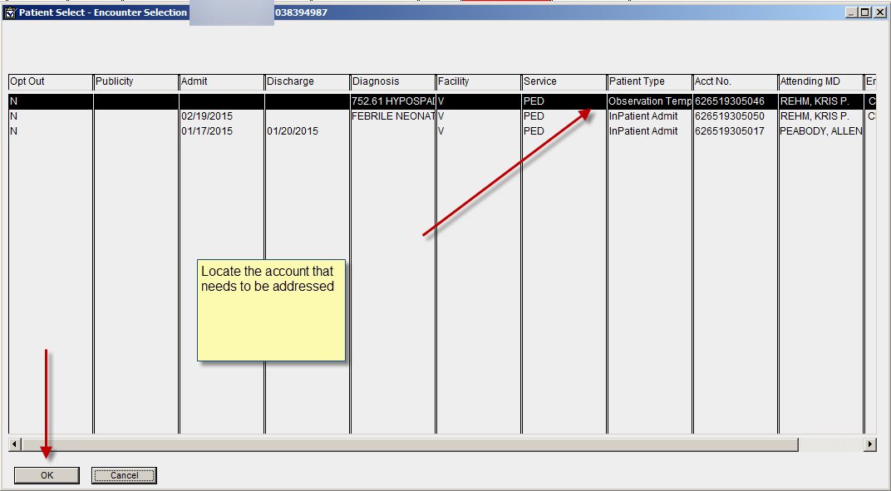
The account will populate Care Organizer
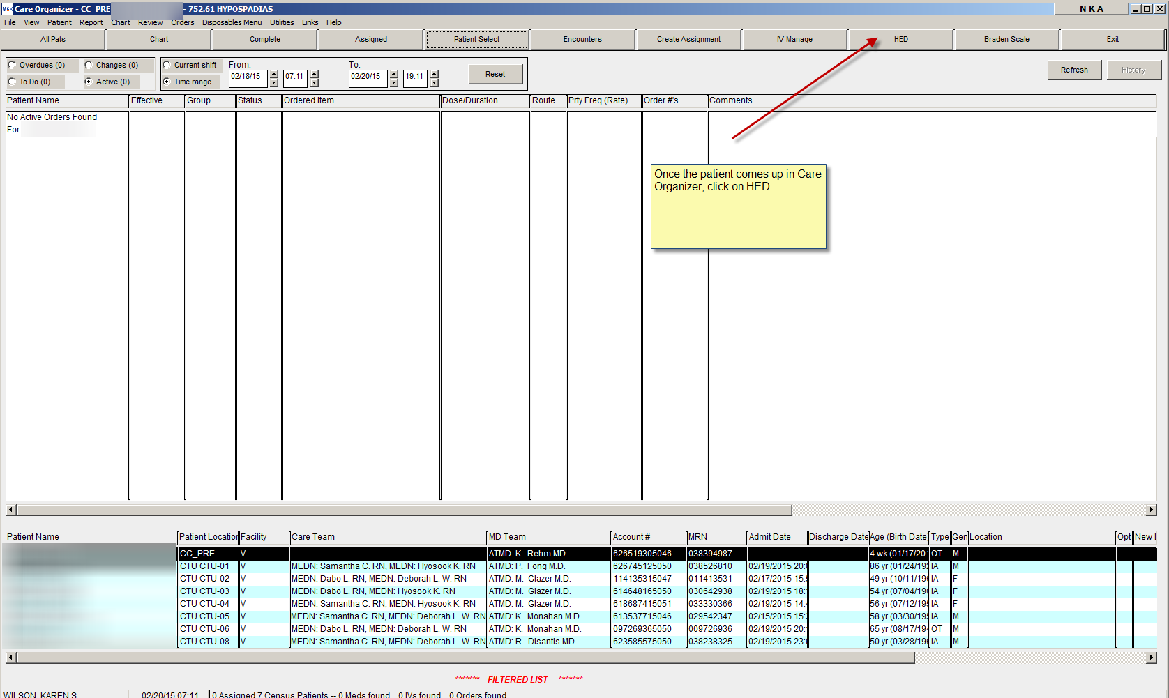
TIP: Have nurse bring the correct pt and encounter up on another computer side by side and enter the date before deleting from the wrong account or patient (data will be lost). Or write it down before deleting.
To Clear or delete the entire column of data: IE wrong encounter or wrong patient
- Click on Gray area by date
- Click on Clear
- Verify these are the results you want to delete on this patient!!
- Click on Clear Results
- Click on Save
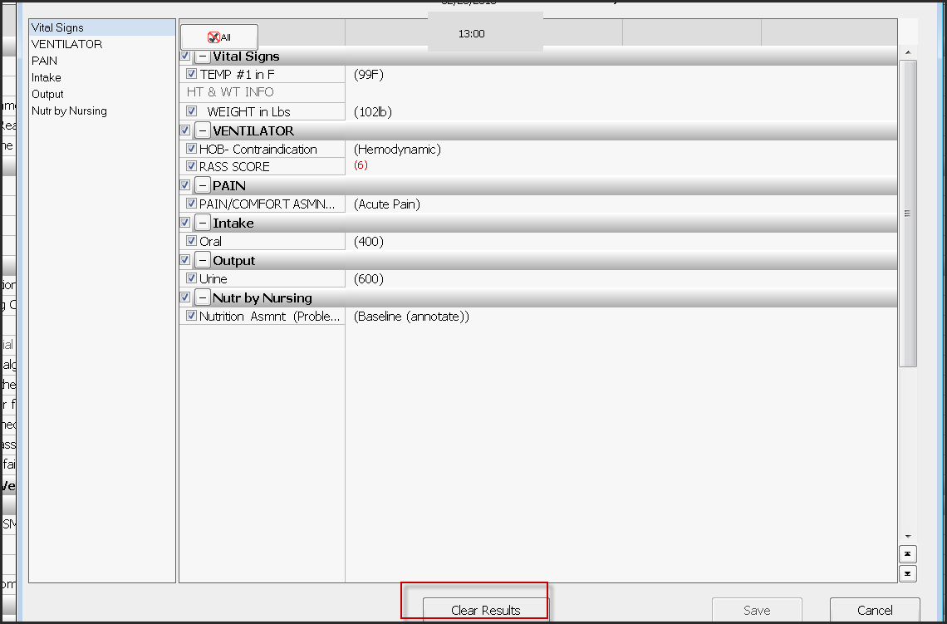

To Move to another time: i.e. charted at wrong time
- Click in the grey area under the time that needs to be cleared and a dropdown will appear
- Click on Move
- Enter the correct time in popup to move an entire column of data to another time
- Click Save
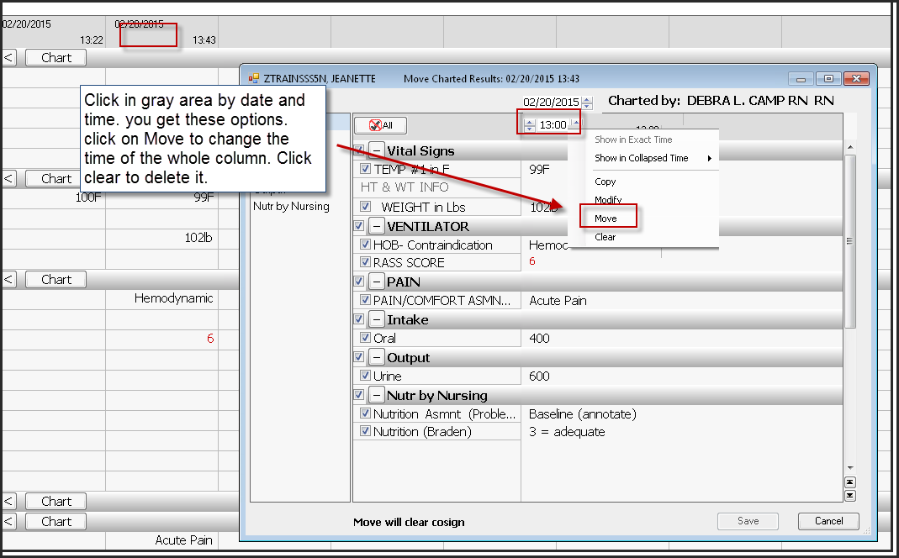

To modify/clear just one field:
- Click directly on that field and a popup will come up.
- Click in the blue box to modify/update/cosign the field.
- Click in the field you want to change and enter correct data, (or Clear Results or Cosign)
- Click Save
