How to find out who is On Call for Other Groups
5.15.15 sm

Check XMatters first. If XMatters is not available then you can check the following link (warning may not be as up to date as XMatters.
OnCall next 12h https://itsmweb.mc.vanderbilt.edu/oncallcalendar/VU%20Workgroup%20On-Call%20Alarmpoint%20Schedule%20Report.pdf
XMatters:
- Sign into XMatters
- Click on “Groups” on the home page
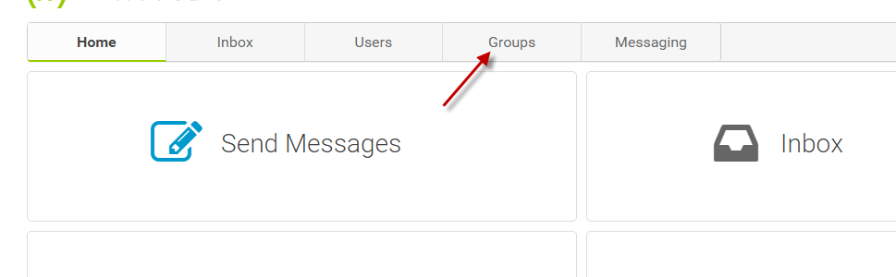
- Click “Who is On Duty:”
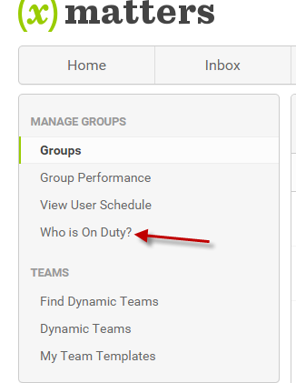
- Click on field that says “Begins With” and select most appropriate choice
- Type in the name or some part of the name (i.e. HCI)
- Click on “Find”
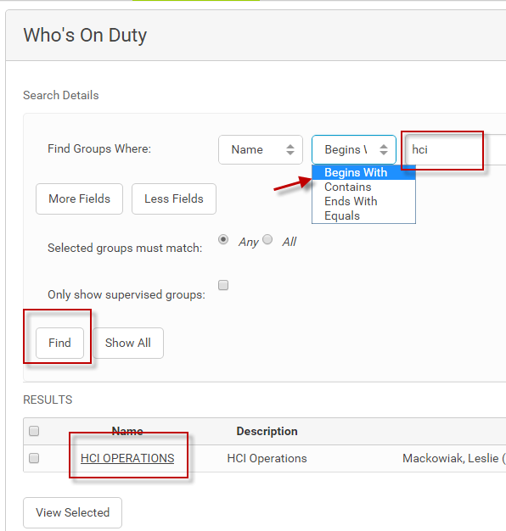
- On call rotation will display:
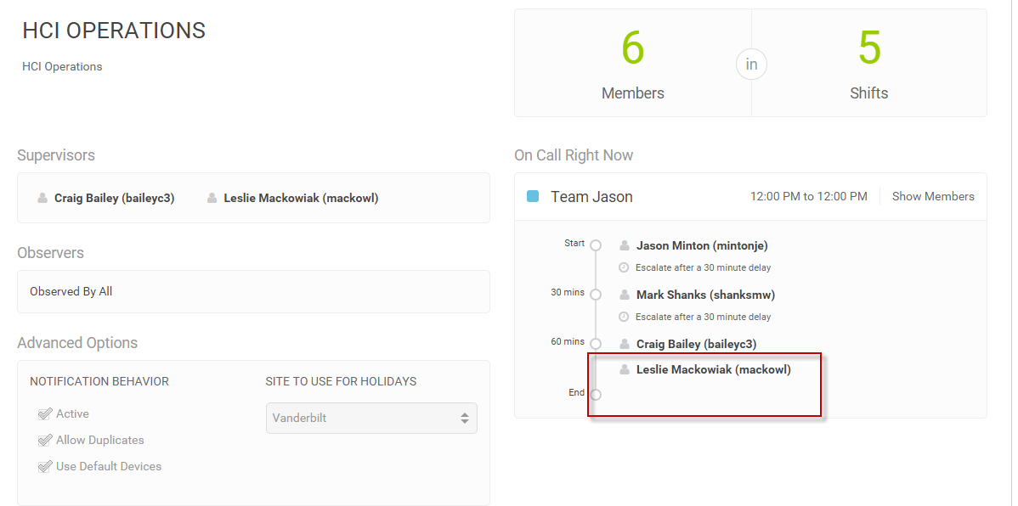

- Click on name to see contact information:
