- From the ED Whiteboard, the user will click on the D/C column associated with the patient that needs to be discharged from the ED.

** If the patient is an Inpatient or Observation-boarded patient, the user should complete the patient discharge through HEO/DMR.

- From the Discharge pop-up, the user will select “ED Discharge.”

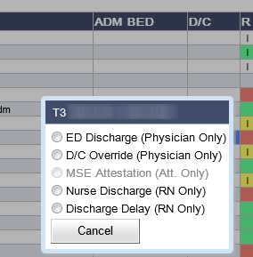

- The ED Discharge application will load for the selected patient and default to the Instructions Tab. If the patient is a STAT patient, the ED Discharge application will default to the STAT tab to allow the user to enter the patient’s real name that will appear on all documentation, including prescriptions. Once the user provides the override information, the user will be re-directed to the Instructions tab.

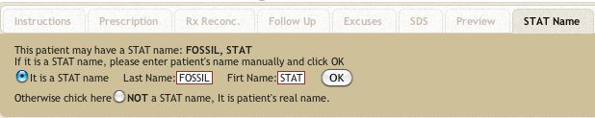

- The user will search, browse, and/or customize the needed patient instructions and Insert them for printed documentation.

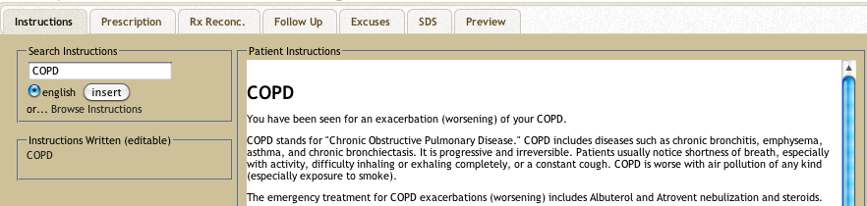

- If prescriptions are needed, the user will click on the Prescriptions Tab. ED Discharge will launch RxStar within the Prescription Tab. The user will complete all prescriptions through RxStar.

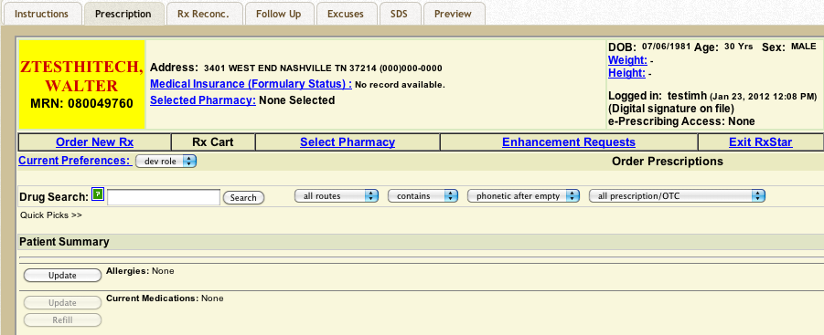

  - Patient’s Header will include: patient demographic and MRN, insurance-formulary, pharmacy (where prescriptions will be sent to), height and weight, user information (e.g. e-prescribing status). **Blue links allow the user to update or refresh the information.

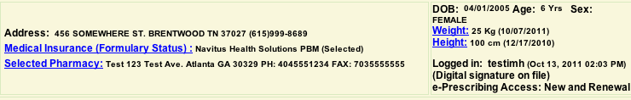

  - From the Order NewRx page (default), the user can begin to build a prescription in four ways:

    - Complete a drug search (with adjusted filters) and select a medication from the result list (if not on the result list, the user can complete a free text medication)

    - Click on a specific medication name within the Patient Summary section and renew or update an existing prescription

    - Click the Refill button within the Patient Summary section and renew more than one existing prescription at a time

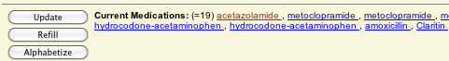

    - Select one or more pre-built prescriptions from the user’s Prescription Favorites list.

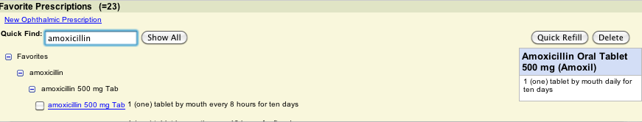

- Once the user selects the medication, the user will complete the remaining components for the prescription on the RxBuilder page:

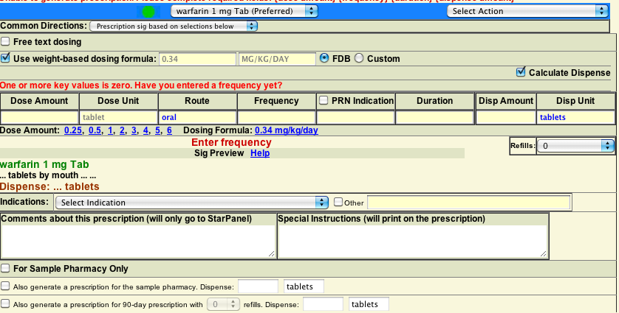

  - Formulation – Formulation defaults based on user selection. User can change the formulation through the Formulation dropdown list, if needed, so that the user does not have to re-search for the medication

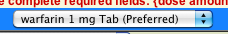

  - Sig – The user can complete the Sig through the structured boxes (which have dynamic menu options as the user navigates through the boxes), select a pre-built Sig from the Common Directions dropdown list, use the weight-based dosing formula, or complete a customized Sig through Free Text Dosing.

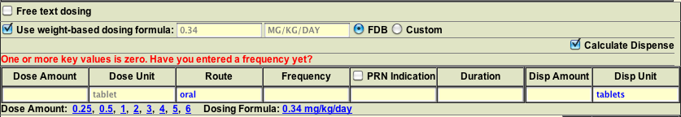

  - Refill Count – The user can indicate how many refills are needed for the prescription.

  - Substitution – The user can indicate whether the pharmacy can substitute the prescription (e.g. switch from brand to generic).

  - Indication (optional) – The user can provide an Indication for the prescription.

  - Comments – The user can add comments that will only appear within the Patient Summary’s Medication List and/or add Special Instructions to the prescription.

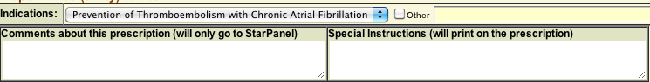

  - Additional prescription types for the current medication (e.g. Sample or 90-Day) - Beyond the standard prescription, the user can “clone” the prescription for a Sample or 90-Day prescription.

  - Add to user’s Prescription Favorites Section – The user can also save a built prescription to his/her Favorites list to re-use on future patients.

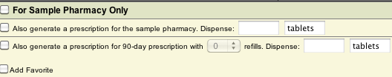

- Once the user has completed all prescriptions, the user will route prescriptions through the RxCart page.

  - The user can update or select a pharmacy.

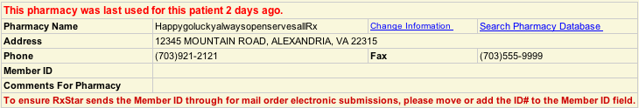

  - The user will see a “cart” that contains the list of generated prescriptions.

  - The user will have the option to “Save Cart” in case their session is interrupted or if a resident needs to save a cart for an attending to review and approve.

  - When the cart is ready to complete, the user can route the prescription is three ways:

    - Submit Electronically (mutually exclusive with Fax) – All applicable prescriptions will be sent electronically to the selected pharmacy. Controlled Substance prescriptions will print at ED Discharge.

    - Fax (mutually exclusive with Submit Electronically) – All applicable prescriptions will be faxed to the selected pharmacy. Submit Electronically and Fax are mutually exclusive and Fax requires a digital signature on file. Controlled Substance prescriptions will print at ED Discharge.

    - Print at ED D/C – All prescriptions will print when the user selects “Save and Print” through ED D/C.

    - Phone In – RxStar will document prescription(s) in the patient’s chart that the provider “called-in” the prescriptions to the selected pharmacy.

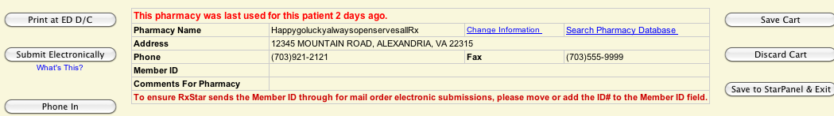

- Once the user routes the prescriptions through RxStar, the user will click on the Rx Reconc. Tab to complete the medication reconciliation process.

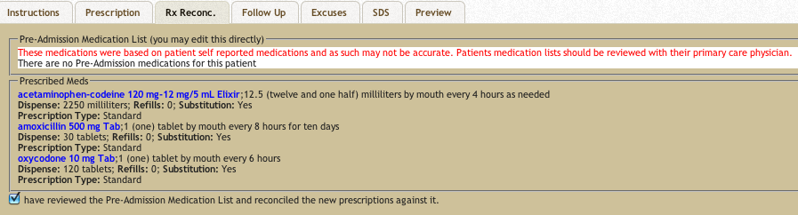

  - Review pre-admission medications that may be listed in the Triage Note or other sources
  - The prescriptions routed through RxStar will appear within the Prescribed Meds Section.

  - The user will attest to the medication reconciliation by selecting the medication reconciliation statement at the bottom of the screen. If the user does not generate any medications through RxStar, the user still needs to attest to medication reconciliation before the user can complete ED Discharge.

- Once the user attests to medication reconciliation, the user can complete any Follow Up documentation or Excuses, as needed, by clicking on the Follow Up and Excuses Tabs, respectively.

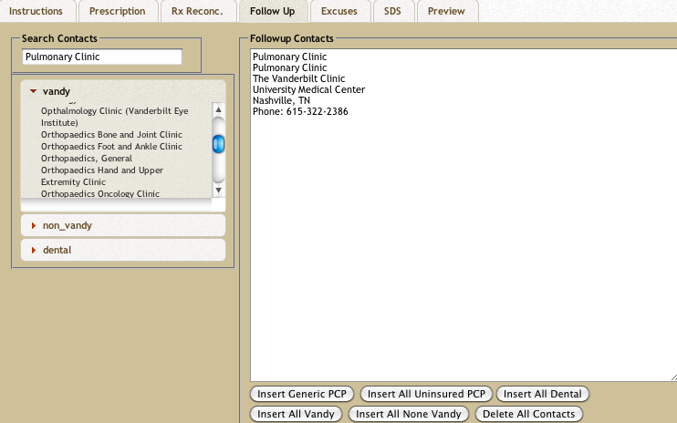

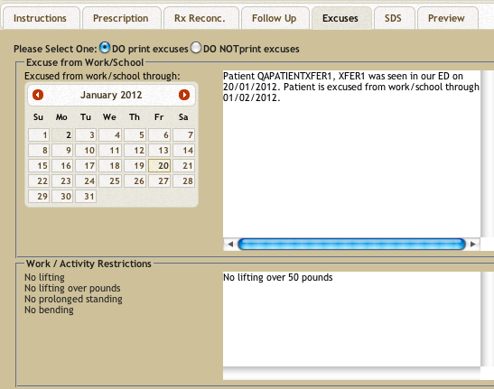

- Once the user completes all post-care documentation, the user will review and update, as needed, the Structured Discharge Summary by clicking on the SDS Tab.

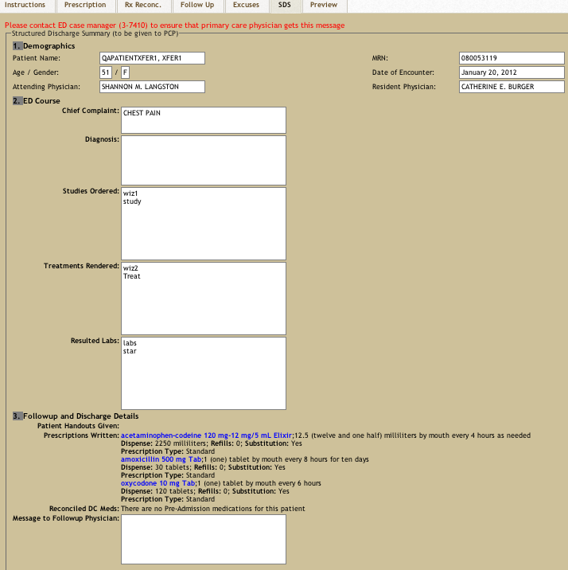

- After completing all documentation, the user will click on the Preview Tab to complete ED Discharge.
  - Preview Prescriptions

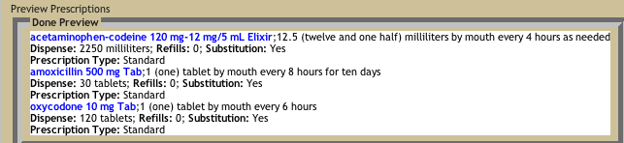

  - Preview Patient Handout Documents

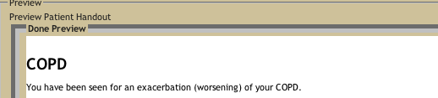

  - Preview Discharge Summary

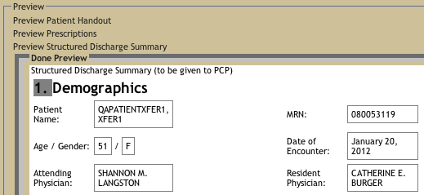

  - The user will identify the document/prescription printer and click “Save and Print” to route all documents to the selected printer and complete the ED Discharge session.

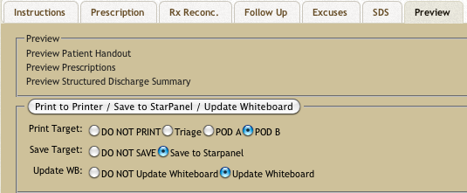

  - When the user completes the ED Discharge session, ED Discharge will send the Structured Discharge Summary and Discharge Instructions to the patient’s chart and RxStar will send the RxSummary to the patient’s chart, update the Patient Summary’s Medication List and Medications Log.

Decision Support

RxStar provides the user with decision support for the following items (mostly through the Decision Support Bar on the RxBuilder page):

- Drug-Allergy Alert
- Drug-Drug Alert
- Drug-Food Warning
- Duplicate Drug Therapy Alert
- Geriatric-Drug Alert
- Pediatric-Drug Alert
- Pregnancy-Drug Warning
- Lactation-Drug Warning
- Genome-Drug Alert (specific to genome-tested patients)
- Dose Warning Alert
- Weight-Based Dosing Formula
- Dose Rounding

Launching RxStar

- “Print at ED Discharge” and prescription integration printing will only be available when RxStar is launched from ED Discharge.

- When launched from ED Discharge, RxStar will only load a previous session or cart if that cart was originally created through the ED Discharge process.

- If a user needs to re-route a prescription (e.g. the patient lost the prescription or the pharmacy did not receive it), the user will launch RxStar through the patient’s chart (Rx Tab) and re-route the prescription through the Recent RxActivity page (to the same or different pharmacy). To Note: If the user re-routes the prescription by re-printing it, the prescription will print to the “RxStar,” single tray printer (there is only one printer per ED).

Routing Prescriptions

- Upon cart routing, if the user selects “Submit Electronically, Fax, or Phone In,” RxStar will update the Patient Summary with the medication(s), route the prescription(s), and send the RxSummary to the patient’s cart.

  - Upon cart routing, if the user selects “Submit Electronically, Fax, or Phone In,” and the cart is a “mixed cart” (non-controlled and controlled), RxStar will send all medication(s) to the Patient Summary, route all non-controlled prescription(s) and send the RxSummary for the non-controlled prescription(s) to the patient’s chart. Upon the user completing ED Discharge, RxStar will route the controlled prescription(s) to the printer and send the RxSummary for the controlled prescription(s) to the patient’s chart.

  - Upon cart routing, if the user selects “Submit Electronically, Fax, or Phone In,” and the cart has “sample” prescriptions and the user chooses to print the sample prescription (s) (versus routing it with the other prescriptions), RxStar will send all medications to the Patient Summary, route all non-sample prescription(s) and send the RxSummary for the non-sample prescription(s) to the patient’s chart. Upon the user completing ED Discharge, RxStar will route the sample prescription(s) to the printer and send the RxSummary for the sample prescription (s) to the patient’s chart.

- Upon cart routing, if the user selects “Print at ED Discharge,” RxStar will update the Patient Summary (medication list) with the medication(s). Upon the user completing ED Discharge, RxStar will route the prescription(s) to the printer and send the RxSummary to the patient’s chart.

- If a user needs to re-route a prescription (e.g. the patient lost the prescription or the pharmacy did not receive it), the user will launch RxStar through the patient’s chart (Rx Tab) and re-route the prescription through the Recent RxActivity page (to the same or different pharmacy). To Note: If the user re-routes the prescription by re-printing it, the prescription will print to the “RxStar,” single tray printer (there is only one printer per ED).

