PURPOSE: To assist end-users in how to submit a form that they want approved to go into e-docs
E-Docs: How to Submit a Form for Approval

Date of Creation/initals: | 1/25/2012 JCE | Date of latest revision:

- Create the document to be approved in Word, Excel, or Visio
- Document owner/creator will submit a request for approval via E-Docs Website
- Access E-Docs from WIZ or StarBrowser

From Wiz: Click on Web….
Click on E-Docs.
Click on Request Form

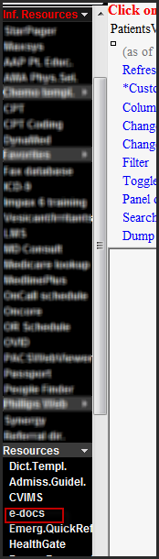
From StarBrowser: Click on InfResources Open Resources under this tab Click on e-docs
Click on Request Form
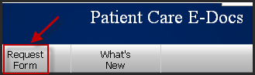
Fill out the form (on line or on paper) and then follow instructions at the bottom of the page to submit.
Once submitted, requests usually take 14 days for approval. An E-Docs administrator will notify the creator once the document is approved for publication in E-Docs.

Contact person for E-Docs is Darnez Pope 343-4400 darnez.pope@vanderbilt.edu

