How to Download Lync to Your Home Computer
Purpose: If virtual VM ware is not working and you would like to make phone calls via computer using home Wi-Fi instead of using your personal phone.
- Log into the VUMC Software Store with VunetID and password

- Select the Lync for 2011 for Mac users and select Microsoft 2010 for Windows. (Some have issues with 2013 so check for updates)

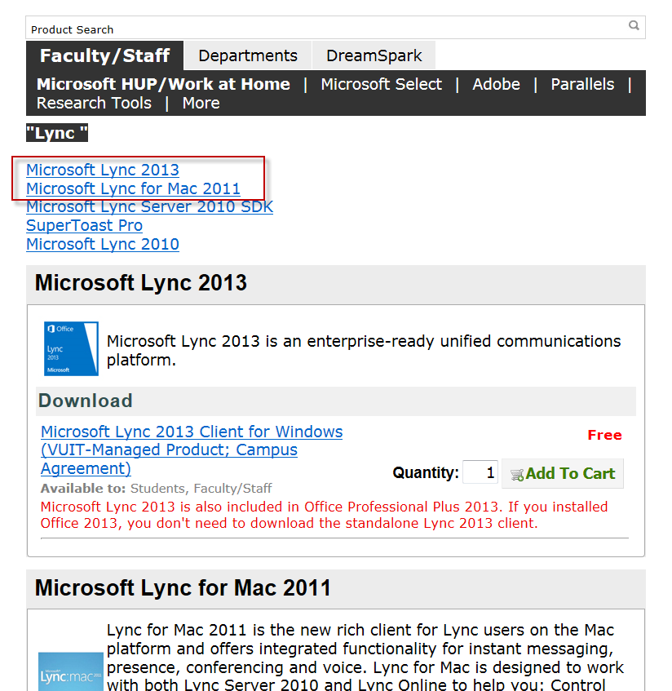

**There is a Knowledge Article on Lync on how to download to mobile devices, order for new SSS folks, and tutorials Knowledge Article 10451
There is also information on the V drive under Dept. Business> Lync

