Creating a Pop-Up in StarPanel
INITIAL SET UP IN STARPANEL
- Make sure you are on the team - adminPopups@dario (email Sarah, Heather K, or Julie if you need to be added. Current members: Gwen, Karen, Sarah, Heather K, Julie, Cindy, Debi
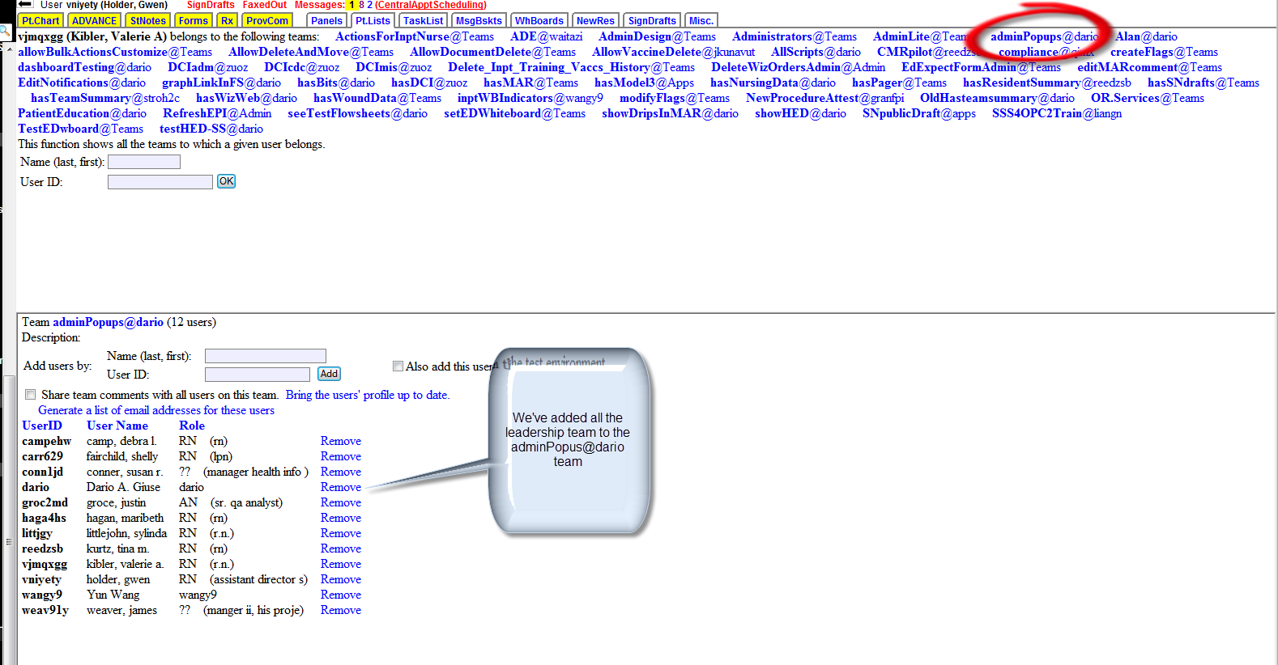
- Customize Administration to add the option “Manage initial popup message” and “Reset some of popup messages you already acknowledged”
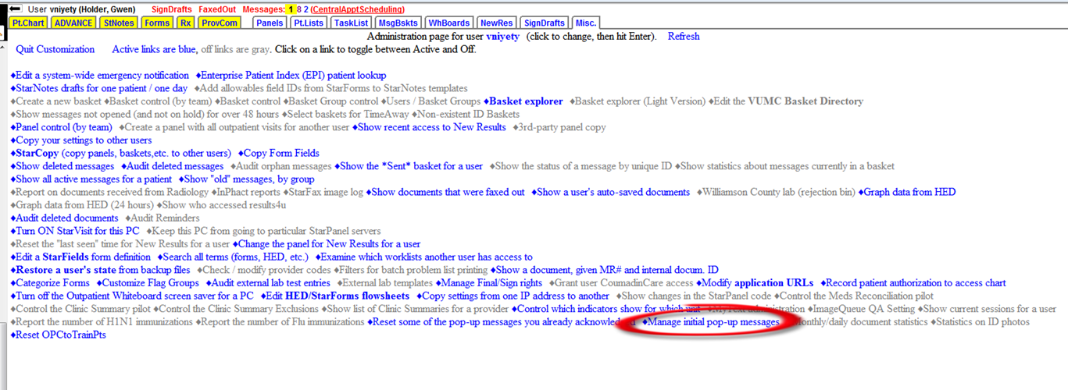
POSTING PROCESS:
- Create the message in a document in the appropriate Microsoft application
- Save as a Word document type: on YOUR local (or SHARED drive if more than one needs to access) (SSS use V: WebDav>Web Page) -this is just a safeguard step to have the document local and available to make changes if necessary.

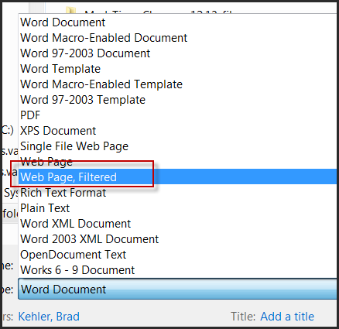

- Copy the document from V drive, go to Etrain drive and save in the WebDav folder as document type: web page, filtered (to make it HTM). Rename with underscore between words and no spaces. I.E. Communication_Global_Template

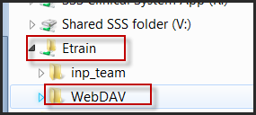
- Go to StarPanel: Administration
- Click “Manage initial popup message”
  - You will see the past messages
  - Click on “Create a New Pop-up”
  - Dialog box appears with options to create a new pop-up
  - Type in a name for the pop-up in the Pop-up ID box
  - Specify a width and height. 800 X 600 is a large display
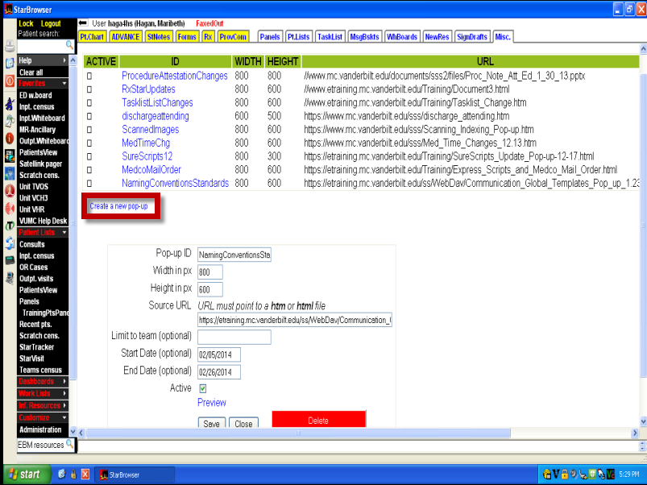
Type name in the Pop-up ID box:
Specify width and height

- Type in the name of the Source URL. The Source URL always begin with (copy and paste this from a previous post to make it easy):

  - https://etraining.mc.vanderbilt.edu/ss/WebDav/
  - Go back to Webdav on the Etrain server, R click on document, click on rename to open the field - copy the name displayed
  - Paste in your filename and add .htm : <filename>.htm
Example of a posted URL:
https://etraining.mc.vanderbilt.edu/ss/WebDav/Communication_Global_Templates_Pop_up_1.23.14.htm
- Type in the Start date – Date you want the Pop-up to be viewable when users log into StarPanel
- Type in the End date- Date you want the Pop-up to no longer be viewable when users log into StarPanel – SSS usually sets for 2 weeks
- Click Preview
- If OK, Put a check mark in the Active Box
- Click Save
- Type in the name of the Source URL uploaded to the etraining server.
- Specify the start and end date
- Preview
- If correct, click the Active box
- Save
- Viewable immediately
IMPORTANT TIPS FOR POSTING STARPANEL POPUPS WITH VIDEO:
Include appropriate instructions in the popup:
- To start video: Ctrl-Clk to open the video in Google or Safari
  - Include: video will open in another window or tab
- To open in StarBrowser – R click on link and choose Open in another window
Format link properly:
- Format you tube link: https:youtube…. (use https for secure sight)
- POPUP URL must be the same as host name (no WWW if not in host name, OK if it is in host name). Don’t just copy and paste from the instruction sheet
TEST ON CWS IN GOOGLE CHROME, SAFARI AND IE WITH A TEST USER ID!

If you also need to send information out via email see Update: IT Systems and Processes below.
UPDATE: IT Systems & Processes (see V drive for latest list of contacts)
(email to providers)
Scope: To provide a standardized communication process to Providers for updates & changes in the IT Systems & Processes. Intent is to create a branding of the message by standardizing:
- Subject line
- distribution process (coming from GME for house staff
- physician leader for attending MDs
- direct supervisor for NP’s
- standardized email template
- standardized approach to educational materials (with theory of “less is more”
- white space
- bullet points
- meaningful screenshots
- no clip art
- plain background for PPT slides – no color

The UDPATE: IT Systems and Processes communication is to be sent out by Systems Support Services on behalf of Neal Patel, MD, CMIO. UPDATE: (anything medical records) is sent out on behalf of Titus Daniels. Consider other formats to “publicize” the change/update, I.E. StarPanel pop-up message, MyVU articles, etc.
Goal: To improve recognition of communication messages in hopes of increasing recognition & thus awareness of changes.
Team Members: SSS: Debi Camp, Lisa Grunwald & Julie Shadburne ; MIS: Nancy Anderson; Outpatient: Kathleen Mandato
Sponsors:
Neal Patel for IT changes: labeled - UPDATE: IT Systems & Processes,
Titus Daniels for MIS changes: labeled - UPDATE: Naming Convention (example)
Process:
- Need for UPDATE Communication identified by Neal Patel, SSS leadership, SSS lead on project, other organizational leaders.
- Content development to be initiated by the project lead or content expert most closely associated with update/change.
- Content screening for Inpatient by Debi Camp, Lisa Grunwald, and Julie Shadburne – proof for the basic premises noted above in scope description. (see screen shot at end of document)
- Submit content to Neal Patel for approval – use standardized subject line w/ timeline for desired turnaround. Example: UPDATE: IT Systems & Processes - Approval required TODAY PLEASE
  - MIS notifications are approved in committee with Titus Daniels present so do not need to be sent to him for approval
- In conjunction with Neal (per the email for approval) determine the appropriate distribution points. Using the guide below to send the email to the appropriate distribution points for mailing to providers.
  - Use the following subject lines
    - UPDATE: IT Systems & Processes
    - UPDATE: Naming Convention
    - UPDATE: Scanning
    - UPDATE: Medical Records
    - : UPDATE: IT Systems & Processes. (UPDATE: Naming Convention…)
  - Include directions to the distribution point contact – such as “send to all NP’s providing services to Adult ICU pts.”

UPDATE: IT Systems & Processes Distribution Guide
Provider Group | Distribution Point | Specifics – Contacts
House Staff  Email: Molly Cole, Lisa King, cc Don Brady | GME distribution – identify which house staff should be alerted for update (i.e. House Staff providing services to Adult Patients) | Molly Cole  cc-Don Brady, MD – assoc dean of school of medicine “oversees” the process)
NP’s  Email: Jason Jean, Jerita Payne, Michelle Terrell, Jill Kinch, Devin Carr, Scott Simms, Avni Cipril | NP Supervisor – APN Directors or Administrative Director | Shana Scalin in Advanced Practice Office provides spreadsheet updated & sent every 3 months – contact info & instructions
VUH Attending Physicians  Email: VUH Medical directors distribution list –(includes VUH and VCH attendings and service line directors and Lisa McMahan, Neesha, Stephan and Sunil)  And  ICU Medical Directors distribution list | VUH Chiefs (& Kripalani) review the UPDATE communication & provide validation for which physicians should receive. If a targeted group, often Neesha &/or Sunil will handle themselves. If VUH Medical Directors or VUH ICU Directors, Debi or Maribeth should send via distribution list. | Neesha Choma, Stephan Russ, & Sunil Kripalani (in distribution list)  VUH Medical Director distribution list updated by: Megan M Rogers (also does Executive Medical Director list)  ICU Medical Director Distribution list provided & updated by Barbara Martin
VUH Surgical/Anesthesia Attgs –  Email: Roger D’mochowski, MD  only send to Roger when appropriate for this group | Surgical – Quality Champion (he has only needed to do this once in early spring 2012 – will likely need “reminder”) | Roger D’mochowski, MD
VCH Attendings, Medical Directors (see above) | Chief of Staff for VCH prefers to be in loop for all communications to peds providers – they are sent from her office with addendum at top from her – with the UPDATE email below.  John Brock, MD, Surgeon-in-Chief is the contact for surgical services – but this too shall go through Chief of Staff’s office & she will send to Dr. Brock for further dissemination. | Meg Rush, MD – Chief of Staff (not in distribution list but Lisa is)  Lisa McMahan
VMG Faculty & Clinic managers  Email Kathleen Mandato, Geri Brumfield |  | Communicate with Kathleen Mandato to send the update if outpatient is affected.

Example – Update email:

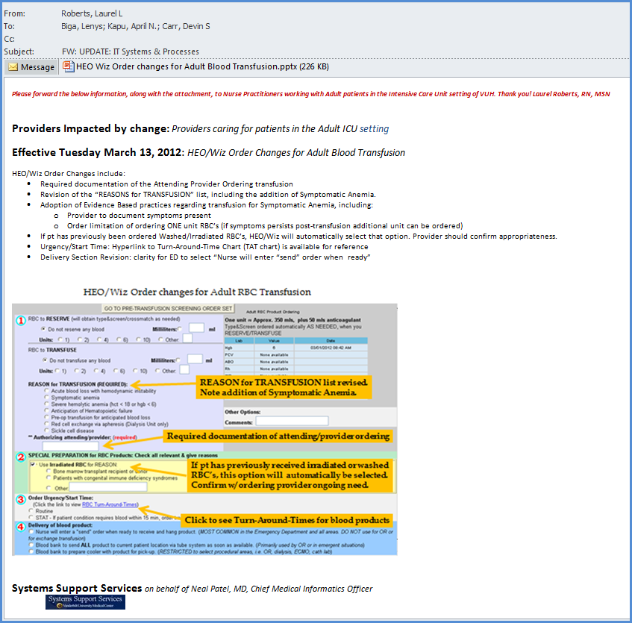

This file is on the Call Manual folder under StarPanel and under Update IT Process. Please update both places with any changes.

