Correcting a Vertical Blue Bar in StarPanel
(Incorrectly Representing an Inpatient Visit)
I
This can be reported via numerous methods:
- HelpDesk Pegasus ticket
- email from StarTeam
- Email
- Phone call

Make sure you know the expected Discharge date from the information provided

Following are the STEPS to Correct this Problem
- Verify the blue bar is showing incorrectly in the All Docs view of the MRN provided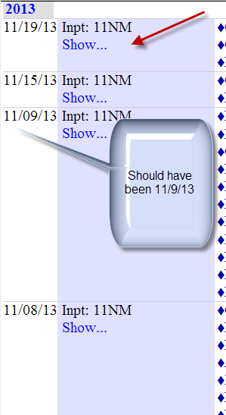
- Open Medipac and find the correct MRN via ADTP – in this view verify:
- that the date provided reflects an inpatient stay
- there is data to support the discharge took place
- note the accurate date/time
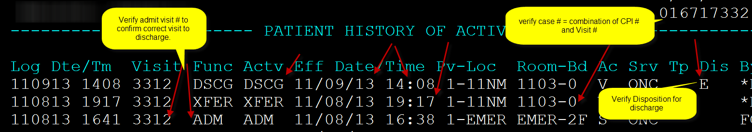
- Return to patient’s StarPanel account and select Appointments: if you are on the correct team, you will see on the far right of the header titles an option “Force a discharge date/time”

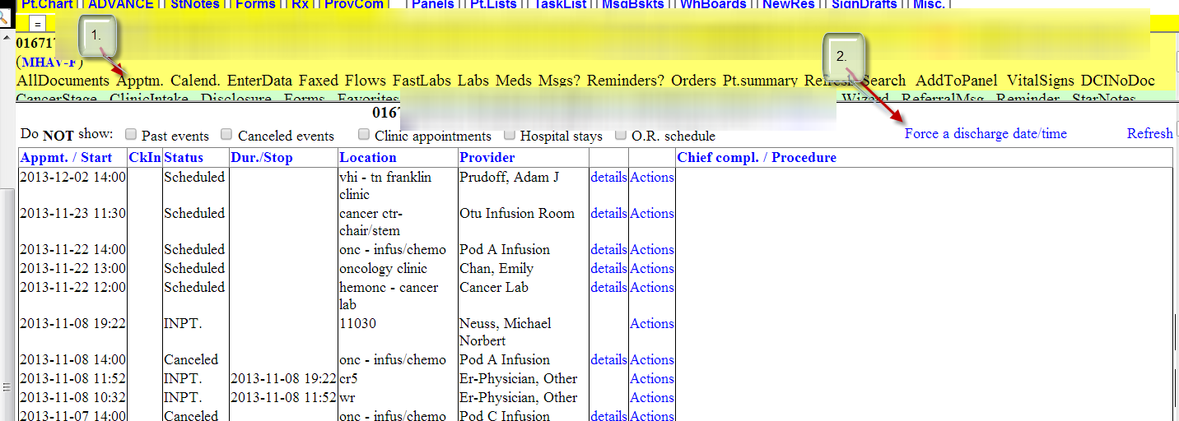
- Click the blue link titled “Force a discharge date/time”
- Scroll down in the patient’s All Documents view until you see a red box displaying
“Set D/C time”
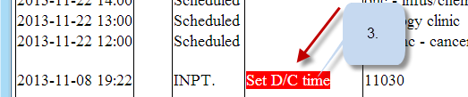

- Click on the RED box-this will display another box

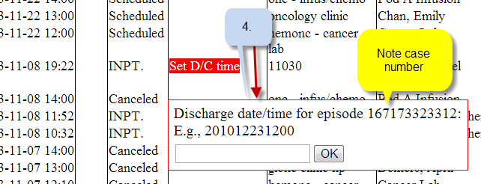
- Noting the correct “ yearmonthdaytime” on the Medipac view
- Confirm in the box provided the Case Number to be corrected and compare to the CPI # plus the Visit # shown in two different placed on the Medipac ADTP screen. Add into the box in that exact order the information as defined in the example provided. When you have RE-VERIFIED the case number (CPI plus visit #) and confirmed the year/month/day/time-click on the OK box.
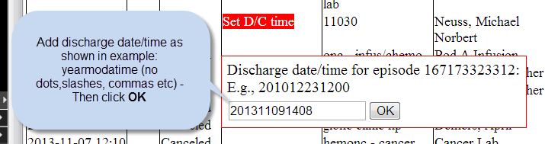
- You will see a message box that states the MRN has been updated. Return to the patient record, click on the MRN in the yellow frame to refresh the record and verify the Blue Bar has been corrected.
- Complete the notification of the Pegasus ticket or reply to the email, etc. to notify the user that this has been corrected.
- If any steps of this process do NOT appear to work as designed, please assign a ticket to the StarPanel team.

It may be necessary to go into VISI to see discharge dates if they are not found in ADTP. You can PF8 forward until you see the date in question.
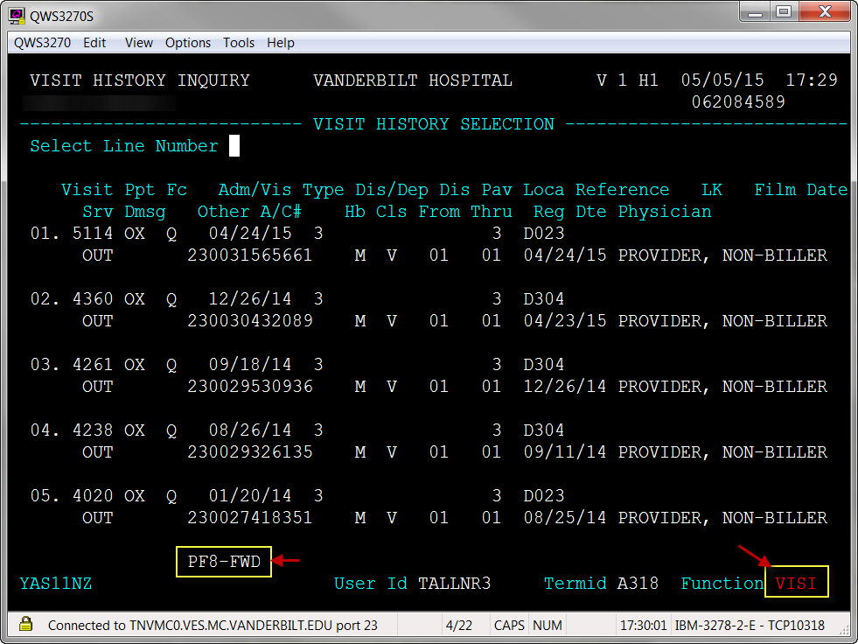cont’d

Once you locate the appropriate visit/date, enter the line number.
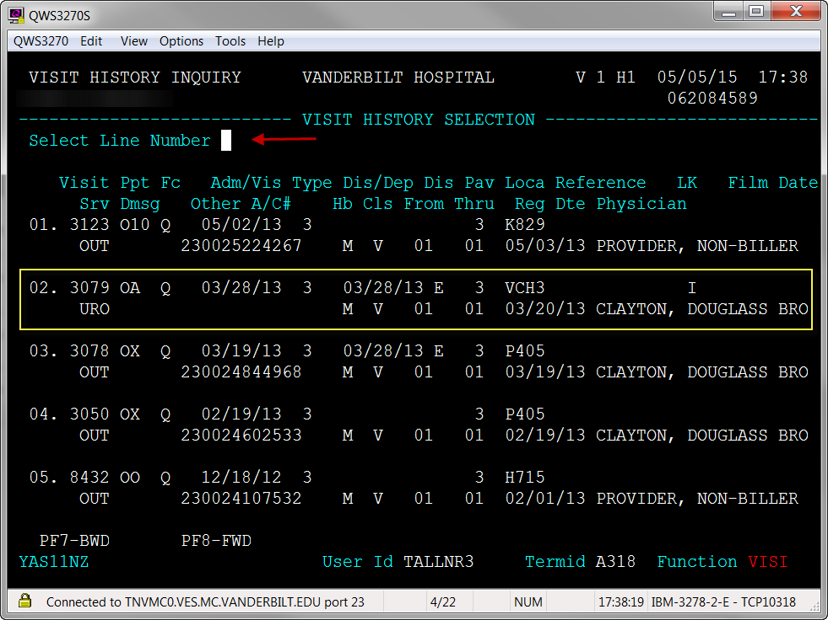
Then look for the Dis/DepDte information. This is the date and time of discharge/departure to enter into StarPanel. Enter as per above steps.
