CORRECTING NAMES AND TITLES IN VARIOUS APPLICATIONS:
- Employee should contact HR and request a name change. They will need to provide supporting documention.
- The employee can log onto AccessVU at http://www.vanderbilt.edu/accessvu/existing/ and click on Enter PII.
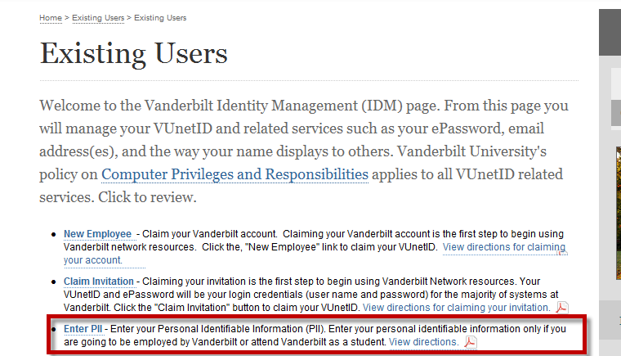
- This will change the name connected to the VUNetID.
- The employee then contacts their security manager to request a change in name/role be submitted on the Identity Operations (SAMS) Online Submission Form. This will change the name in Amanita, StarPanel, HEO/Wiz, HED and Medipac.
- One additional change may be required in StarPanel
  - See How to Correct Role Display under the StarPanel tab in the On Call Manual.

