Anesthesiology Emergency Airway Consult
When to use:
- The consult request is required by the hospital and accreditation bodies
- Only used for Airway Management consult for ADULTS
- The consult request can be entered after calling the Anesthesia service, it is not intended to delay getting Anesthesiology to the bedside

From HEO Wiz order entry:
Type in Consult Wizard and select:
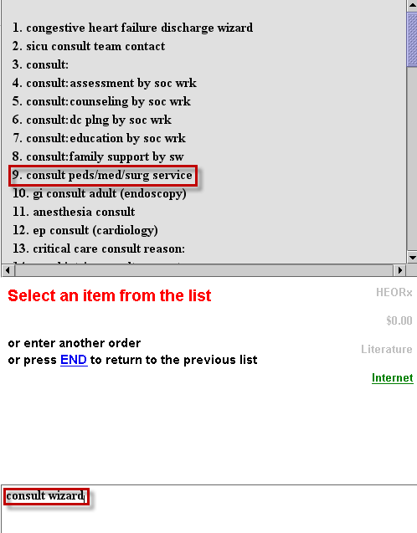
Select: Adult Anesthesiology Airway
Provi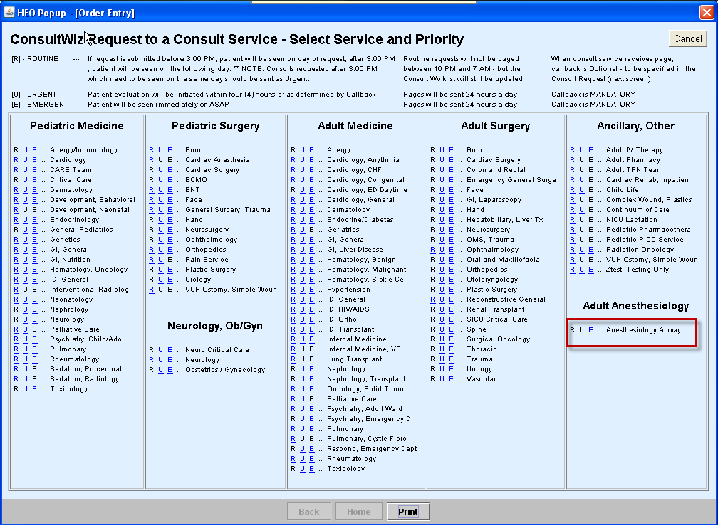
Provider chooses Routine, Urgent or Emergent

