Advance Directive Changes Coming to VUMC
New section “Advance Directives/Code Status”
- Provides Access to the following forms
- Code Status Form (Adult and Peds)
- Procedural Code Status Form
- Link to Advance Care Plan (For Print then Scan ONLY)
- Link to Advance Care Plan Spanish (For Print then Scan ONLY)
- Link to Appt Healthcare Agent Form (For Print then Scan ONLY)
- Link to Health Care Decision Maker/Surrogate Form (For Print then Scan ONLY)
- Link to POST (For Print then Scan ONLY)

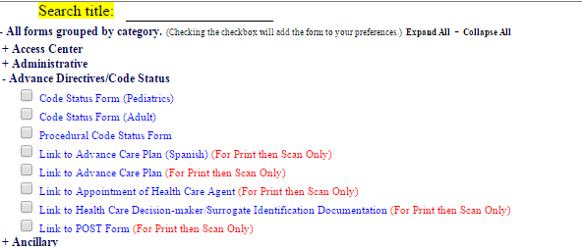

New Adv Dir Tab
- The forms above must be printed and then given to an MR to be scanned into StarPanel
- Once scanned into the patient chart, they will be indexed in the Adv Dir tab
- Any external Advance Directive forms brought into VUMC by the patient/family will also be indexed to the Adv Dir tab

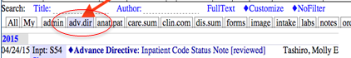

Go-live July 1, 2015
Physician Order for Scope of Treatment (POST) - New document in Task List
Attending physicians only
- If a house officer or NP completes a POST form and was unable to obtain the supervising attending signature on the paper form, an electronic signature by the attending will be required
- Once the form is completed and scanned, medical records will route the scanned version of the POST to the attending’s (as identified by the house officer or NP) task list
- Attending physicians must electronically sign the POST to acknowledge review of, and agreement with the active outpatient resuscitation order for the patient placed by a supervisee.
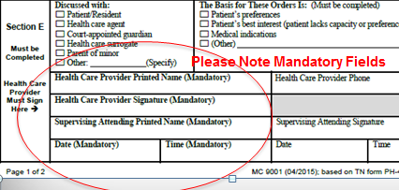

Go-live July 7, 2015
New: Yellow Banner Changes-
- Change: Dates will no longer be posted but can be obtained by hovering
- New: Display will now show POST: yes/no which refers to presence of a POST document in the EMR. Remember, the POST represents the “outpatient” setting code status order
- AGAIN: The purpose of the Code Status and POST displays in the yellow banner are to increase awareness, provide easy access, and help guide discussion and decision making. Resuscitation wishes of the patient must always be readdressed and re-evaluated for each new healthcare encounter.
- “Code status” and “POST” Displays serve as a link to the most recent forms. Providers need to access the actual forms to review patient wishes.
Below is a summary of the documents used at Vanderbilt, who initiates them and how they are to be placed into the EMR.
