Adding and Removing Items in the StarPanel Actions Menus
In order to use this feature, you need to be added to the following StarPanel team:

(Currently Heather Knott and Debi are on this team)

- Access the Actions menu for a patient
- Make sure your view is “My Actions”
- Click on customize
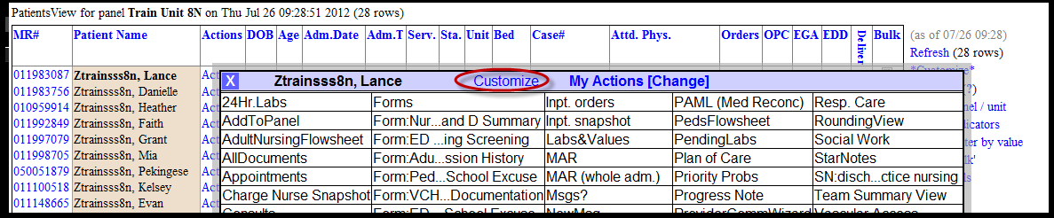
- Click “Switch to Bulk mode” on your customize screen (this is only visible if you are on the team allowed to make changes to the Actions menus)
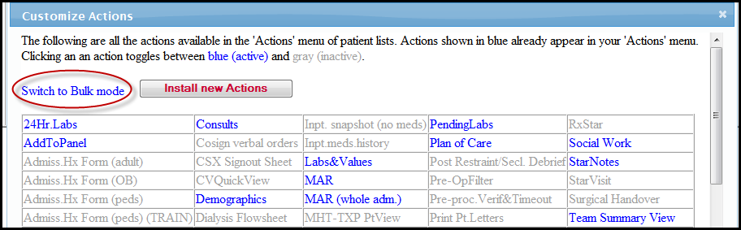
- Click on specific Actions menu needing modification

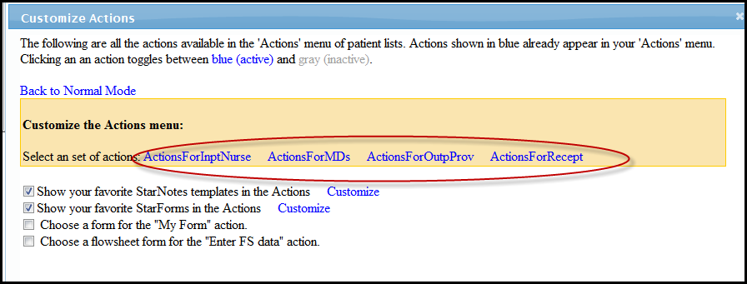
- To add an action, click the title of the action to turn it blue (active)
To remove an action, click the title of the action to turn it gray (inactive)

- Once modifications have been made, click “Bulk set Actions” button
