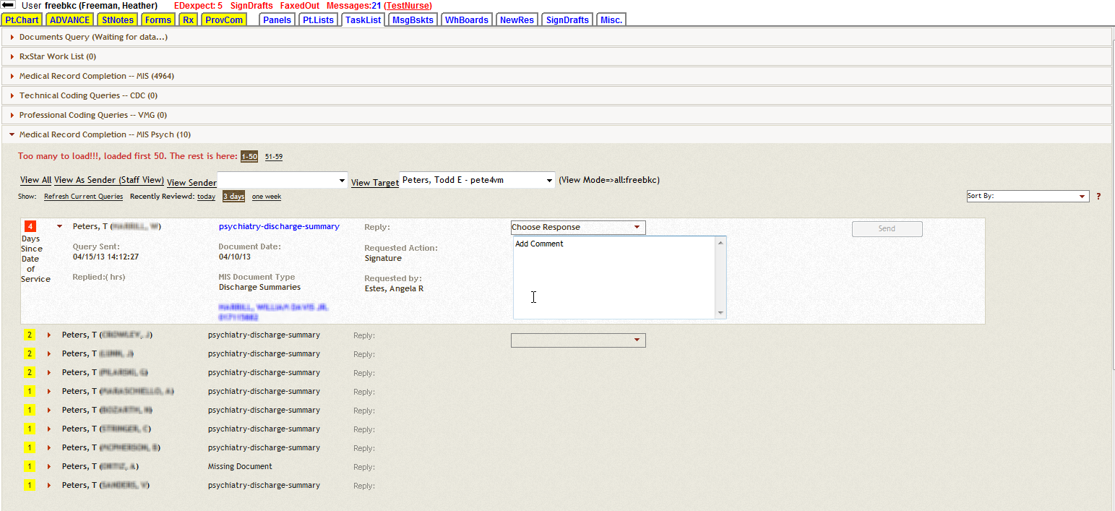
6
5
2
4
3
1
Viewing a Provider’s TaskList
- Determine what type of query the provider is asking about and select that accordion.
- Click on the dropdown menu and select the providers name and “View Target”
  - This will display the providers TaskList for that particular accordion
  - Note: The provider’s name will not display if they have never received a query.
- “Requested Action” and “Requested by:”
  - This displays what the request is for and who is sending the query
- Links to document in question and patient’s medical record
- Document will load automatically in the 2nd frame
- Provider completes request, selects a response from the drop down, may enter an optional comment, then clicks “Send” to remove item from tasklist

