Two Known Internal Application Errors
SSS Should Handle
1/28/14 nr/kh
There are two known Internal Application Errors that SSS needs to walk the users thru resolving – do NOT refer tickets for these IAE’s on to the HED team. The technical team has all the info they need. Work is in progress to correct them but this will take some time.

- “Internal Application Error: UI errorINput string was not in a correct format” user will not be able to save vent DAS data because the vent is sending text to a numbers only field in HED. Ask the nurse to check the HED flowsheet for a value similar to these: STANDB* and ADULT should be numerical values.
  - Workaround is to clear that value from the data entry field or uncheck the box if checked. And then they should be able to type in the value and save.
  - Fix is to have the nurse remove the VueLink module from the monitor, wait 10 seconds and reconnect. If that does not correct the problem, Respiratory Therapy will need to restart the ventilator. ( see details below and attached)
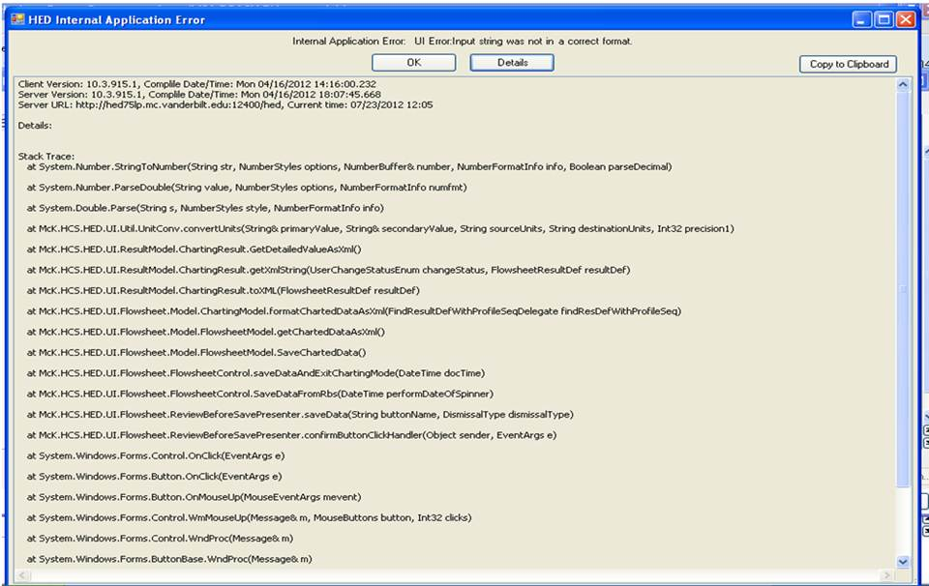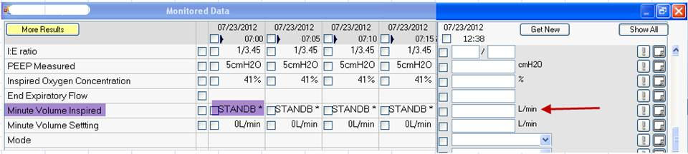

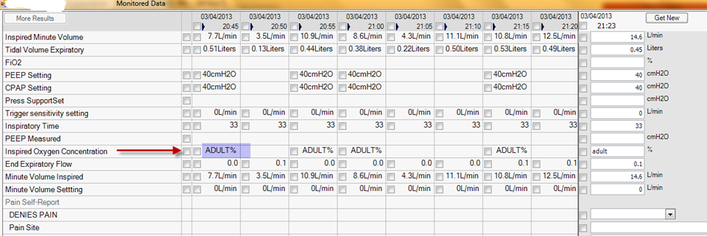
- Internal Application Error: UI Error Cannot access a disposed object. Object name: ’CheckBoxPopupWidget’- user will get thrown completely out of HED when they get this one.
  - Happens when they are in Admin-Rx, have a nonmed drop down box open and try to scan a med
  - FIX: Ask user to retry med administration but make sure they don’t have any drop down boxes open when they scan medicine barcode. (see examples below)
- Proper scanning sequence in Admin-RX to avoid this INTERNAL APPLICATION ERROR,
  - Click on Admin-Rx tab
  - Scan all medications
  - Enter HED charting assessment charting (i.e. pain)
  - Exit charting by clicking on screen outside of that field
  - Scan pt. armband
  - Click confirm
Advise user to avoid having HED Charting fields active while scanning medications or pt. armband –
Scan all barcodes first, then enter other data on Admin-Rx screen!

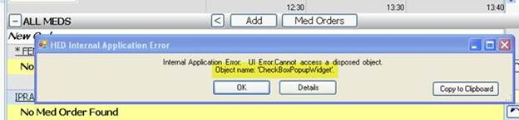

  - Occurs with Medication Administration in Admin-Rx + Assessment Charting in HED
    - It has a relatively low level of incidence
    - It is a traumatic error causes loss of charted data and kicks the User out of HED
  - Three scenarios known to result in this IAE:

Scenario 1:
1. Launch Admin-Rx flowsheet
2. Open an HED assessment charting dropdown
3. Select a checkbox
4. De-select the checkbox (checkbox remains highlighted, but the box isn’t actually checked)
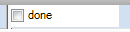
5. Scan medication barcode - error is generated

Scenario 2:
- Launch Admin-Rx flowsheet
- Scan medication barcode
- Open an HED assessment charting dropdown
- Select a checkbox
- De-select the checkbox (checkbox remains highlighted, but the box isn’t actually checked) 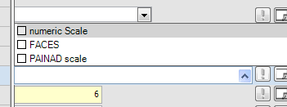
- Scan patient armband - error is generated

Scenario 3: - most recently reported:
- Launch Admin-Rx flowsheet
- Scan patient Armband
- Scan or select a med
- Next select option from “Pain Scale” and then select two options in “Pain Site”, but do not close the box
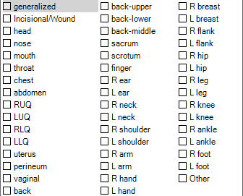
- With the “Pain Scale” dropdown list still open, scan patient armband – Error is generated
