iPad Set Up to Work From Off Campus
There are two must haves to begin this process:
- iTunes account (know the password)
- Virtual access registration
To complete Virtual registration:
- Use your name badge to Tap in to a computer on any floor (VCWS)
  - You will get a prompt to set up your virtual PIN in VUAccess
  - This registers you to use virtual on campus and off campus
- Alternatively, you can sign into a VCWS and click on the Badge Icon on the desktop to register in VU Access
If you do not have access to a CWS, put in a Help Desk “New Request” ticket:
- https://pegasus.mc.vanderbilt.edu/Default.aspx

- Once a virtualization license is set up, VMware View for iPad must be downloaded from the App Store (free)
To set up VMware:
- Add view connection server
- Enter the host name cws-vdi-s1.mc.vanderbilt.edu, click connect
- Enter a VUnetID and Password in the Username and password boxes
- You will see CWS-00[1-8] select whichever one is available to connect
The vCWS desktop will display .

Special Considerations:
- Screen size dictates that iPads are great for viewing data;
  - data entry is somewhat challenging
- iPads, like MACs, use Safari as default browser; FireFox tends to work better
- Safari does not work well with frame-based applications (see below for navigation tips)

The “=” will allow you to go back a step. The numbers 1, 2, 3, and 4 are representative of the frames. If the boxes are not present, try signing out then back in.

You can toggle between frames by selecting a number.
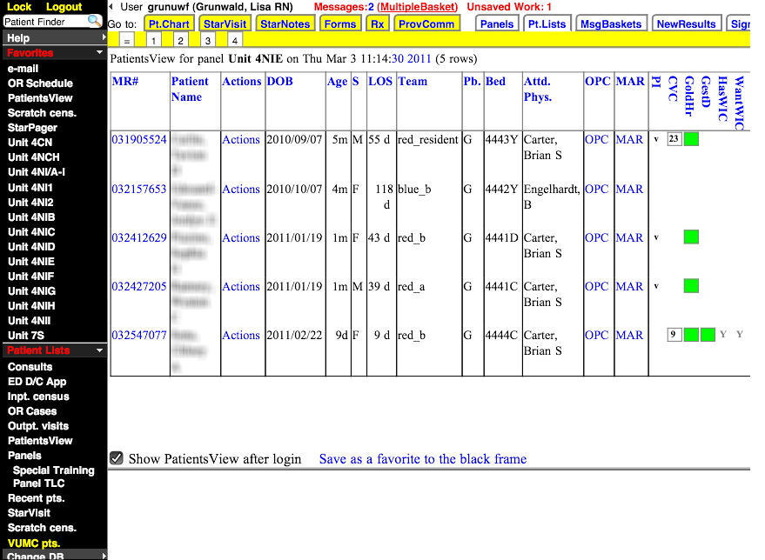
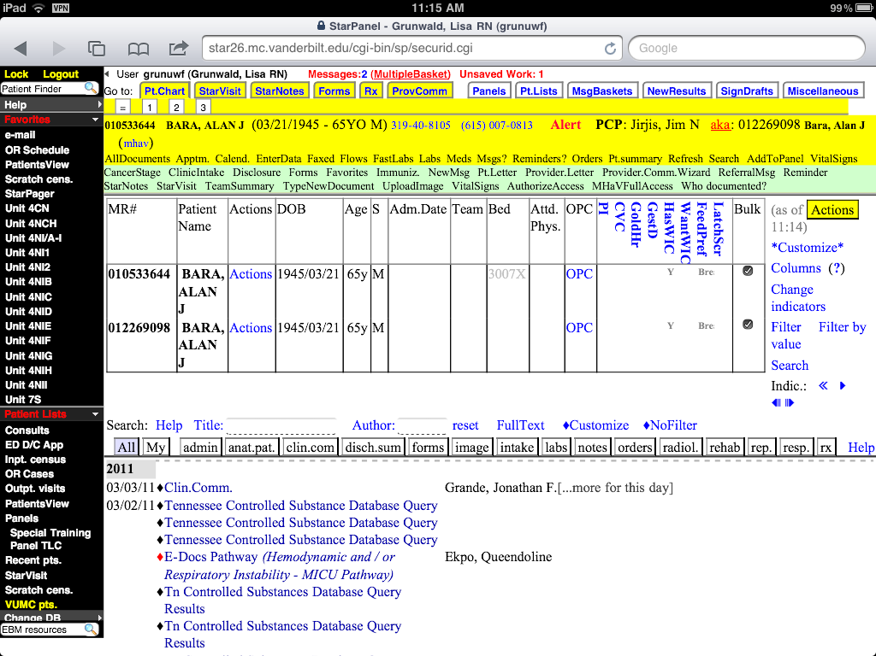
To open a note, simply tap on the desired document. This can be difficult as the area to tap is extremely small
To expand the frame size, repetitively tap on the frame that is desired to be enlarged
There is no formal iPad support at Vanderbilt at this time. In the Department of Medicine, the LAN Manager will assist with iPad issues.

To remote into your work computer (AWS) from your iPad, MAC or PC at home:
- Download these 2 free apps
  - RDP (Remote Desktop
  - Junos Pulse

To set up Junos Pulse:
  - Click on the >
  - Add a new configuration
  - Enter a VUnetID in the Name field
  - In the URL field enter vpn.mc.vanderbilt.edu
  - Leave certificate as None
  - Click Save
  - Click Connect
  - The Juniper sign in box will open
- Click on Junos Pulse and sign in, minimize
- Click on RDP and enter your AWS IP address

