New match meds view in the discharge medication reconciliation tab (DMR)

Select ‘Match Meds’ in the view drop down in DMR

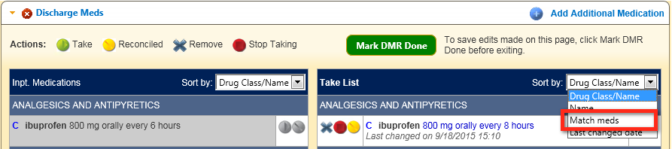

Medications will be aligned and matched between the inpatient and outpatient lists

