When the ED Whiteboard is Unavailable
- Determine the extent of the problem and possible interim solutions:
  - Are other clincial applications (StarPanel, Wizorder, other CWS desktop links) working?
  - Is the whiteboard working from other clinical or administrative workstations?
- Report problem to the help desk: Call 3-HELP = 3-4357, or use the desktop 3-HELP icon.
- Capture current information from the whiteboard using screen capture:
  - Press and hold <CTRL>, then <ALT>, then <PrtScn> keys (you’ll be pressing three keys simultaneously at the end). Nothing will appear to happen but the screen will be copied.
  - Open Wordpad (Wordpad is on the CWS desktop, or you can use email or another program if you choose), and select ‘Paste’ from the ‘Edit menu’. The screen image will be pasted into the document.
- Consider starting manual processes for tracking patients and other whiteboard functions.
- Remember that many applications (including StarPanel and Wiz/Horizon Expert Orders) can be launched from outside the whiteboard. These other applications might still be working and can be used outside the whiteboard as described briefly below. Detailed instructions and screen shots can be found on the following pages.

To place orders in WIZ: Go to the workstation desktop, click on blue wizard hat . The patient will be on the “EMER” census for Adult ED and “ED/P” for Peds ED.
Procedure notes: Go to StarPanel and click the “Forms” tab. Note: You must first have a patient’s chart open (by entering name or MRN in top left “Patient Finder” box). StarPanel can be launched from the desktop or Wiz.
Resident history: Go to StarPanel. Click on Forms Emergency MedicineED Resident History and Physical. (must have patient’s chart loaded first by typing name or MRN in top left “Patient Finder” box)
E-docs: Go to StarPanel. Look in black tool bar under Inf. Resources-Resources.
Nursing Assessment: (for Adult ED only), go to forms in StarPanel NursingED Assessment (must have patient’s chart loaded first by typing name or MRN in top left “Patient Finder” box)
Nurse AMA/LWBS form: Go to forms in StarPanelEmergency MedicineVUMC ED AMA LWBS form. (must have patient’s chart loaded first by typing name or MRN in top left “Patient Finder” box)
Social Screening form: Go to forms in StarPanelNursing ED Nursing Screening (must have patient’s chart loaded first by typing name or MRN in top left “Patient Finder” box)
Registration forms: Go to patient’s chart in StarPanelformsAdministrative ED Registration Forms. (must have patient’s chart loaded first by typing name or MRN in top left “Patient Finder” box)
Pre-procedure time out: Go to patient’s chartformstimeout/universal protocolpre-procedure verification and timeout (must have chart loaded first by typing name or MRN in top left “Patient Finder” box)
Adult Nursing Admission History: Go to patient’s chartformsAdult Nursing admission history (must have patient’s chart loaded first by typing name or MRN in top left “Patient Finder” box)
ED School/Work Excuse: open patient’s chartformsEmergency medicineED Work/School Excuse. (must have patient’s chart loaded first by typing name or MRN in top left “Patient Finder” box)
How to use WIZ and StarPanel if the ED Whiteboard is DOWN
and WIZ and StarPanel are working

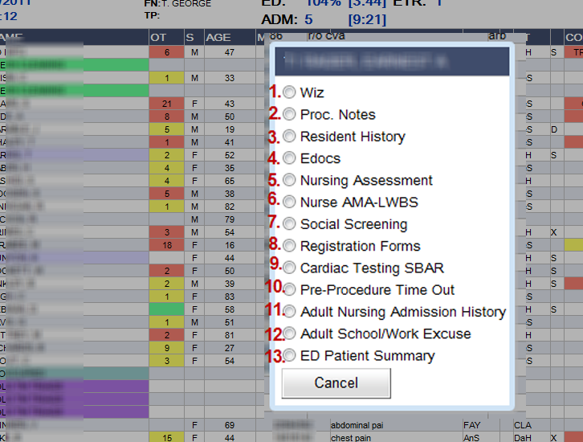

- To place orders in WIZ, go to the desk top , click on blue wizard hat . The patient will be on the EMER census for Adult ED and ED/P for Peds ED.

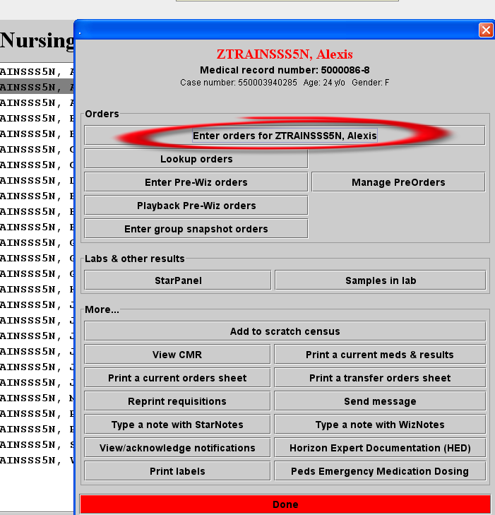

- To access procedure notes go to StarPanel and click forms. Note: you must first have a patient’s chart open in StarPanel (by entering name or MRN in top left search box) before the notes will load. StarPanel can be accessed from the desktop or Wiz in ED Whiteboard downtime. 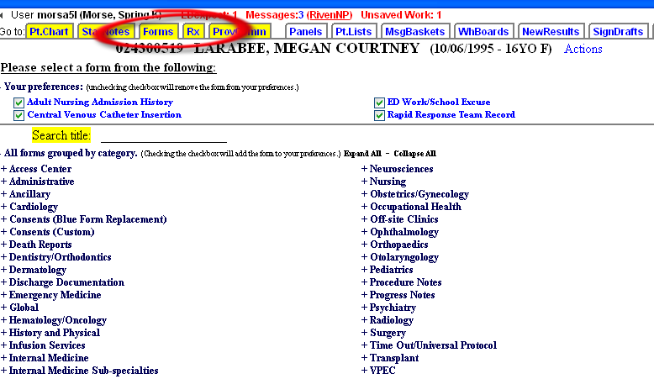
- To access resident history, go to StarPanel. Click on Forms (must have patient’s chart loaded)
Emergency MedicineED Resident History and Physical

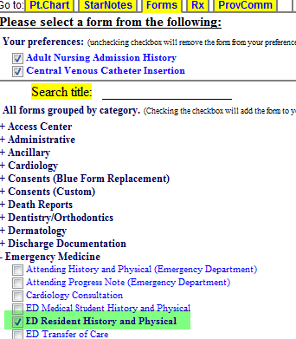
- To access e-docs , go to StarPanel. Look in black tool bar under Inf. Resources-Resources.

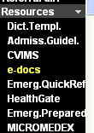
- Nursing Assessment (for Adult ED only), go to forms in StarPanel (patient’s chart must be open in StarPanel by by entering name or MRN in top left search box) NursingED Assessment

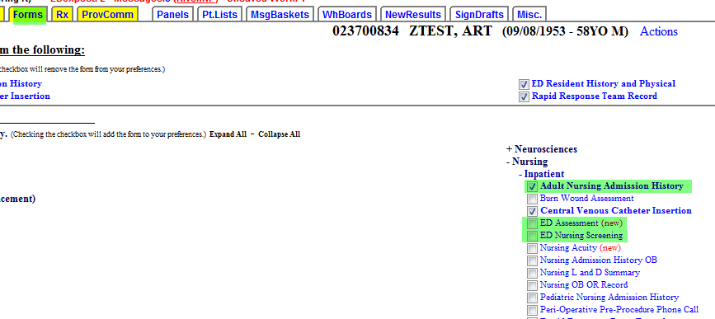
- Nurse AMA/LWBS form: open patient’s chart, go to forms in StarPanelEmergency MedicineVUMC ED AMA LWBS form.
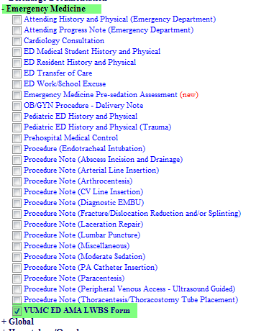

- Social Screening form: open patient chartformsED Nursing Screening (see above #5)
- Registration forms: go to patient’s chart in StarPanelformsAdministrative ED Registration Forms.

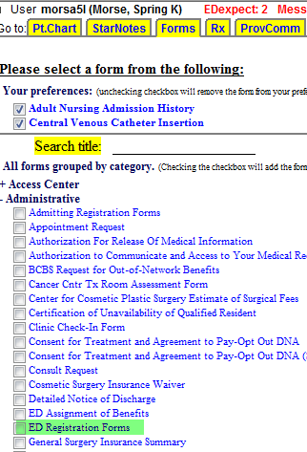

- Cardiac Testing SBAR—is form is currently not being used
- Pre-procedure time out: go to patient’s chartformstimeout/universal protocolpre-procedure verification and timeout.
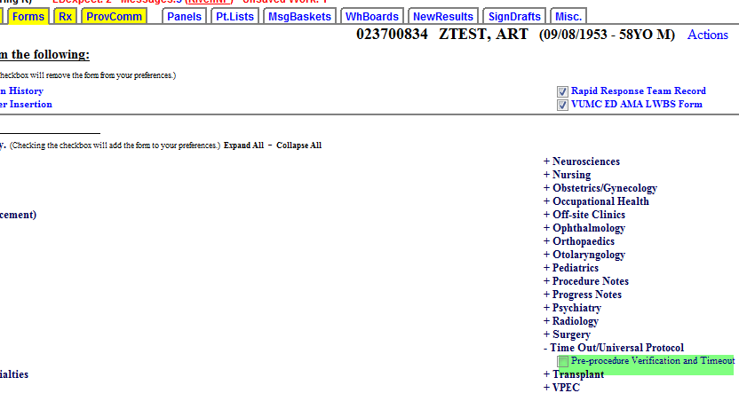
- Adult Nursing Admission History: go to patient’s chartformsAdult Nursing admission history (see #5 above).

- ED School/Work Excuse: open patient’s chartformsEmergency medicineED Work/School Excuse.
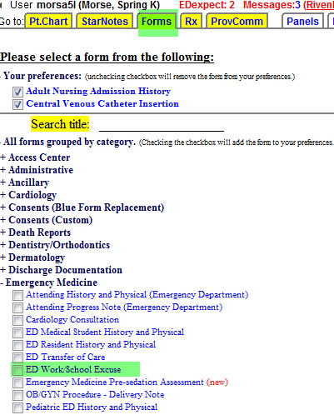

- ED Patient Summary: This is a form that is within the ED Whiteboard. If the ED Whiteboard is down, this form will not work.

