**HOW TO ACTIVATE YOUR VUNETID**

1. How to Activate:
   1. Go to <http://its.vanderbilt.edu/epassword/>,
   2. Click on “Activate VUnetID”,
   3. Follow the prompts to validate your VUnetID
   4. Create your e-password.
   5. Be sure to answer 3 security questions so if you forget your e-password you can reset it yourself by answering the questions.

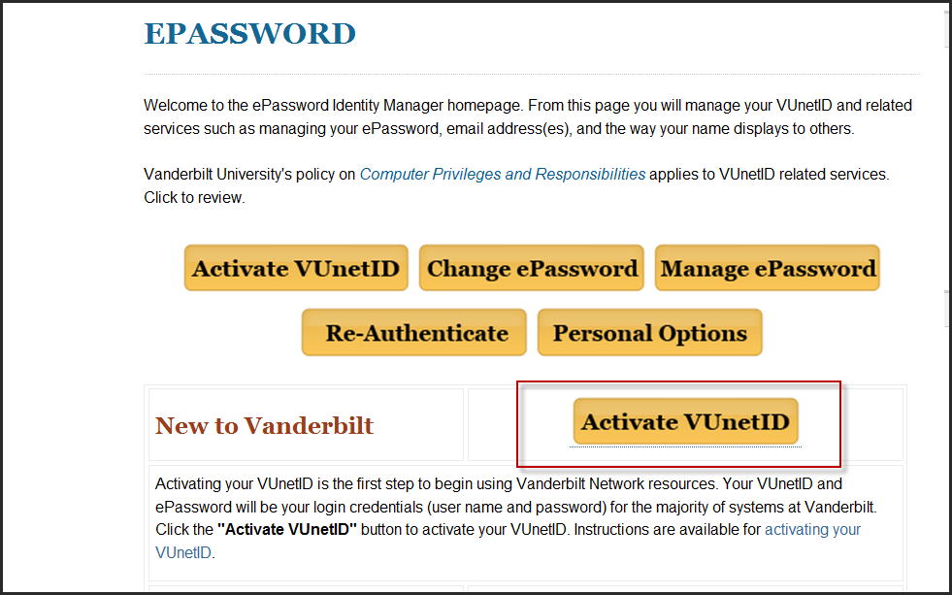

**WHAT TO DO IF YOU FORGET YOUR E-PASSWORD**

1. Reset your VUNETID:
   1. Go to ITS website <http://its.vanderbilt.edu/epassword>
   2. Click on “Change ePassword”

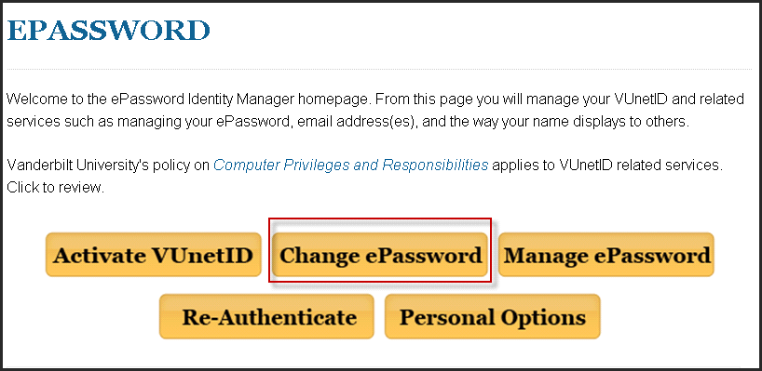

* 1. Click on “Forgot Your E-Password?  Click here”.

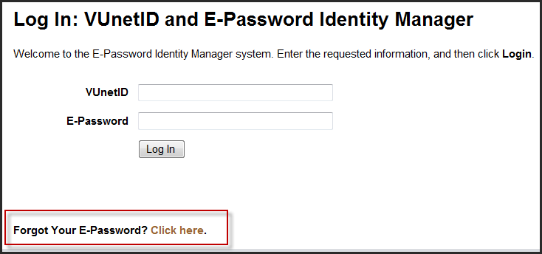

1. If you cannot remember the answers to your recovery questions, call the Help Desk at 343-HELP (4357) and they will reset your account for re-authentication.   You must then go to the ITS web site <http://its.vanderbilt.edu/epassword> and re-authenticate.

