Using TeamNotes in StarPanel
- Create a team in StarPanel
  - Systems Support Specialist (Inpatient) or Clinical Systems Specialist (Outpatient) will need to create team and add/remove members
  - Provide list of members to SSS or CSS to be added to team
- Customize your columns in your panels to display “TeamNote”
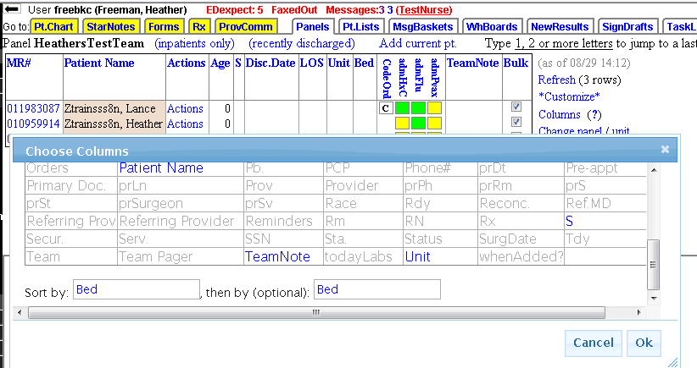

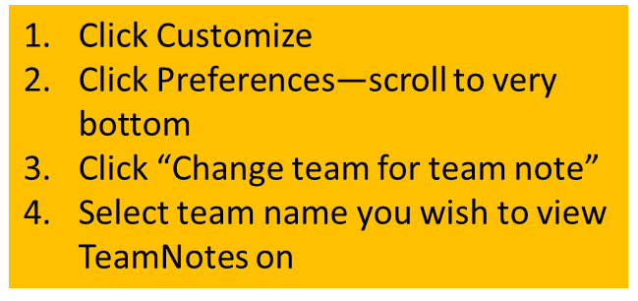
- Customize your view to display TeamNotes for the appropriate team. You may only be on 1 team, but you will still need to “turn on” the TeamNotes (You have to be added to the “team” in order for it to display)
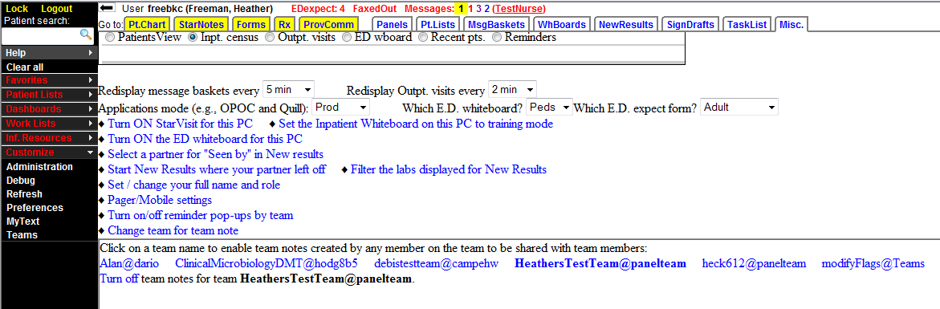
- Type your communication to the team by clicking in the TeamNote column next to patient’s name

