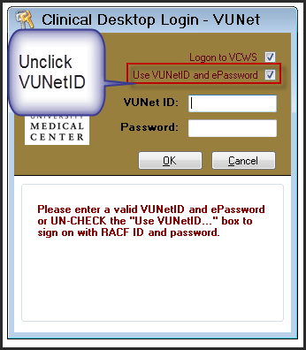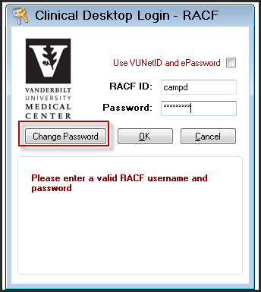

***Steps for Staff to Change Their RacF Password***

***6/25/14***

**Tip:** RacF password (HED, Medipac require this pw) must be reset every 240 days – so have a number in the pw so that is all you change each time ie **testpw1, testpw2, testpw3**

1. PRESS **any key** or the **mouse** to bring up the Clinical Workstation Login prompt.
2. TYPE in **Login ID** (RACF ID).
3. TYPE **Current Password**.
4. CLICK **Change Password**.
5. CLICK **OK**.
6. TYPE **New Password**.
7. VERIFY **New Password**.
8. CLICK **OK**.

