**SYSTEMS ACCESS INSTRUCTIONS**

**(VUNetID and RACF ID)**

**VSA TOOLS FOR VUNETID:**

**New Employee, Transferring Employee, or if you just want to see what access your present staff already has access too.**

* For new employees, the security manager should make sure new employees have the required ID(s) to perform their job and instruct them on how to create their passwords. Nursing Education and Development no longer has a sign on session for new employees during orientation.
* Check to see if their VUnetID is in the VSA Tool, <http://www.vanderbilt.edu/accessvu/admins/> by following the steps shown in the screenshots below:

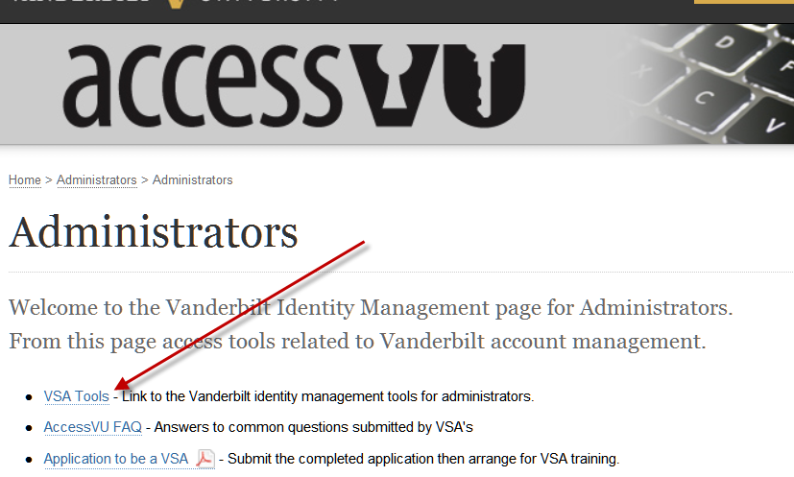

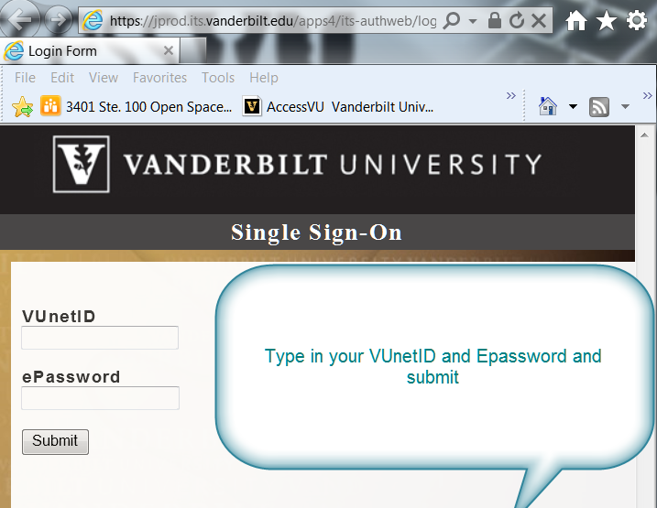

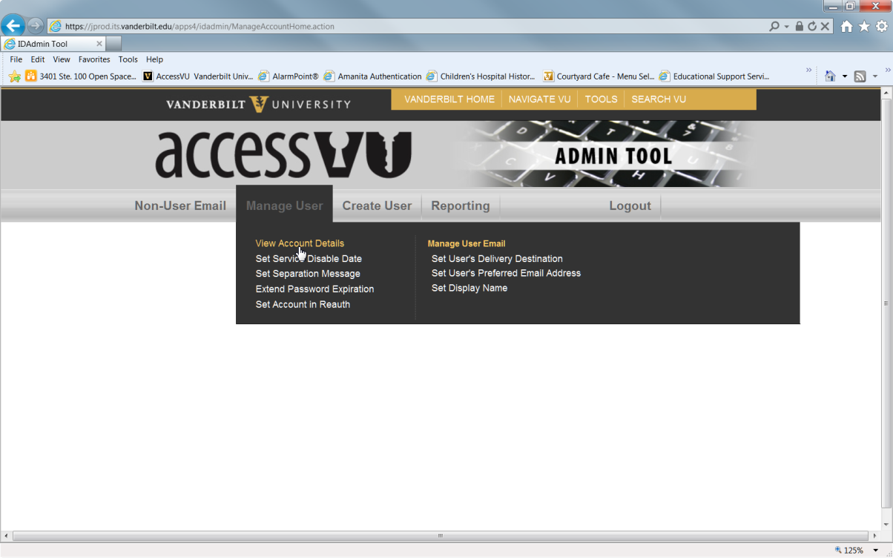

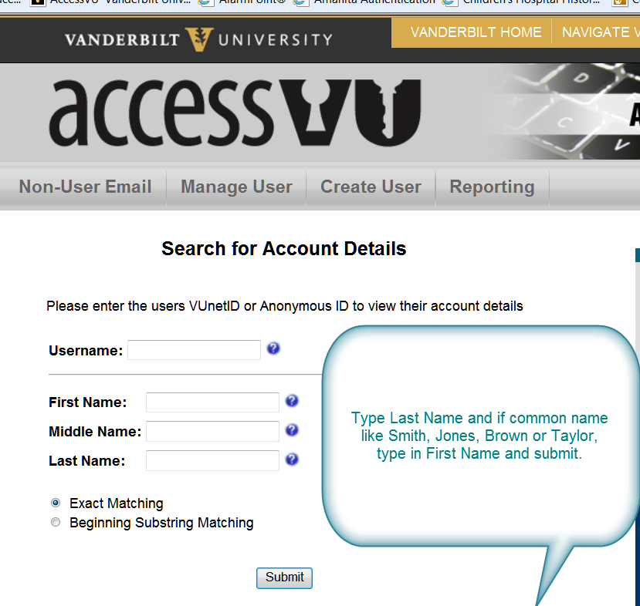

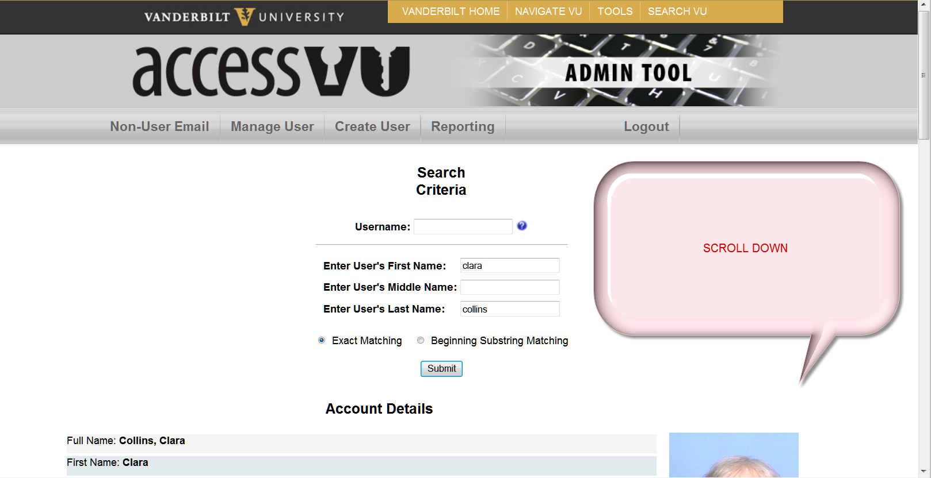

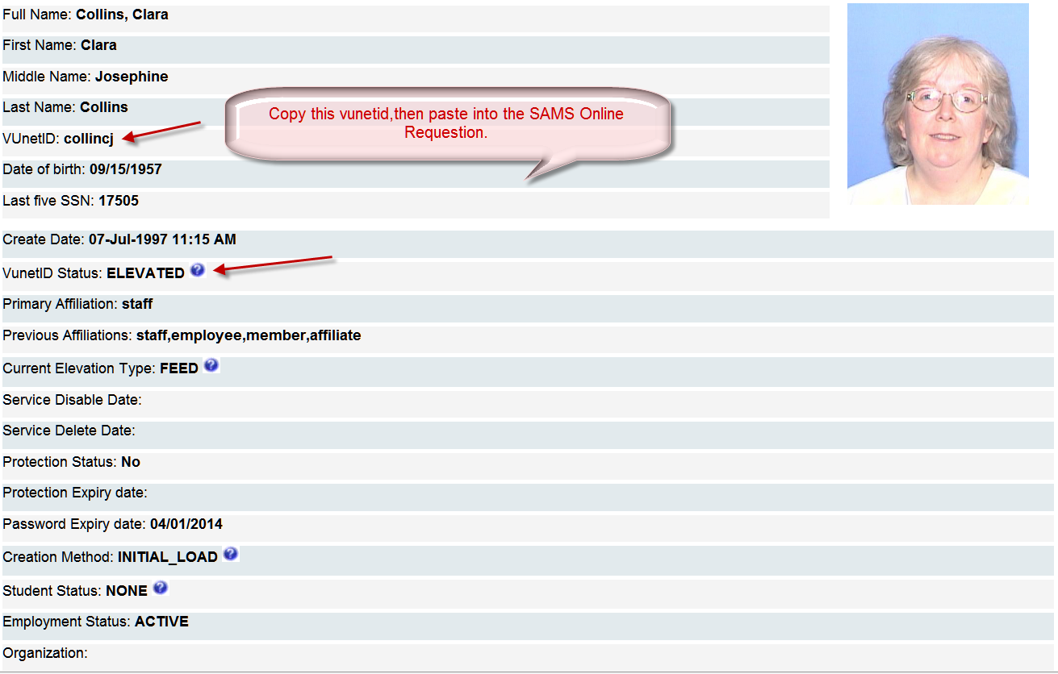

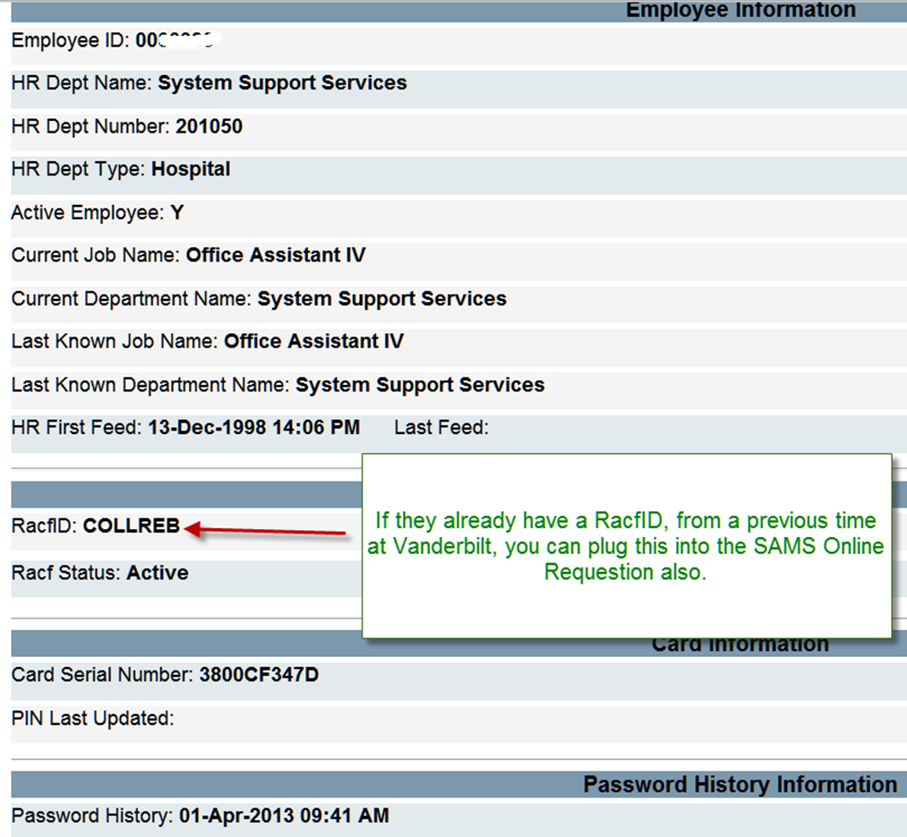

**If the user already has a RACfID from a previous time at Vanderbilt, you can copy and paste it in the SAMS Online request.**

**ONLINE SYSTEMS ACCESS REQUESTS FOR RACF ID:**

* **Access to the Identity Operations or SAMS Online Requisition:** [**https://samprod.mc.vanderbilt.edu/sam/Access.aspx**](https://samprod.mc.vanderbilt.edu/sam/Access.aspx)
* **Type in the VUNetID**
* **Put a checkmark in the 2 boxes**

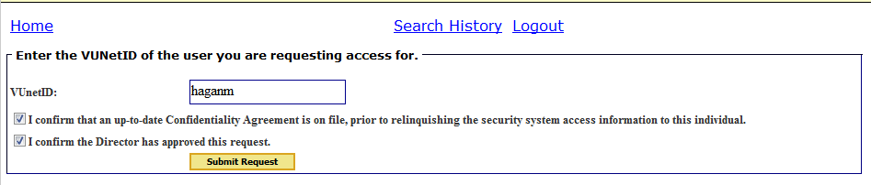

**New Employee:**

* Once the VUNetID is created, request the RACF ID and systems access to the clinical systems needed to perform specific job duties.
* You may receive the message below. Click OK.

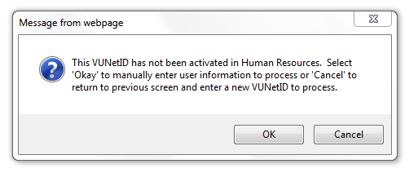

* Complete as much information as possible. Use the Comments section as needed.

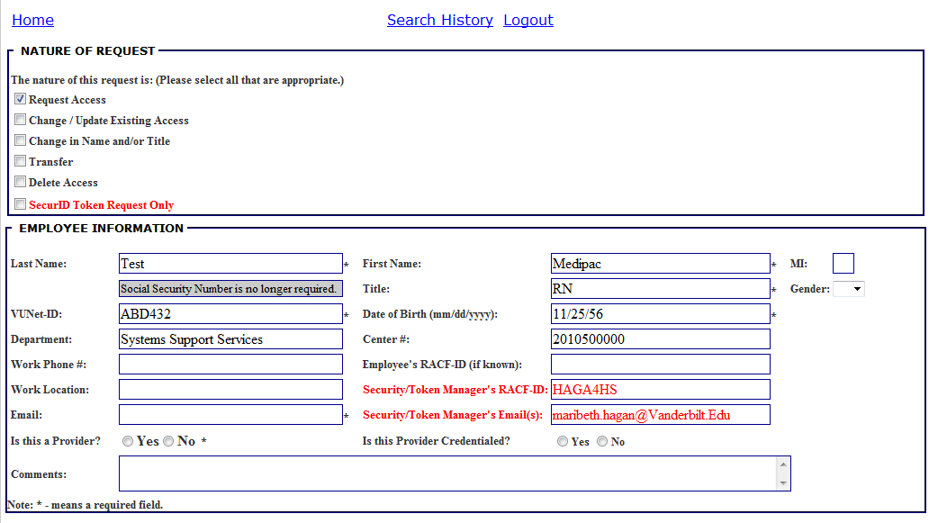

* Select the “add” box next to the systems being requested

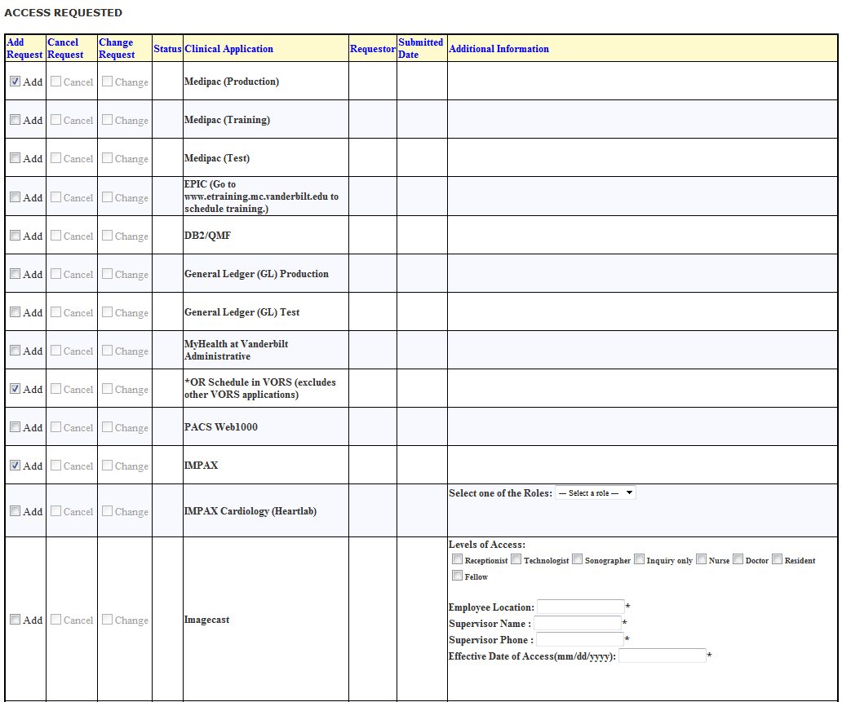

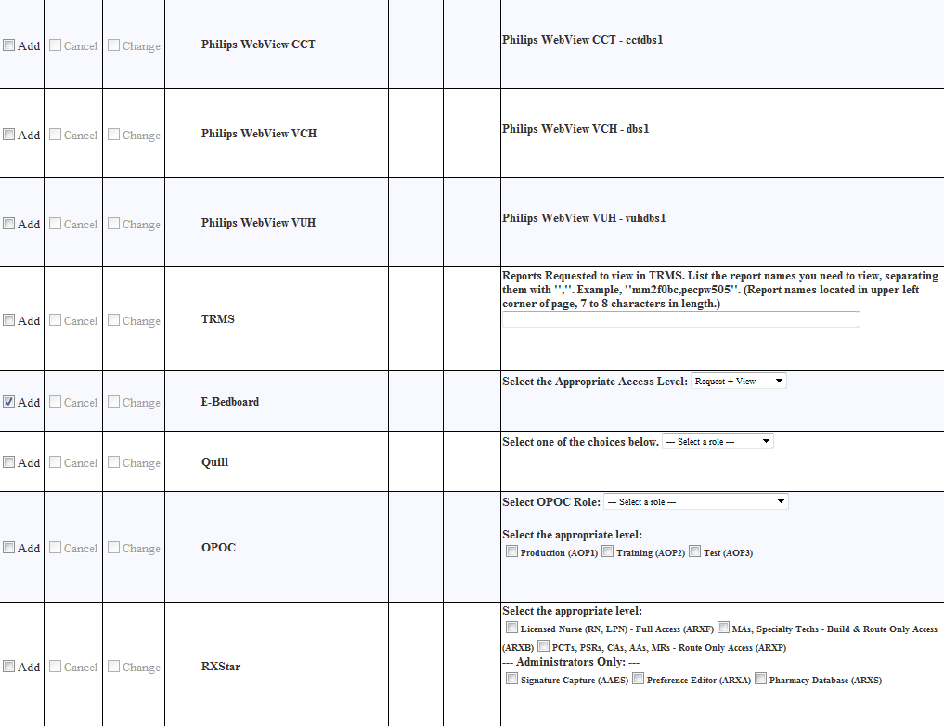

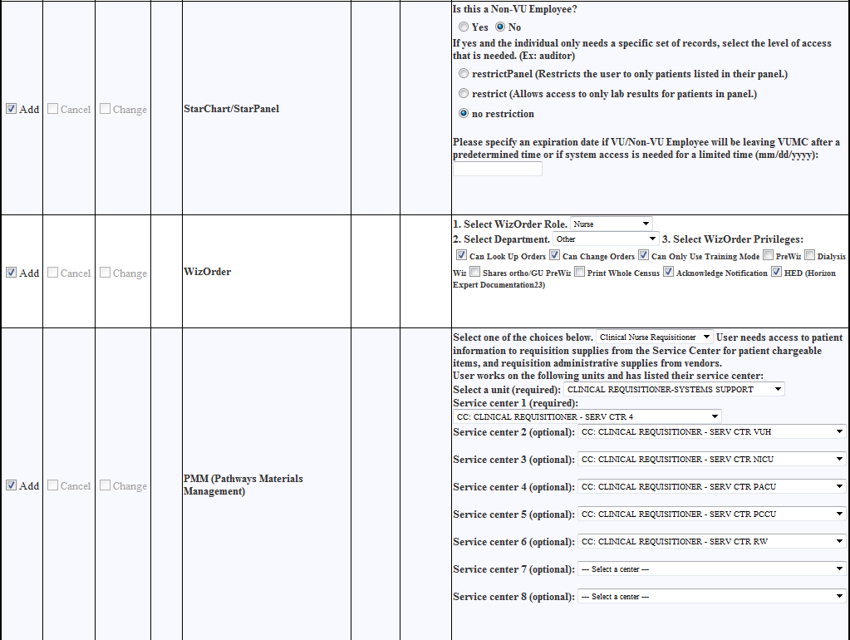

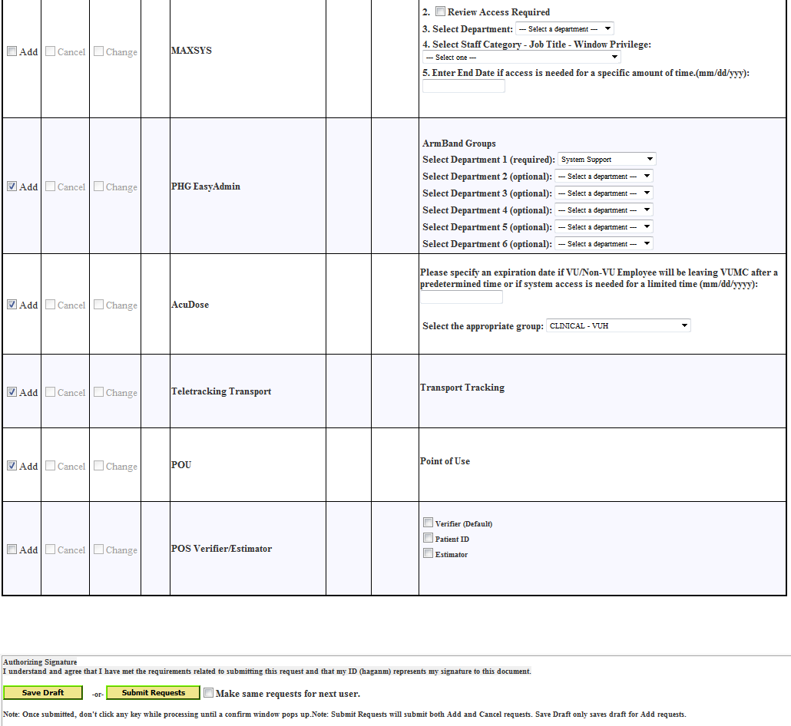

* Click “Submit Requests”. Check “Make same requests for next user” if applicable.

**TRANSFER (TBD by security manager of unit employee is transferring to):**

* Select the “Transfer” section of the online SAMs form
* Complete information for department name, center number, and date of transfer.
* Select “Change” on any access employee will need on new unit and make necessary changes as needed (i.e., PMM, PHG Easy Admin (armbands), AcuDose). Add any new items needed. (Note: no training flag is needed for HEO/Wiz so if checked from prior access, remove check mark)

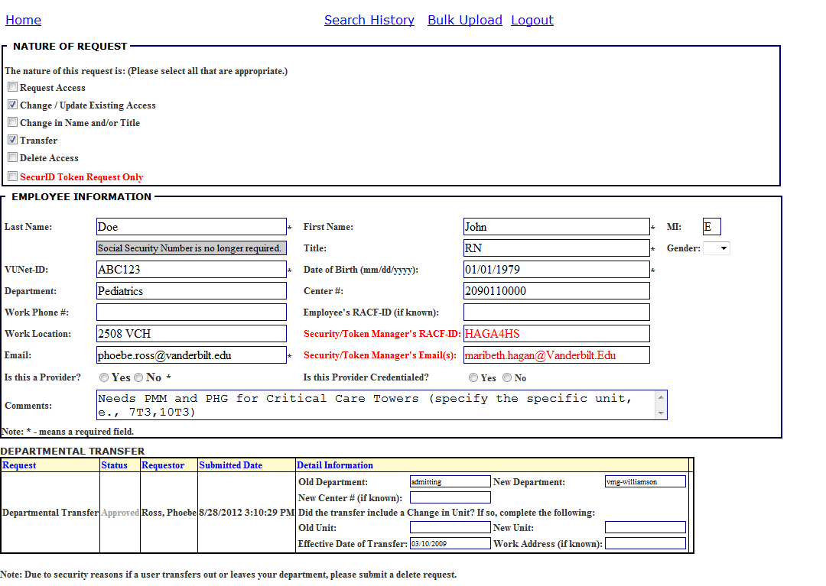

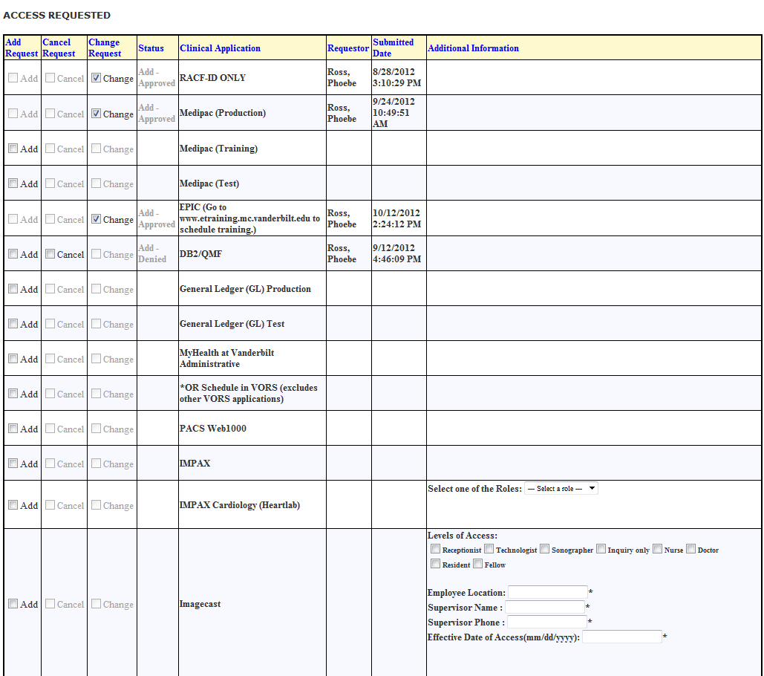

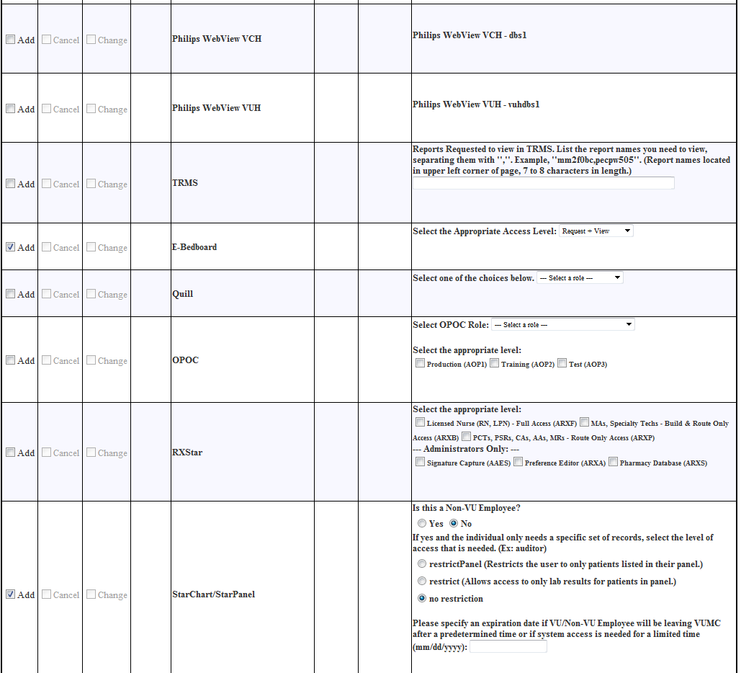

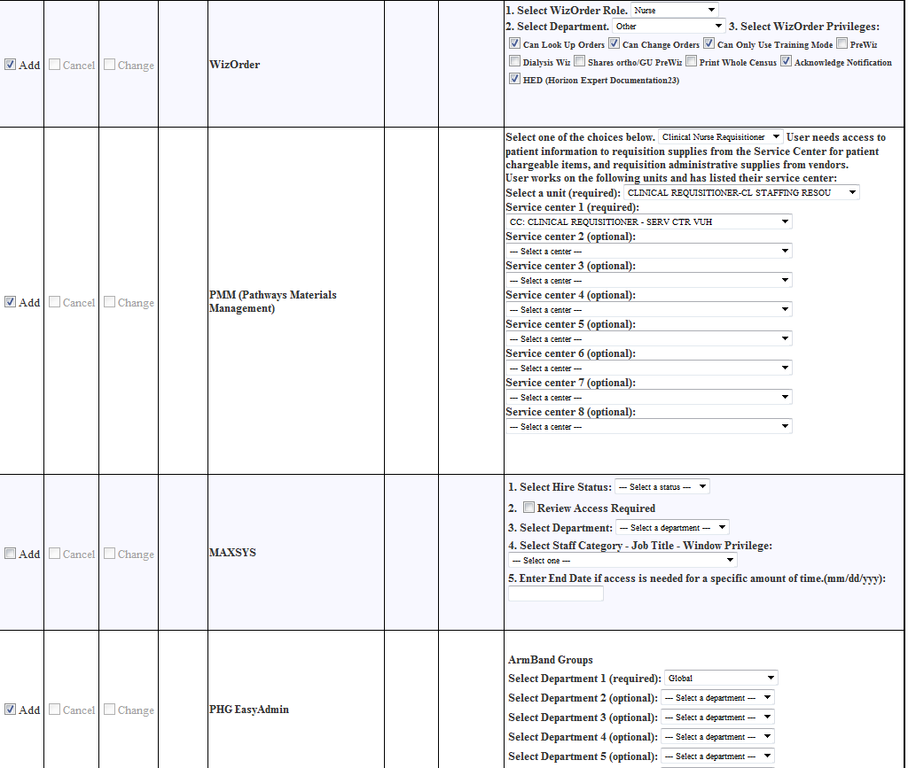



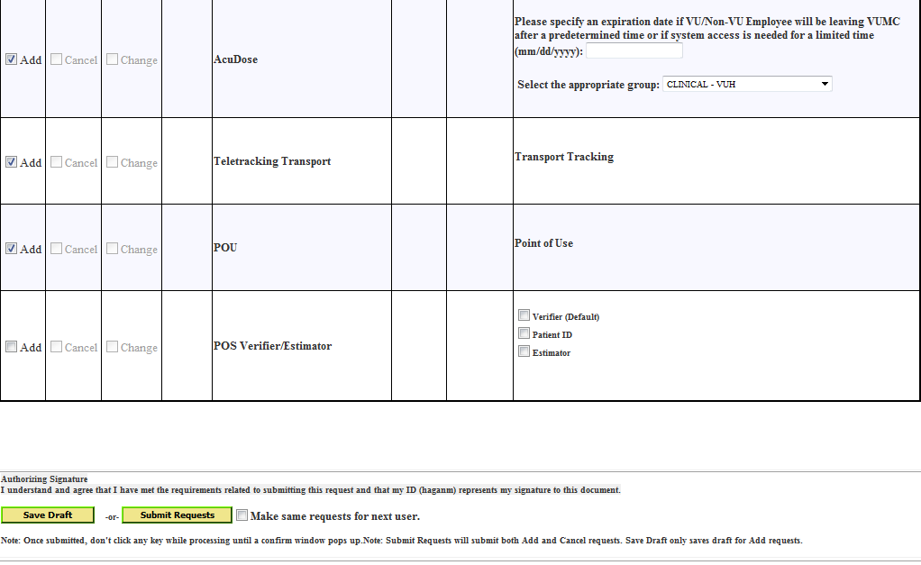

* Click “Submit Requests”

**NAME CHANGE:**

* Verify name change has been processed in VSA.
  + If name change has not been processed, the employee can go to AccessVU to the Existing Users page (<http://www.vanderbilt.edu/accessvu/existing/> ) and click on Enter PII

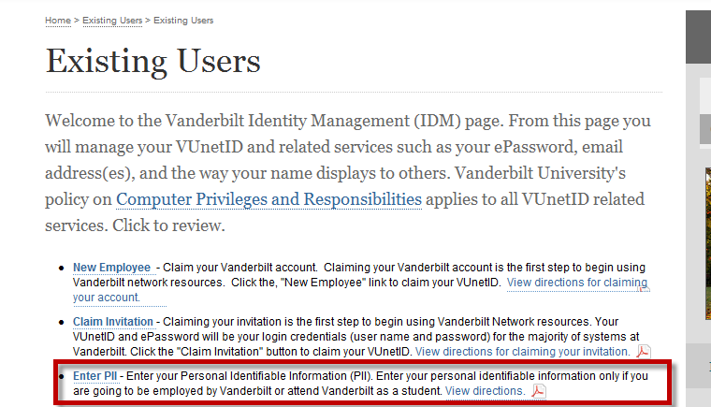

* Select “Change in Name and/or Title” section of the online SAMs form
* Complete information as appropriate

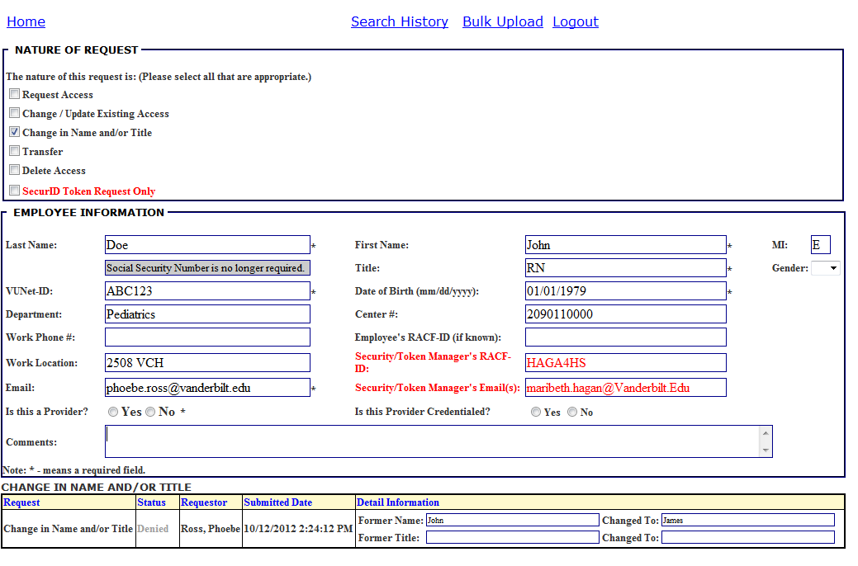

**TERMINATION:**

* If an unfriendly termination occurs during normal business hours and the VUNetID needs to deactivated immediately, call ITS Partner Support at 936-4877. If a VUNetID needs to be deactivated immediately after normal business hours, contact the Network Operating Center (NOC) at 322-2954 and someone on the development team will be paged
* If a RACF ID needs to be terminated immediately, contact the Help Desk and ask them to notify Identity Operations
* Select “Delete Access” section of the online SAMs form
* Select any access employee has which generates a request to deactivate their access for that application
* If no access displays, click on “Search History” to determine what access has been requested

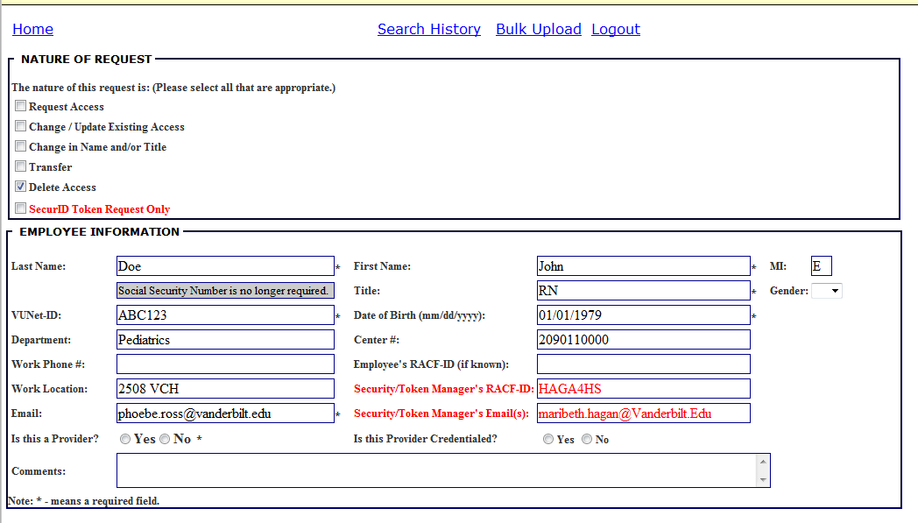

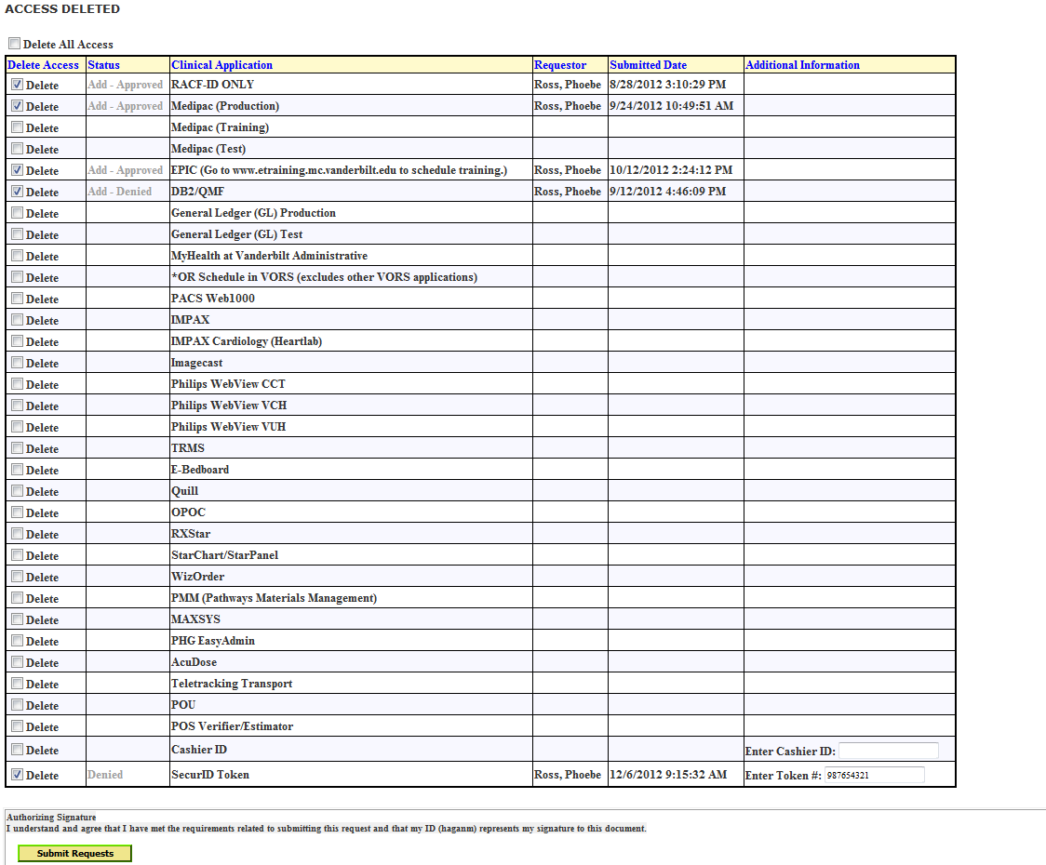

**Other:**

* If you need to Change/Update Existing Access and a transfer or a name change box is selected from a previous session, make sure only the Change/Update Existing Access box is checked, otherwise all the previous access may be deleted.
* If you are making multiple requests for the same access and role, you may click on the Make the Same Request for the Next User button.

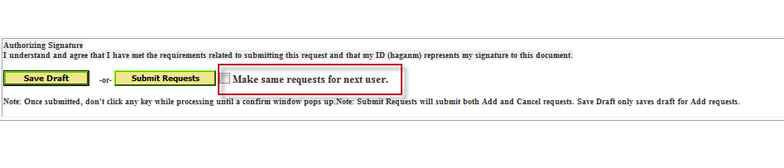

* Use the Comments box as needed for additional explanations, etc.