**How to Order Labs in RxStar**

**9/18/12 kr**

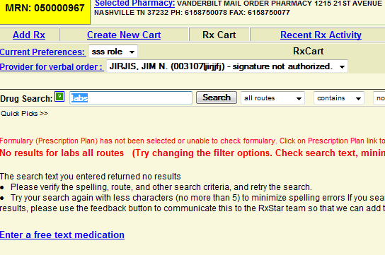

1. **Type “Labs” in the “Drug Search” box, and select “Search.”**
2. **Click on “Enter a free text medication.”**

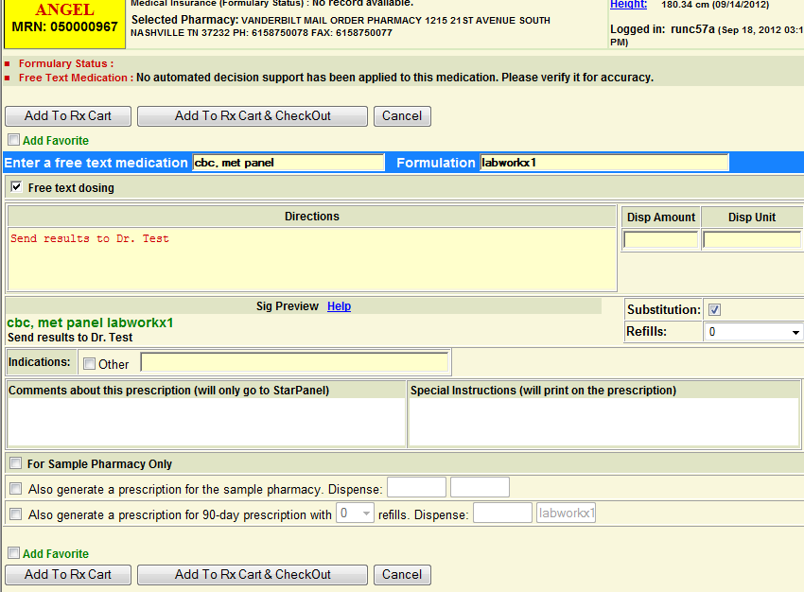

**5. Enter to whom results need to be sent within the “Directions” box**

**6. Select “Add to RxCart and CheckOut.” Continue to follow prompts to print.**

**3. Enter desired lab work in the “Enter a free text medication box**

**4. Enter Labwork X1 in the “Formulation box**