*Initial log-on to HED, RT’s will see the AdminRx tab:
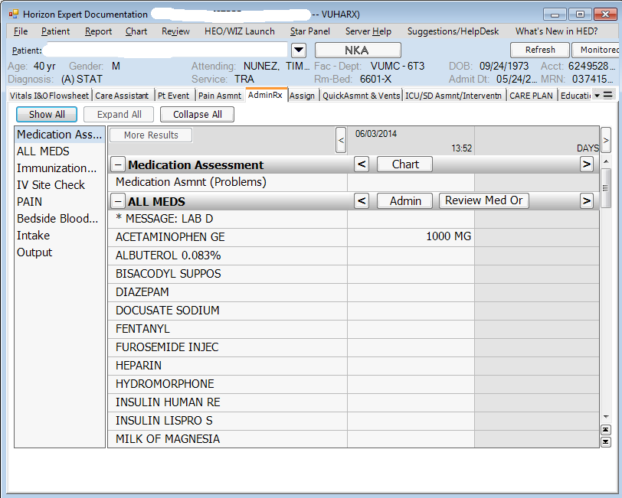
*To launch the HED RT documentation, click the drop-down arrow by Monitored VS (where it says “Launch alternative Monitored VS charting”):
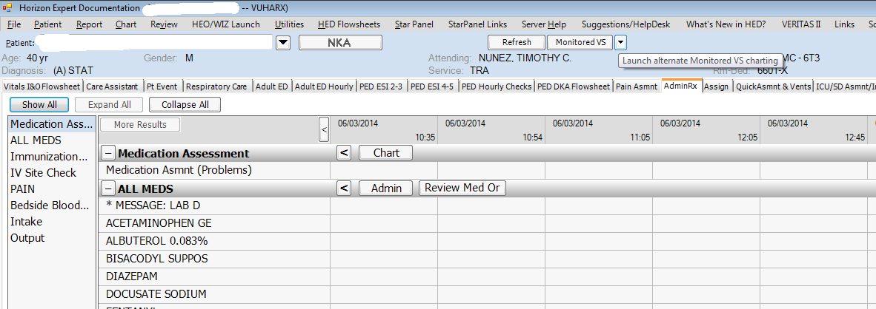
*Click on the Respiratory Therapy selection:
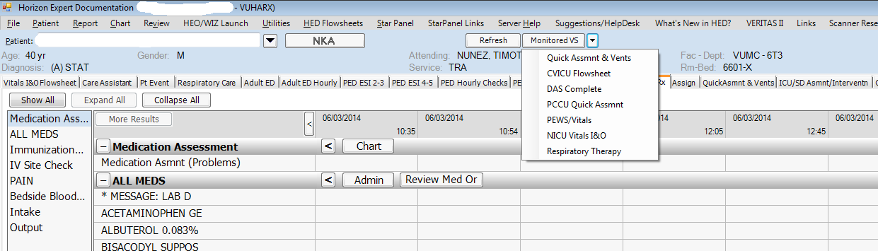
*A new window will open with available ventilator data.
*24hr data feed at selected interval. (Can scroll for review) *Current data (this is what you should chart)
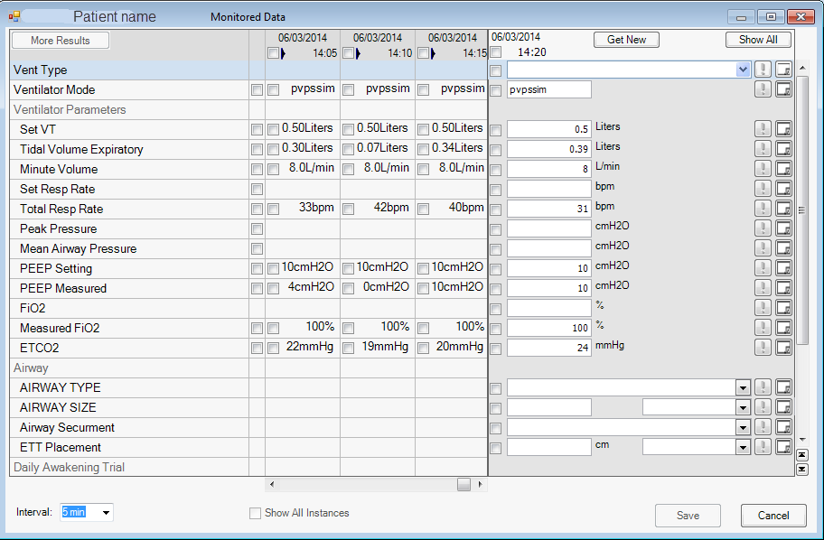

*Click “Show All” to open all of the documentation fields. You will need to chart the items that are missing and appropriate to the mode of ventilation. You can modify data pulled in if inaccurate.
*Check boxes indicated what data will be charted. Checking the top box will send all populated data.
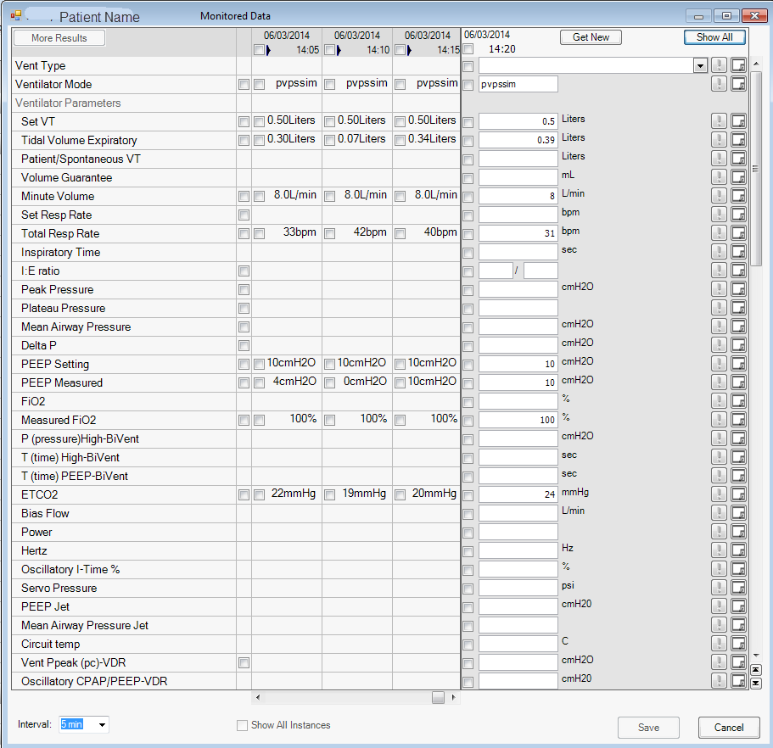
*Click here to add free text notes:
*Click here to highlight a parameter as important:
*Click “Save” to complete the charting episode. This will send data to the HED and StarPanel flow sheets.

Steps to Documenting ventilators in HED

- Log in to Admin Rx
- Navigate to Respiratory Therapy section
- View current data feed
- View previous data in the data feed from VueLink
- Change time interval
- Document appropriate parameters (type in data that is needed, adjust data pulled in if inaccurate)
- Sticky Notes: free text
- Verify/Save vent check
- Review/make changes: This can be done from the HED flowsheet and can only be edited by the person who saved the charting.

