RN TIP SHEET for Care Organizer Changes:
- Labs will display by time due in the TO DO List
- Can see what is due 12h back and 12h forward
- STAT Labs will also display in Overdues after 30 minutes
- Routine orders will also display in Overdues after 60 minutes
- Labs will remain in Overdues for 72h to display outstanding tests such as troughs
How to Complete Labs in Care Organizer
- To remove the labs from your “To Do” or “Overdues” list, it must be Completed in Care Organizer once specimen is sent
- Click on the Complete button in the header of Care Organizer
- In the window that opens up, select the order(s) you wish to complete
- Click on the Complete Button
- The Lab will be marked as “Charted”
- Close the Window
The lab due time(s) will be removed from your work list.
*Care Partners and Registered Nurses will both need to Complete Labs they have drawn or collected.*

ReSet Unit and Shift in Create Assignment:
- Click Create Assignment
- Click on Provider type – select RN
- Click Care Relationship -Select Primary nurse
- Click Shift -Select Days or Nights
- Click Pt Dept -Select your unit
- Click on File- Save Configuration
- Always click on EXIT to save configuration, here and exiting HED!
Make sure Worklist is checked in To DO view to see times labs scheduled times!

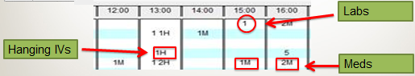
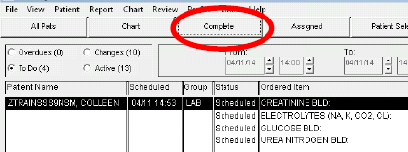
1
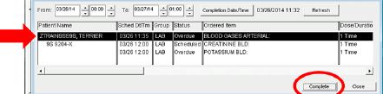
3
2
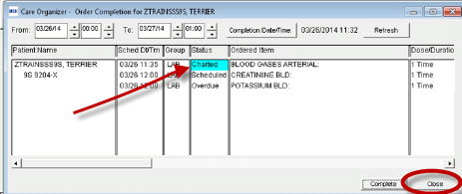
4
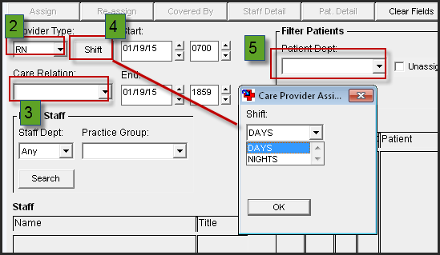
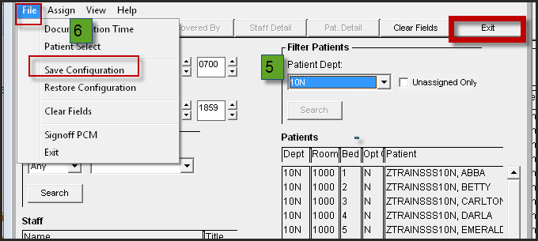

Configuration for RN
- Log into HED. Select View
- RNs - Click on IV, Meds, and Orders
- Click on Configure
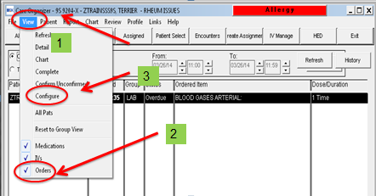

- Select the Include radio button
- Select:
  - MEDS
  - MEDS-RT
  - LAB
- Click Add >> to move to
to the Included Group.
- Then select OK

