SYSTEMS ACCESS CHECKLIST
- Find out who your security manager is (it is the AA on most units).
- They will give you your User/RACF ID Security letter which contains your ID and initial temporary password.
- Activate your RACF ID and create your password.
  - To activate your RACF ID, log onto a clinical workstation but be sure to uncheck both the “Logon to VCWS” and “Use VUNetID and ePassword boxes.
  - Type in your RACF ID from your security letter and the temporary password provided. Or type in abc123 if the Help Desk has reset your password for you.
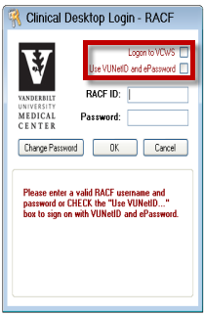
  - If you want to have the same ID for both your VUNetID ePassword and your RACF ID, follow these guidelines:
    - The password must contain exactly 8 characters
    - It must have at least one capital letter
    - It must have at least one number
    - It cannot have any special characters or be a part of your name, SSN, user ID, or date of birth.
    - Example: Coconut1
- Set up your VCWS using the instructions provided. This can also be accessed from the Systems Support Services website, http://www.mc.vanderbilt.edu/documents/sss2/files/Setting_up_VCWS_8_14.docx
- Set up your frames display in StarPanel/StarBrowser.
  - Click on Customize from the black menu bar
  - Click on Preferences
  - Scroll down until you find Show numeric frame sub tabs… and click on no and it will change to yes.
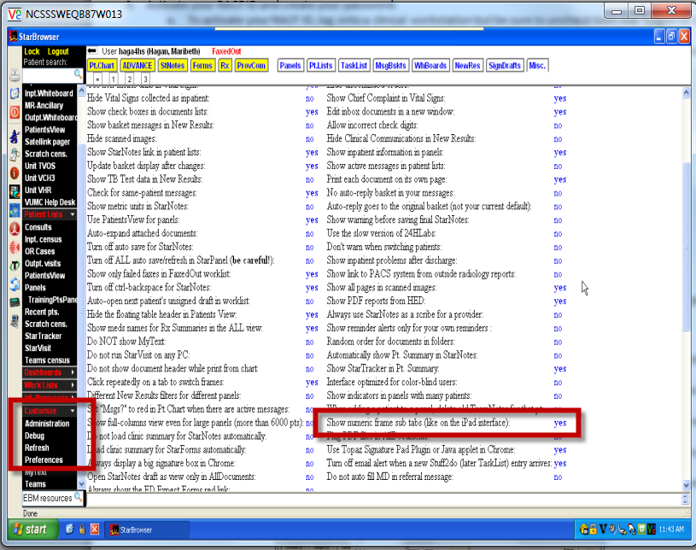
- Configure Care Organizer – instructions are provided under Links in Care Organizer and HED
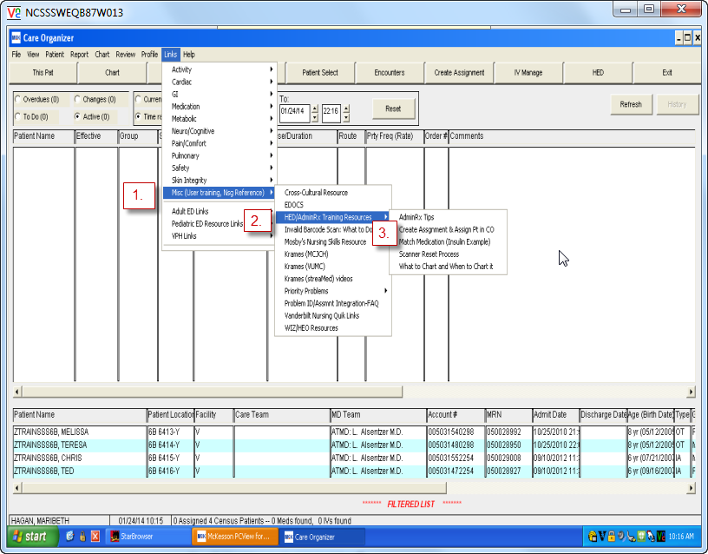
- Have your preceptor sign off you have completed these steps.
Preceptor and Date

