Public Drafts for Standardized (AllStar) Discharge Summary Note
3.14/lg
1. Original author saves DC Summary/Note as a draft.
2. When another author opens the draft, the following warning will appear, requiring the end user to acknowledge and select ‘ok’ before editing is allowed: (This warning will display each time the draft is opened for editing when the author is different from the previous author.)
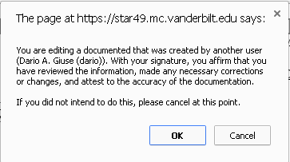
3. After the document has been saved as final, use the ‘Show Versions’ option in the ‘This Document’ menu to view details of each version.
----------------------------------------------------------------------------------------------------------------------------------------
-----------------------------------------------------------------------------------------------------------------------------------------
