**Summary of Nursing Documentation Re-Design**

**Implementation Time Line**

**Sept 15th** : Pilots 8 N/S, 8 VCH

**Oct 13th** 7N, 6S, 5S, CTU/7S

**Oct. 22nd** 10S; S34, 44, 64, 75, CRC

**Oct 27th** Peds Acute Care – 6th and 7th floors

**Nov. 3rd** 9N, 9S, 11N, 6N

**Nov 11th** PICU, PCICU; 10N, 11S

**Novl 17th** 10T3, 9T3, 8T3

**Dec. 1st** 5N, COBS, S54, 6T3, 7T3

**Dec. 8th** Adult & Peds ED Admitted pts.

*(VPH, OB, NICU and Nursery are not implementing this year)*

**Goals for Changes**

* Standardize and streamline documentation
* Better communicate the “patient story”-
* Make abnormals stand out by **not documenting normal data**

**Not Changing**

* No changes to trended numeric data (Vital Signs, I&O) and devices (Vents, VAD, etc. )
* No new changes to the Nursing admission history
* No changes to current practice and/or policies (what & how often) – but changes to documentation

**NEW Assessments Status**

* **WNL** – Within normal limits.
  + **Nursing Problem Identified**
  + **WEL** –Not normal but is normal or a new normal for the patient (example- Musculoskeletal = WEL annotate: *Amputee x10yrs*).
  + **OEL** – Outside expected limits but not risen to level of a problem; will have supportive documentation (example GI- hypoactive BS but otherwise normal assessment)
  + End of shift a **Response to Care/ Recommendation** will be charted

**NEW Starpanel Display of Information-** Customize to show only important fields

* Updated plan of care in OPC, Team Summary, and Integrated Presence;
* 3 Customizable Flowsheets: NSG_DATA+, NSG_CARE, NSG_PLAN

**NSG_ Data+**

* *Trendable Data:*
* Vital signs , Pain, Height, Length, Weight
* I&O, IV Drips
* 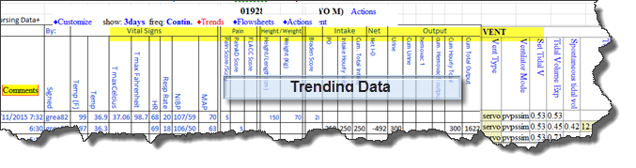Device data (Vents, ICP, VAD, etc.)

**Nursing Care**

* Assessments &Interventions
* *Excludes VS,I&O,IV Drips, Device data*

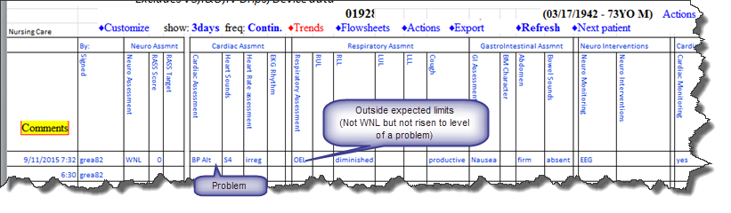

**Nursing Plan**

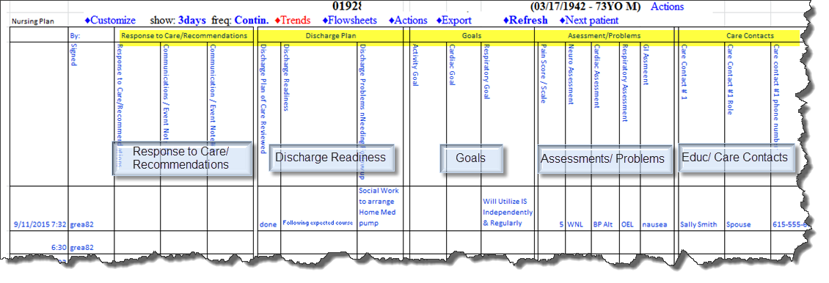

**CARE PLAN VIEW in OPC**, **Team Summary, Integrated Presence**

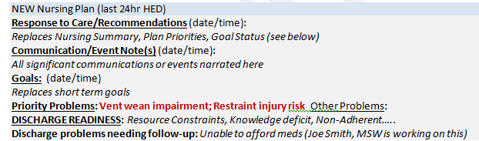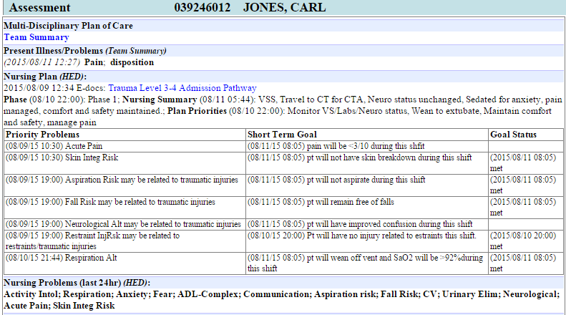

Changing to