**Printing Labels After Patient Discharge**

**VK 6.12**

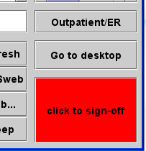

From the WIZ/HEO Stat Screen, select Outpatient/ER.

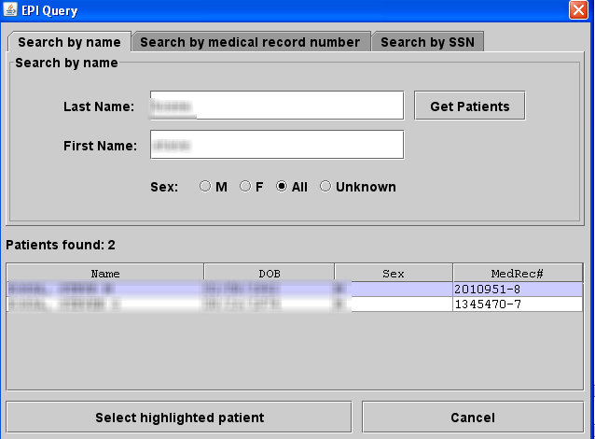

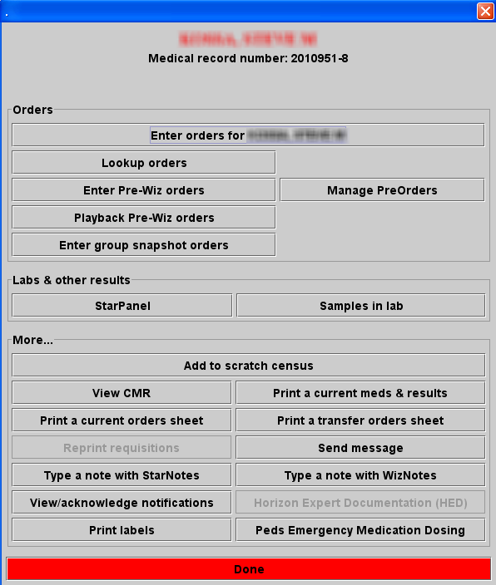first name

Type in patient last and, and select Get Patients. Patients will show up at the bottom, click on patient needed and click on “Select highlighted patient”

Select print labels.