**PMM Access and Troubleshooting Tips**

1. If a user gets the following error message when trying to log into PMM/ Materials Mgt. application, this is an indication that the server needs to be reset.

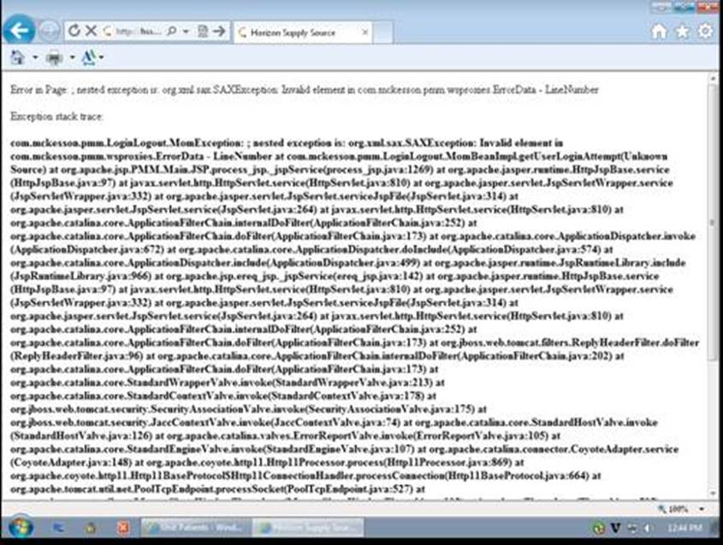

1. There are several different options available to Security Managers when initially requesting systems access and there are pros and cons to each choice.
   1. They can request that staff be set up like Float Pool/Registry Staff by giving them access to the “CSRC” (Clinical Staffing Resource Center) group. This allows them to order for delivery to any location in the hospital BUT they must specify a delivery location for every order. If they fail to specify a delivery location, the order will be canceled. Because of the very high volume of floating staff are required to do, it’s very common for staff to be set up in this way so when they call the Help Desk saying something is not working (eg. I enter an order in PMM but nothing happens), this is indicative of an educational need. We do not teach a formal PMM class to new employees. Instead, they are directed to complete self-paced e-learning available from our web site. This training does include instruction on the need to enter a delivery location.

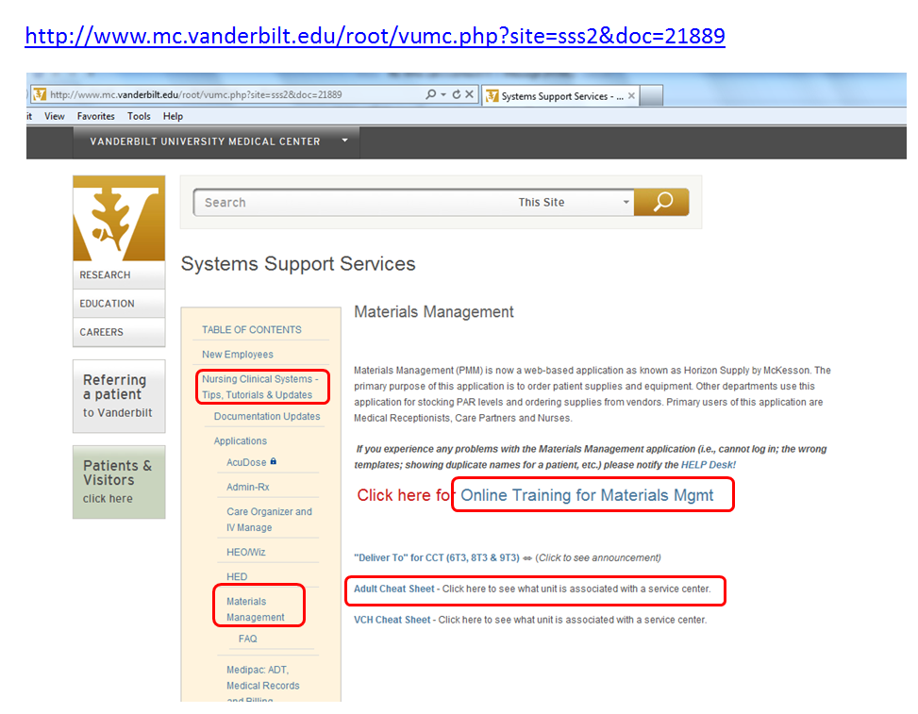

* 1. The other option available to the Security Manager is to give the employee access to order only for specific Service Centers (eg. Just Round Wind or just Critical Care Tower). The advantage to the user of this set up is that they have certain delivery locations that default for them to select from so there is less of a chance they will order supplies without including delivery location information. The problem with this is that if the staff member does float to a unit that does not show up on their default list, they will not know how to get supplies delivered elsewhere. One solution is for them to request the Security Manager to add additional default locations but this is not something that can be done in real time when they are experiencing the problem. Reviewing the same training material sited above might help in this situation too.

If someone calls with the complaint “I can’t order in PMM” and if they don’t tell you why, they are not likely to get directed to the right solution.

**Decision Tree**

1. **Error message on logging into PMM:**
2. **Error message after logon – technical issue**
3. **Able to order item but it does not arrive:**
4. **Other Ordering issues:**

If it’s none of these, it should be sent to the Application Support Team. Systems Support does not provide more than very limited training on this application and are not skilled to do any higher level trouble shooting than have outlined here.