NOTES

STARPANEL/STARBROWER – Electronic Medical Record Application (EMR)
- Inpatient Whiteboard – HIPPA compliant screensaver prior to log on, contains patient census with access to patient chart after log in
- Actions Menu – links/shortcuts that allow navigation to different sections of the patient’s chart
  - Overview of Patient Care - OPC
  - All Documents
  - Fast Labs
  - MAR
  - E-docs Pathway
  - Admission History – Hospital specific (except NICU/Newborn Nursery done in HED)
    - Med List Tool – MLT
    - Allergies
HORIZON ELECTRONIC ORDERS (HEO)/WIZ – Computerized Order Entry
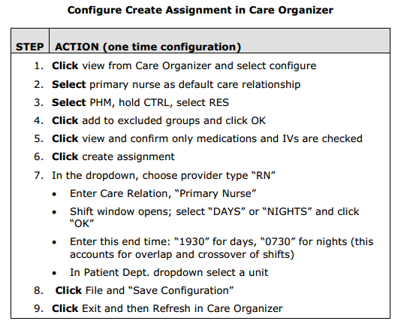
- Look-up Orders
- Enter Orders
  - Verbal
  - Telephone
  - Written
  - Protocol
  - Nurse to nurse
- Request Blood

HORIZON ELECTRONIC DOCUMENTATION (HED) – Nursing Documentation and Medication Administration
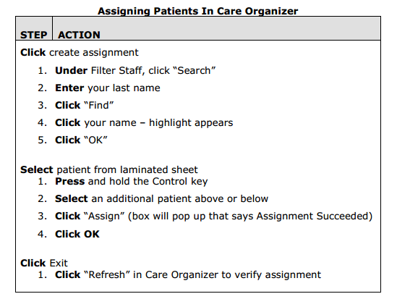
- Care Organizer
  - Create Assignment
  - Confirm Medications
  - IV Manage
- HED
  - Vitals I/Os
  - Physical Assessment
  - AdminRx – bar coded medication administration

